Canadian Aerophilatelic Society

Compilation of Images of Covers and Signatures of Aircraft Pilots Who Flew Mail Services in Canada

From the collections of Denny May and Tom Reyman with additions from John Irvine, John Lewington, Gord Mallett, and Dick Malott
October 2022

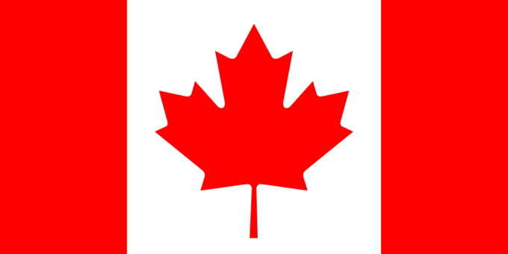

JOHN ALCOCK

JOHN ALCOCK

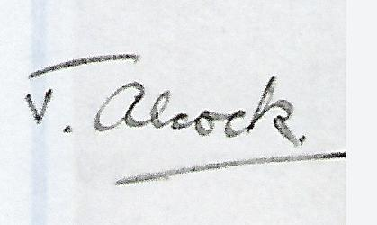

TONY ALCOCK
TONY ALCOCK
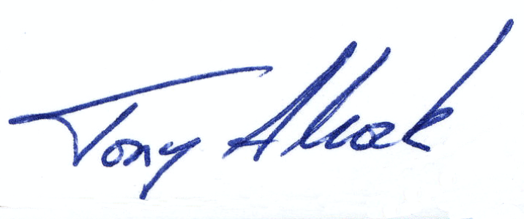

Tony Alcock
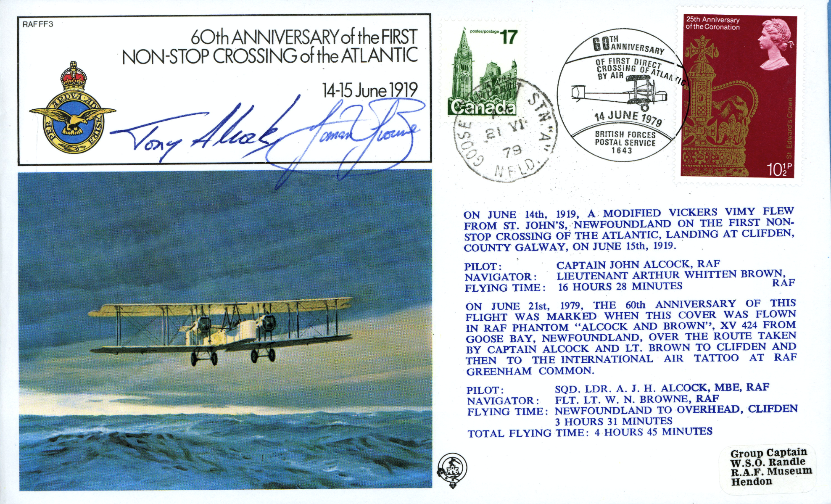

EDGAR A. ALTON

E. A. ALTON
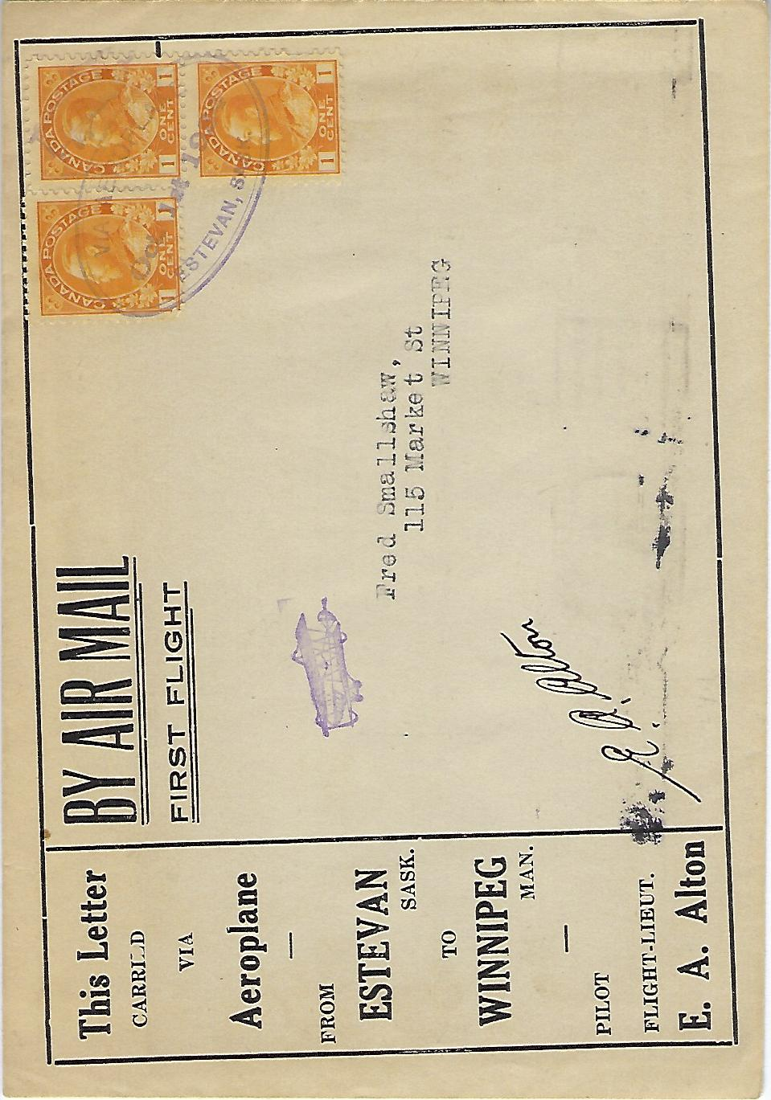

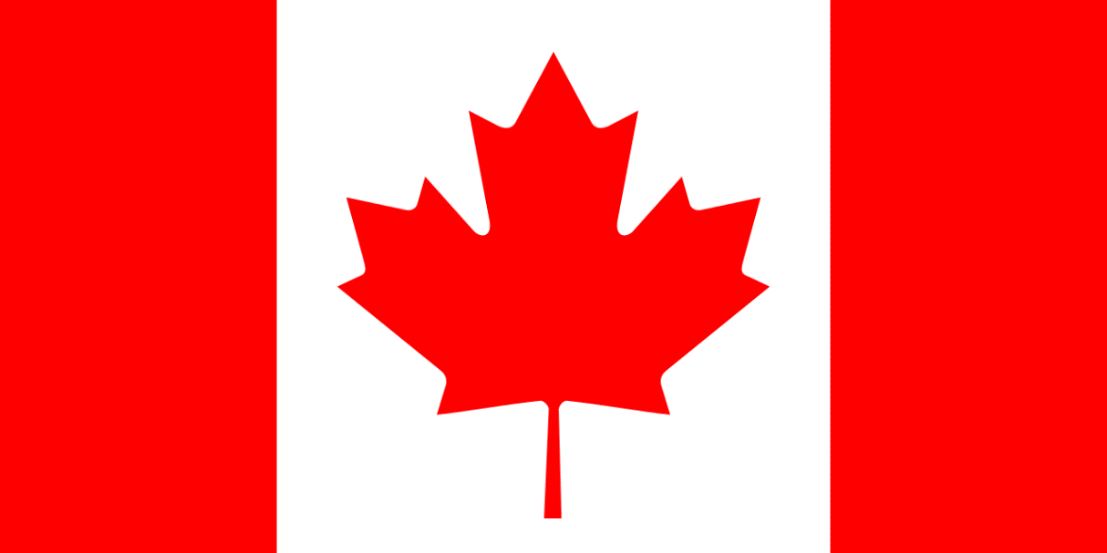

- L. ANDERSON

A.L. ANDERSON

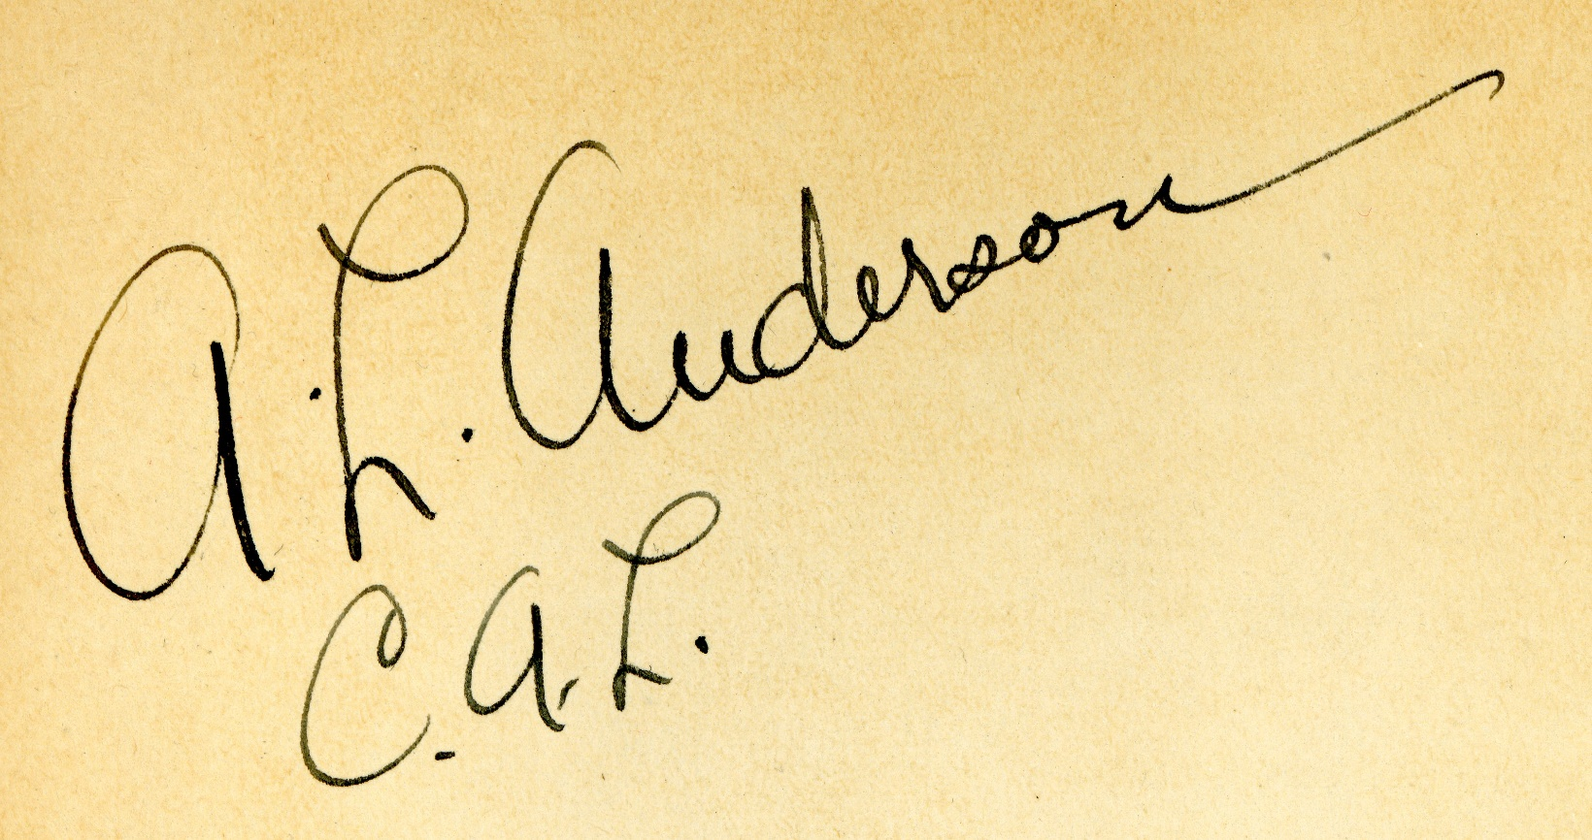

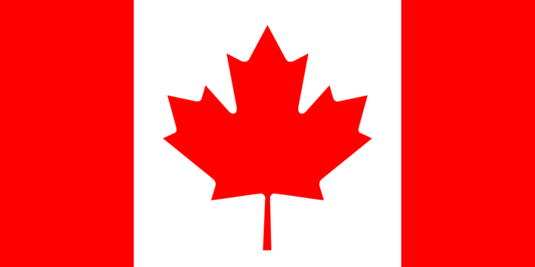

TOM APPLETON

TOM APPLETON
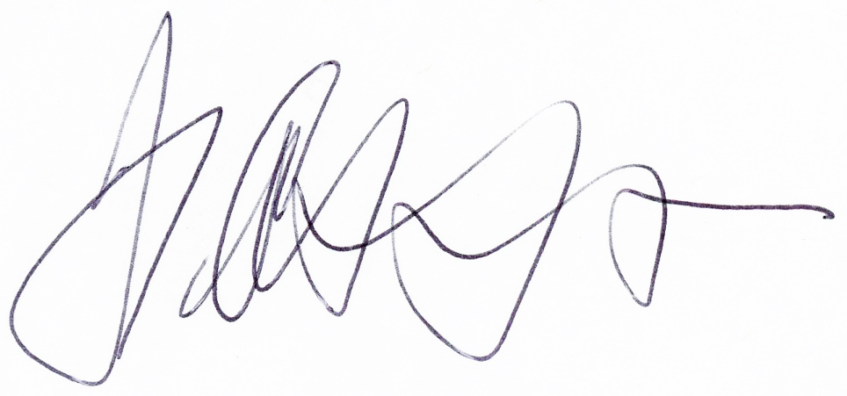

MAJ. J.P ARGUE

MAJ. J.P. ARGUE
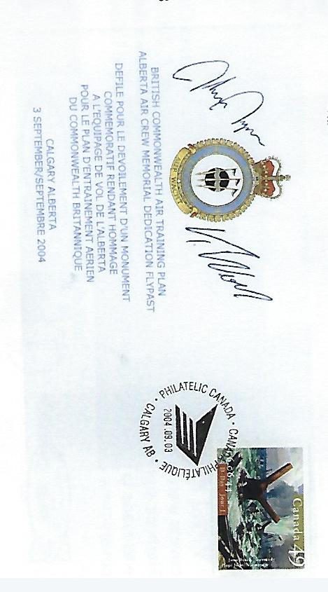

M. E. ASHTON

M. E. ASHTON
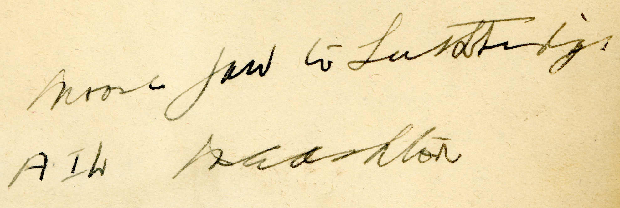

DALE ATKINSON

DALE ATKINSON
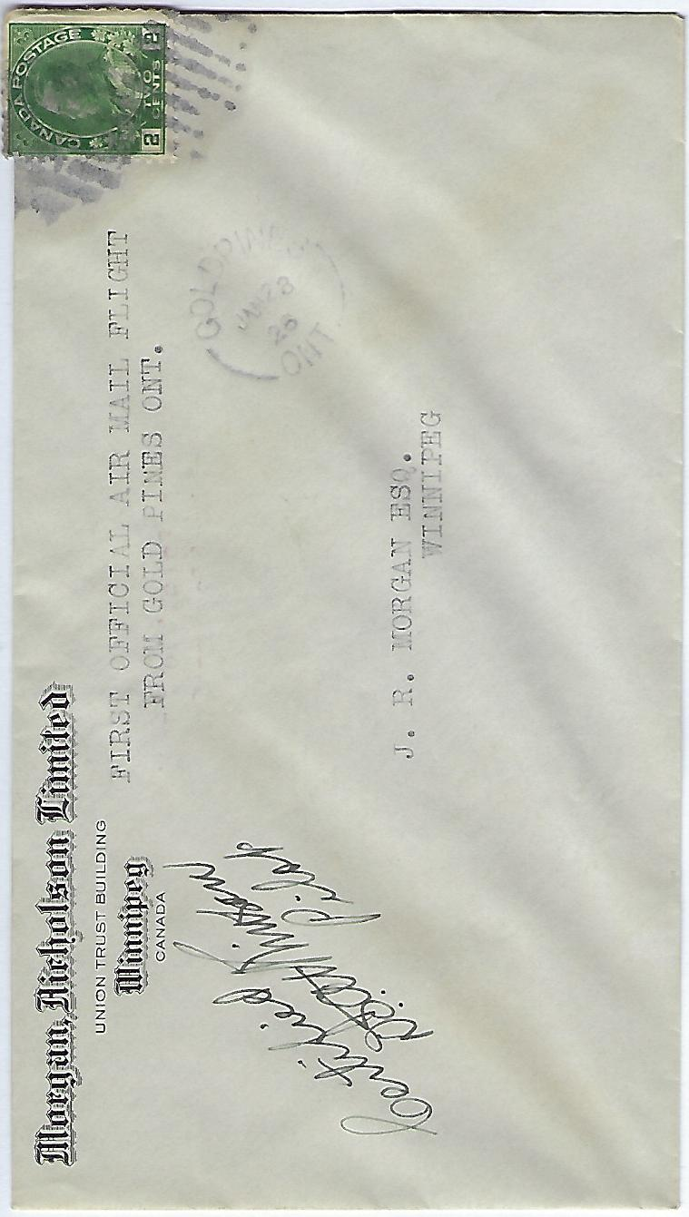

DALE ATKINSON

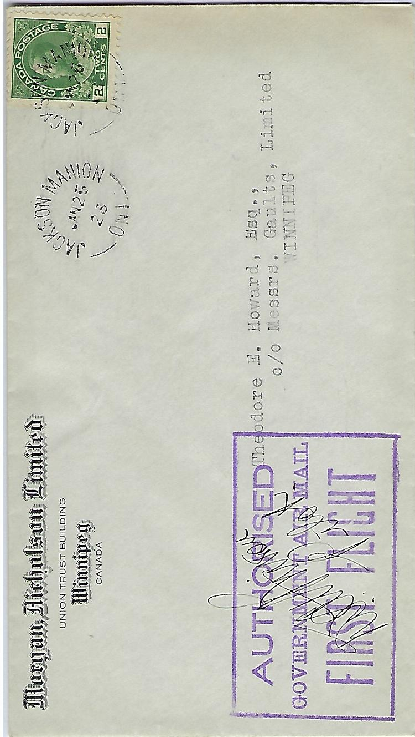

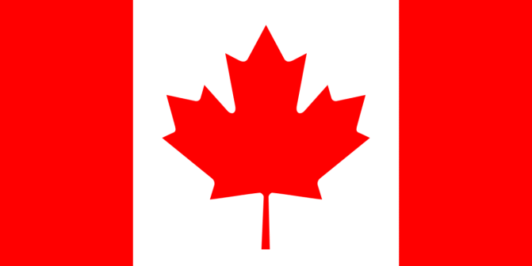

CHARLES “CY” BECKER

CHARLES “CY” BECKER

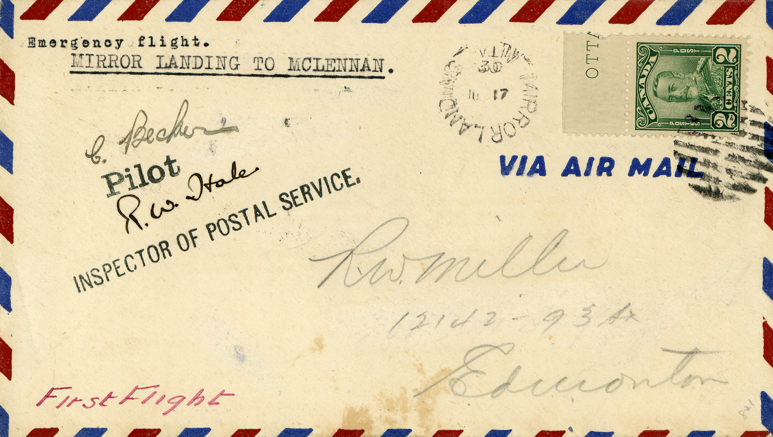

ARTHUR N. BELL
ARTHUR N. BELL
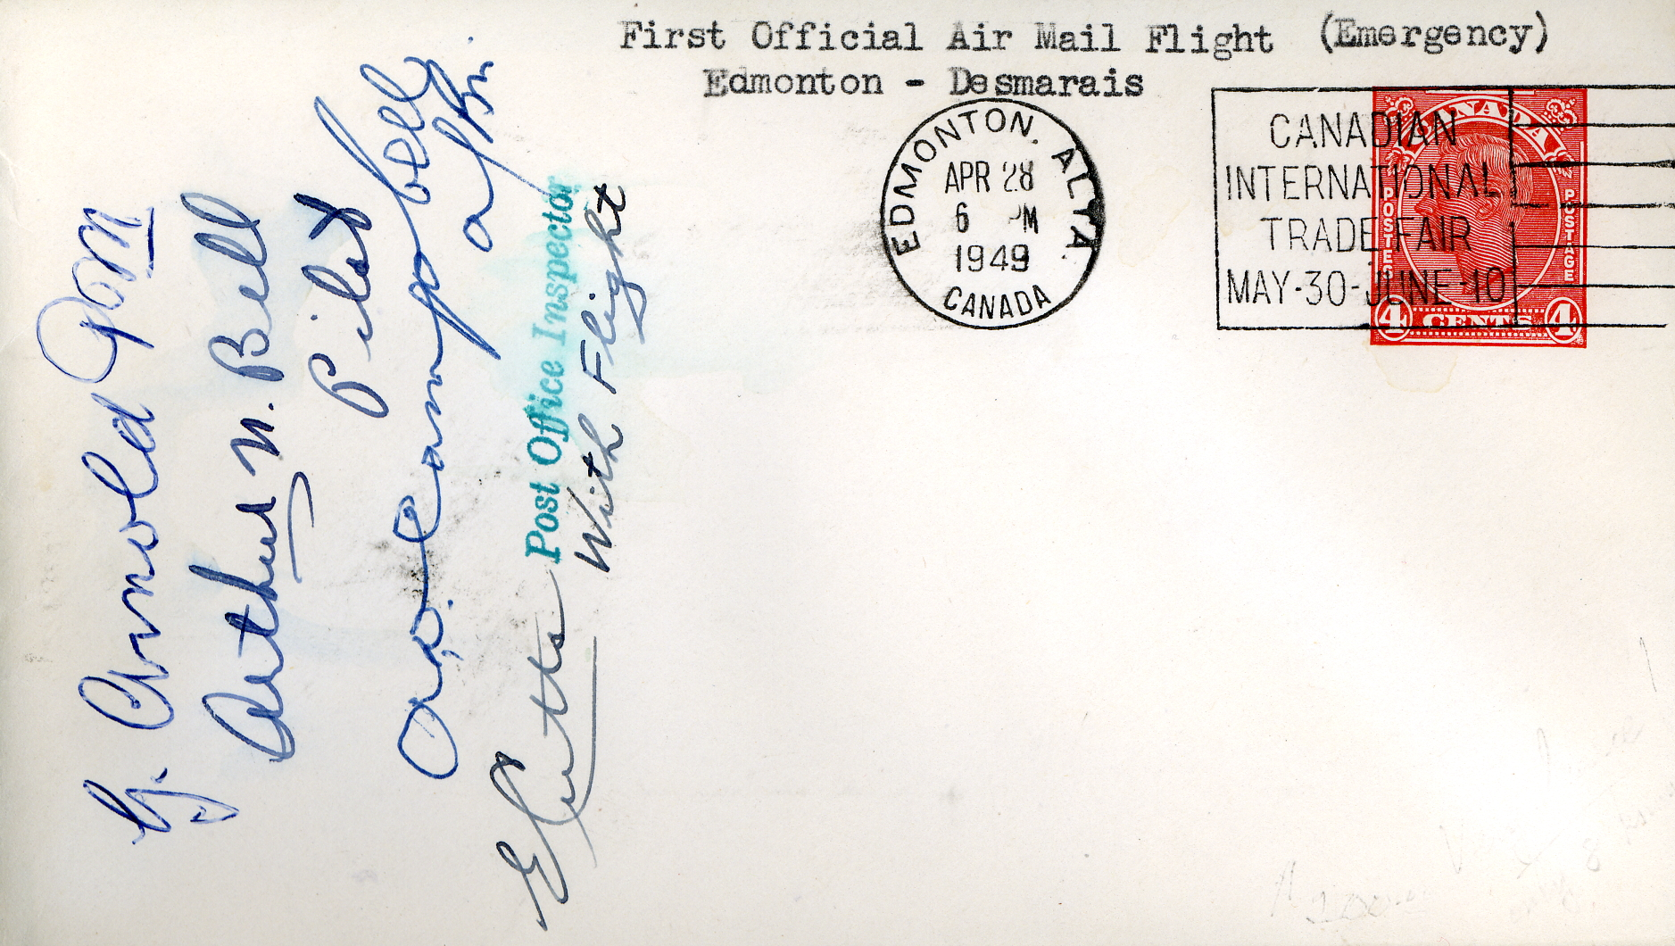

LT. C.H. BIDDLECOMBE NAVIGATOR

LT. C.H. BIDDLECOMBE (NAVIGATOR)
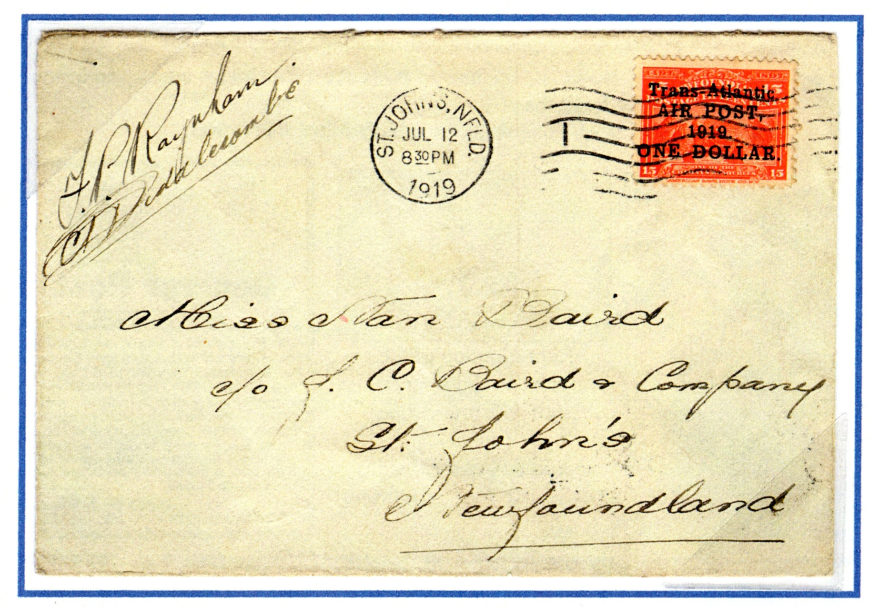

BRETT BINNIE

BRETT BINNIE
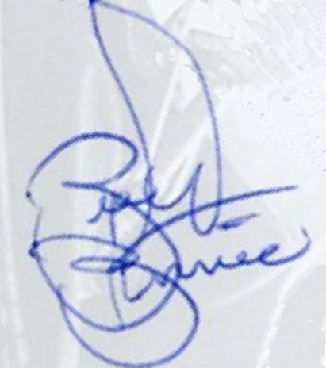
BRETT BINNIE
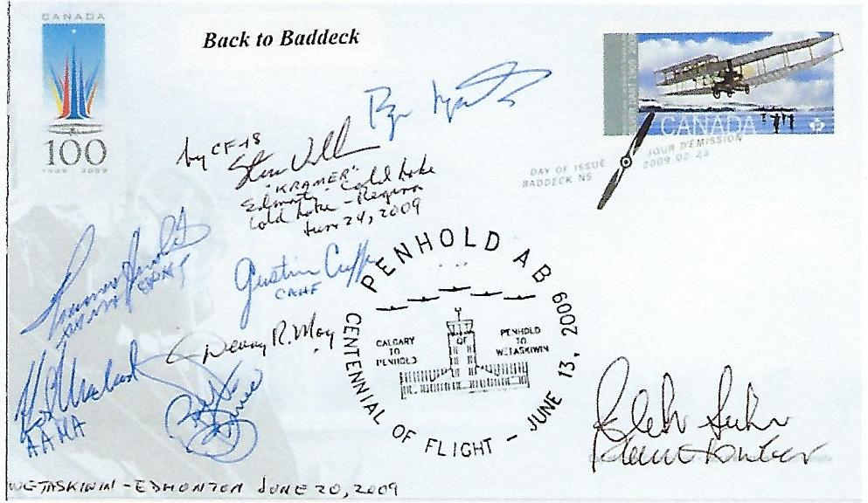

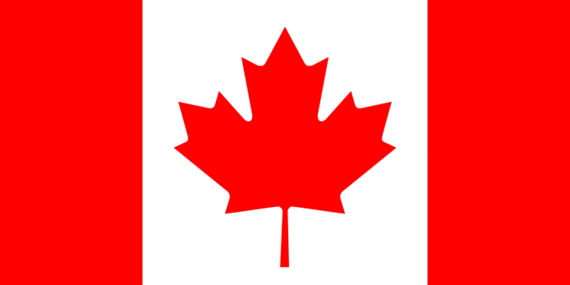

J. ERROLL BOYD

J. ERROLL BOYD
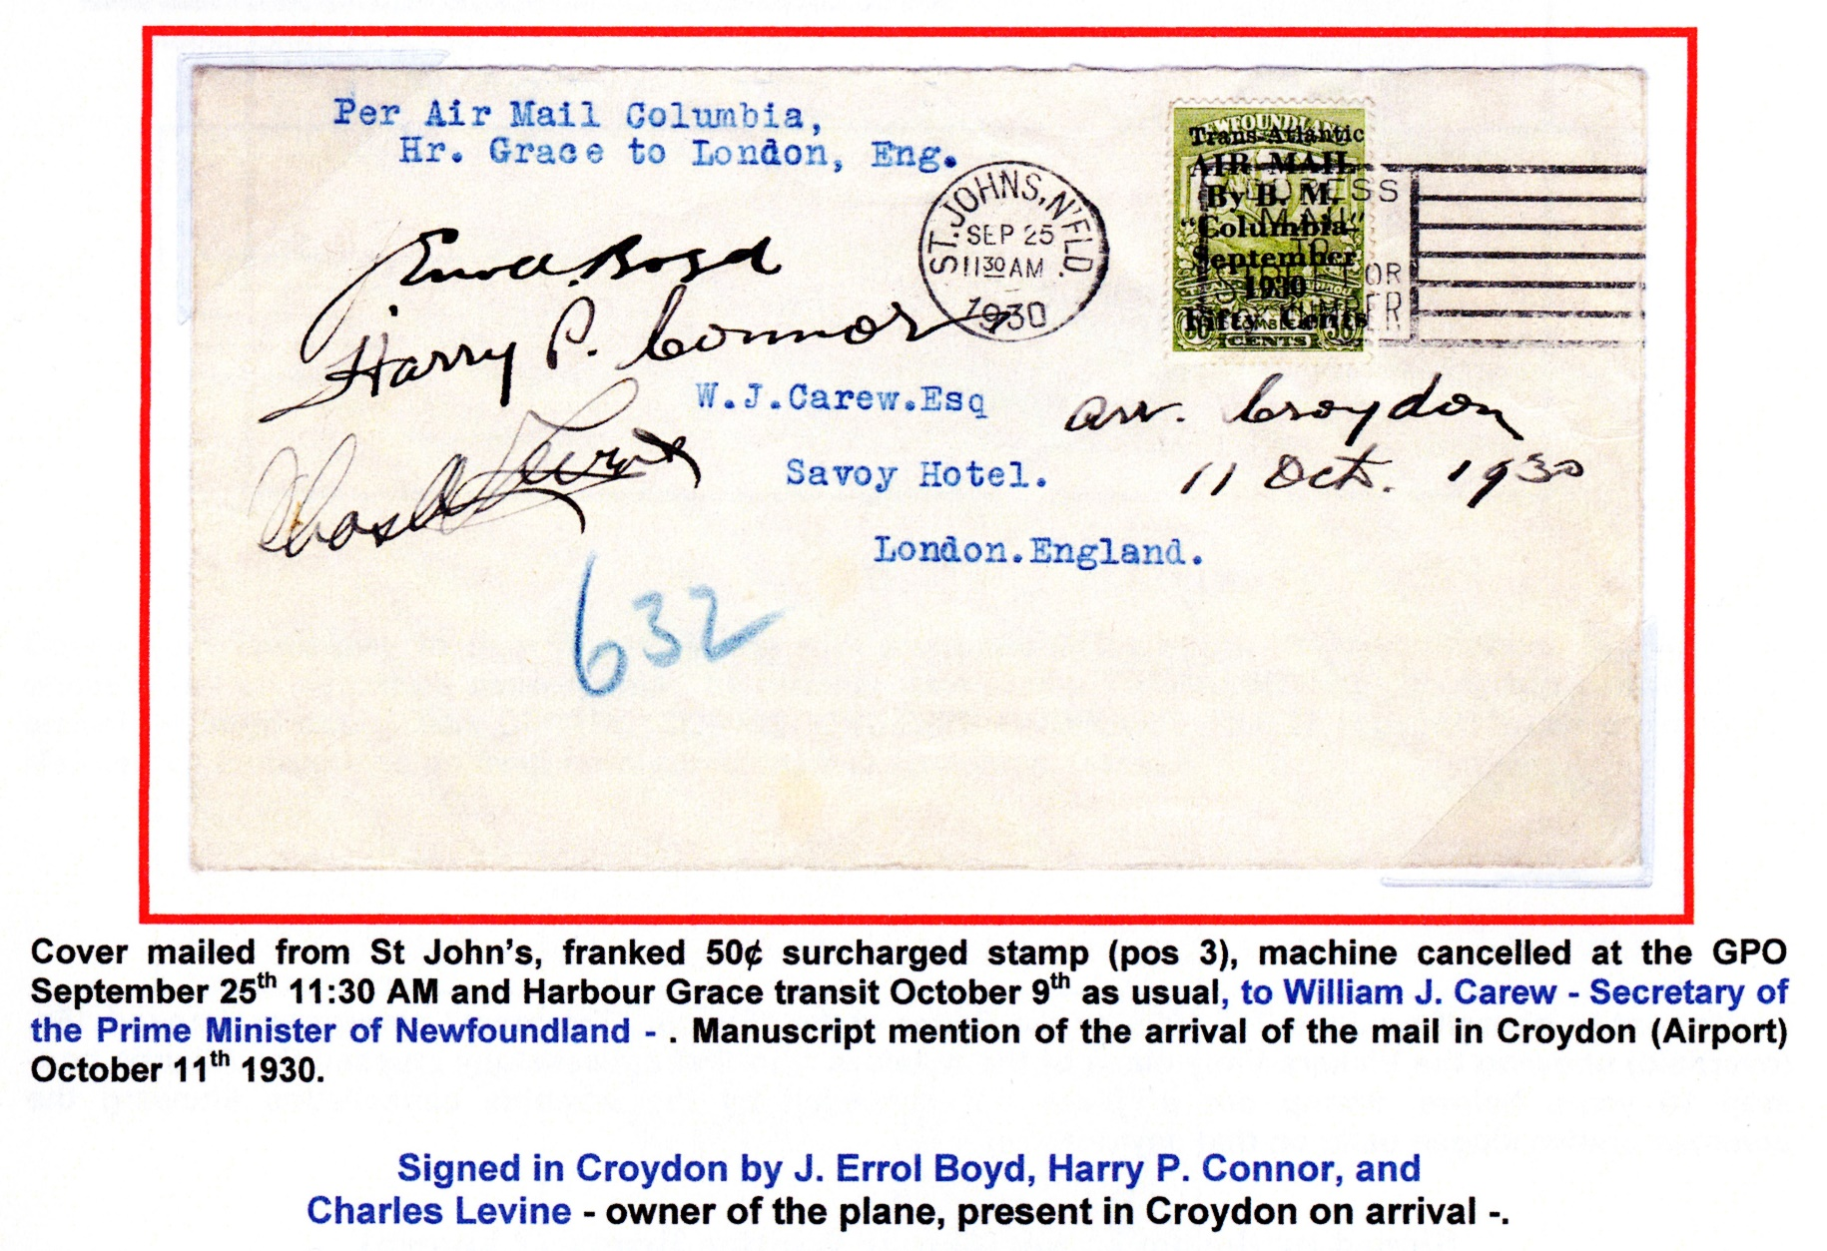
J. ERROLL BOYD
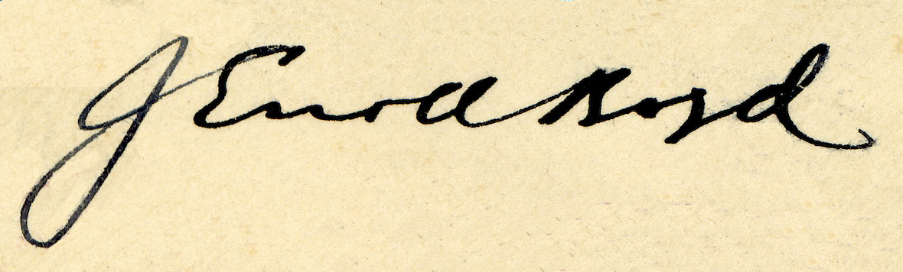

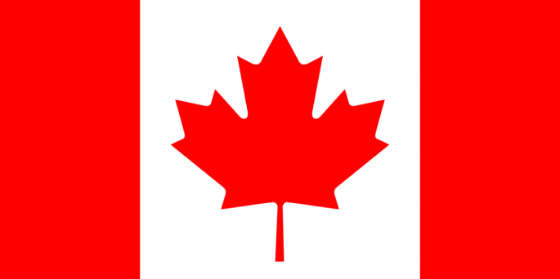

JANNA BREKER-KETTNER

JANNA BREKER-KETTNER
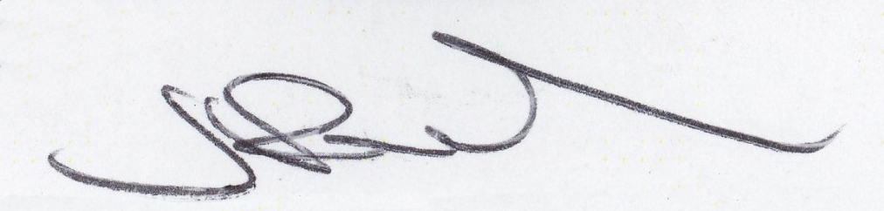

JANNA BREKER-KETTNER
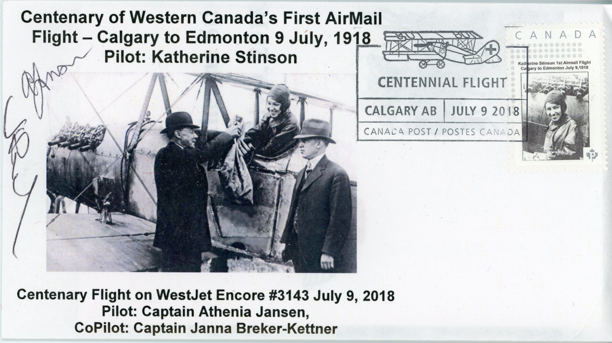

B. W. “BILL” BROATCH

BILL BROATCH

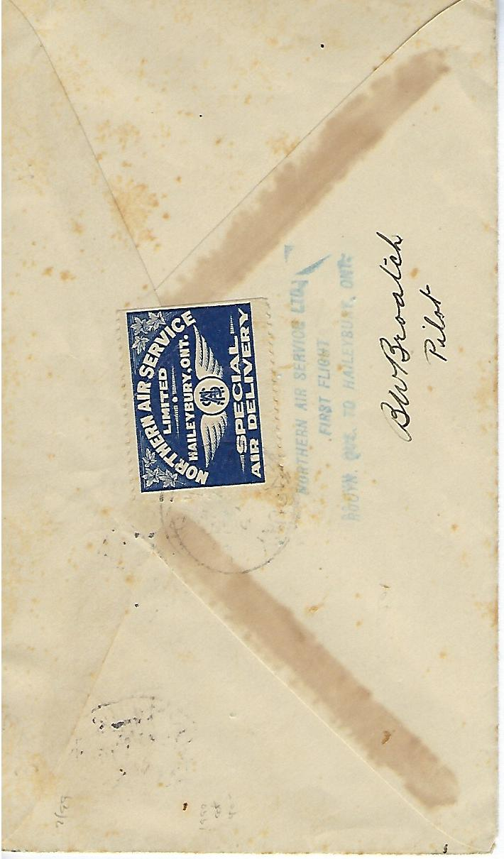

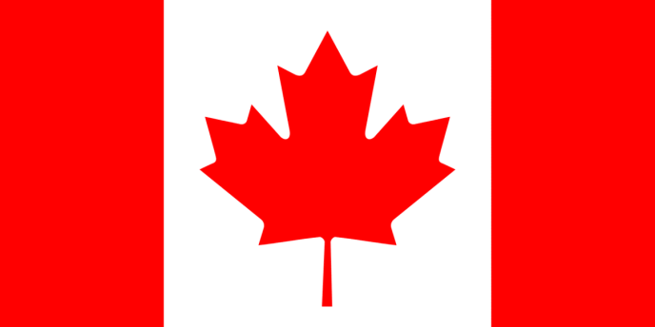

ARTHUR ROY BROWN

ARTHUR ROY BROWN
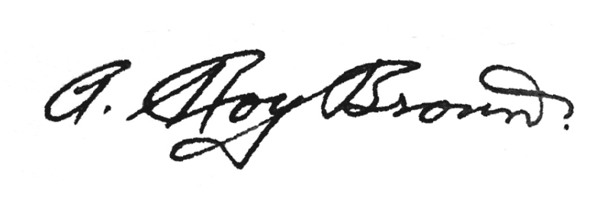

ARTHUR WHITTEN BROWN, NAVIGATOR

ARTHUR WHITTEN BROWN

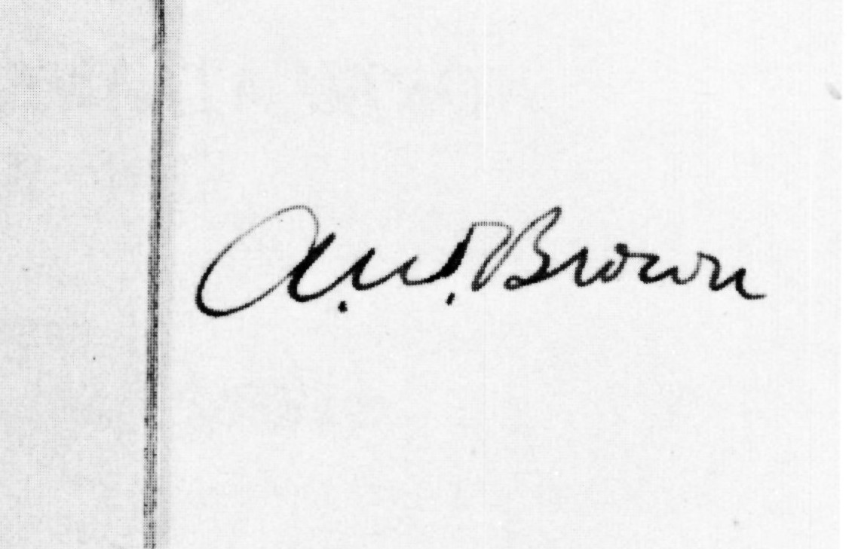

FRANCIS ROY BROWN

Francis Roy Brown

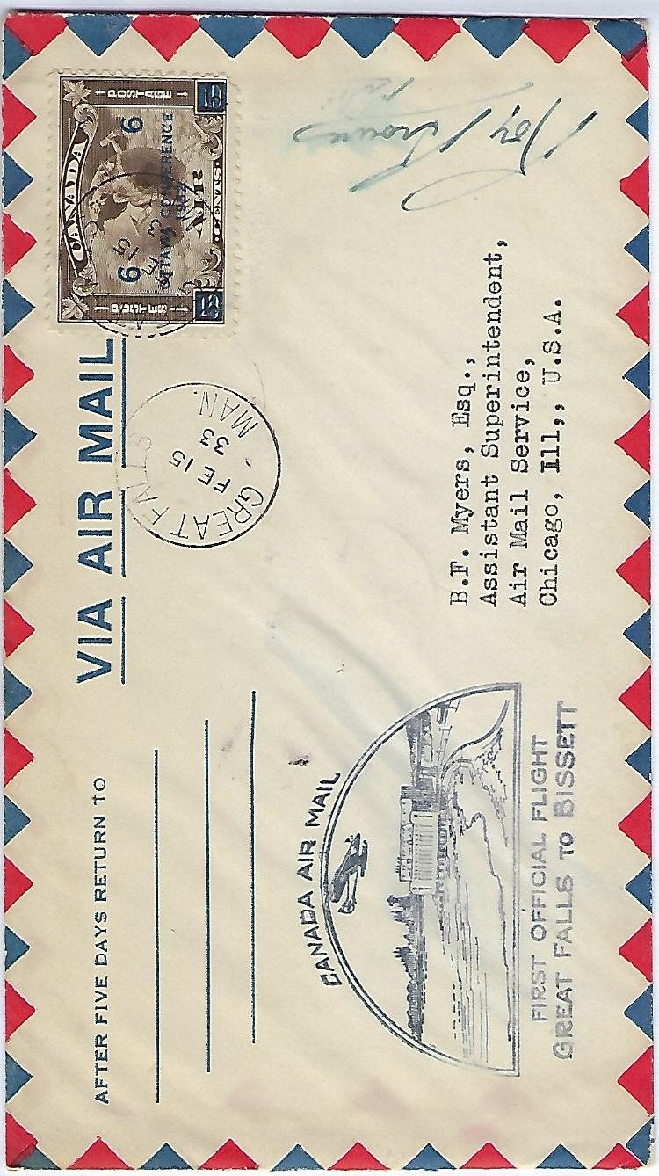
Francis Roy Brown
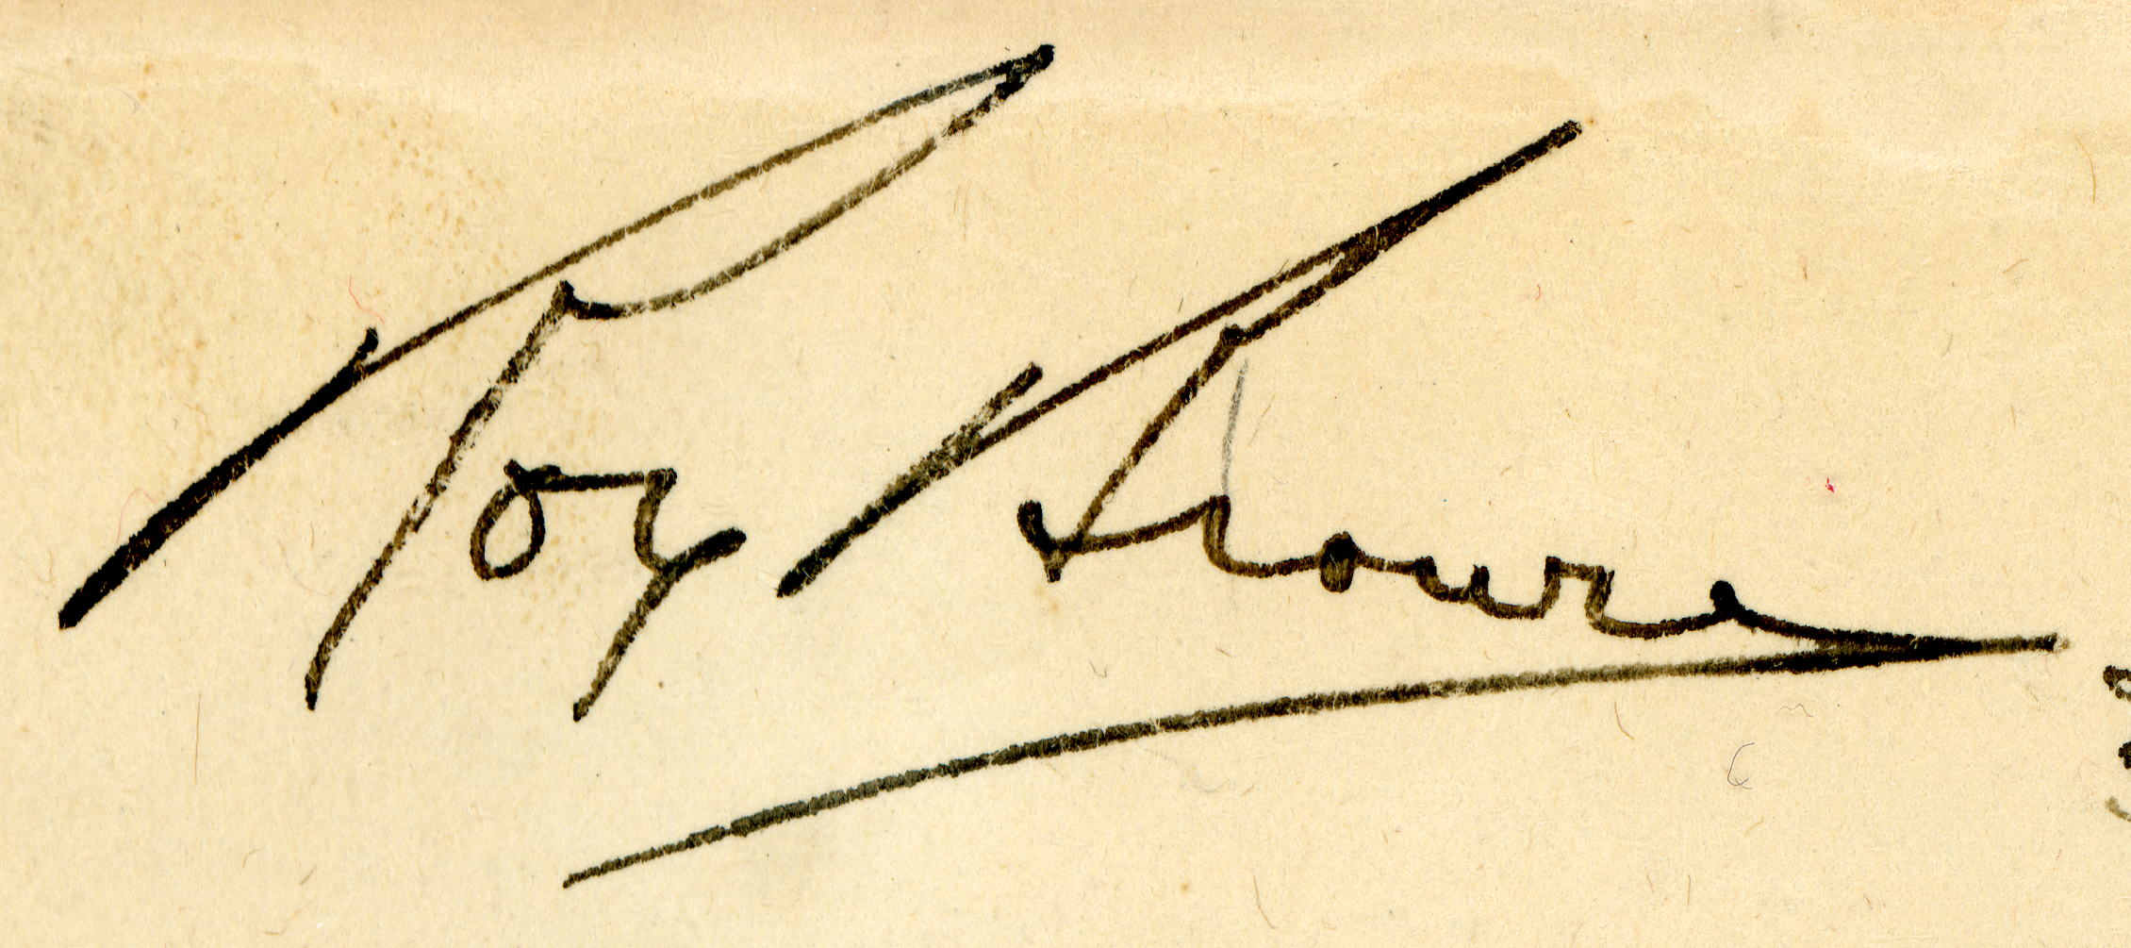

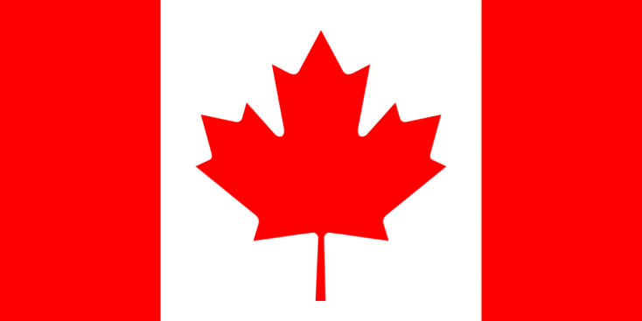

H.A. BROWN

H.A. BROWN
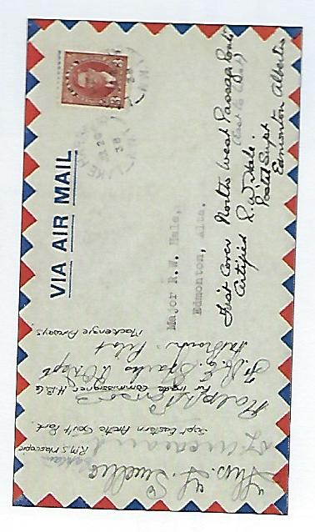

MAURICE “MOSS”
BURBIDGE

MAURICE “MOSS” BURBIDGE
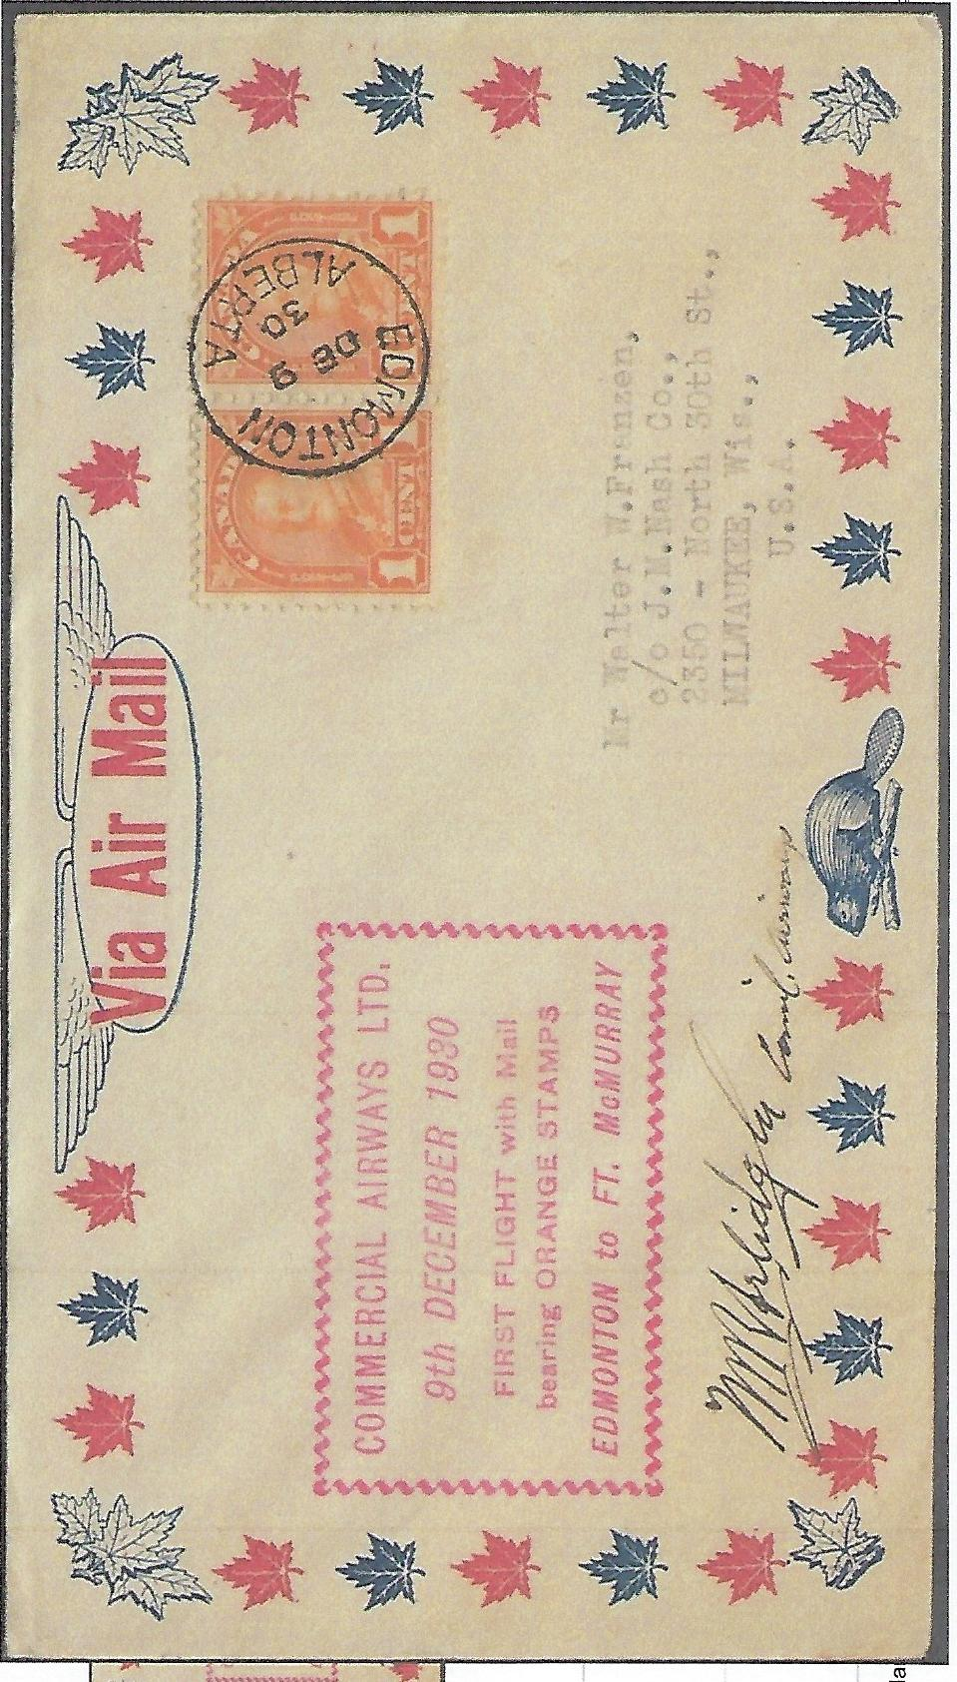

MAURICE “MOSS” BURBIDGE

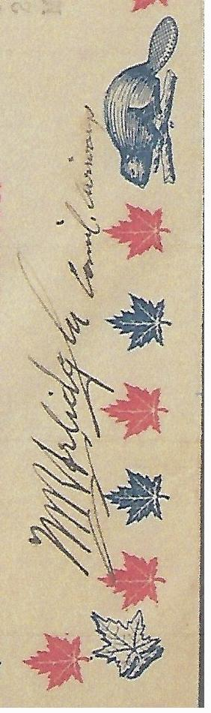

GLYN R. BURGE

GLYN R. BURGE
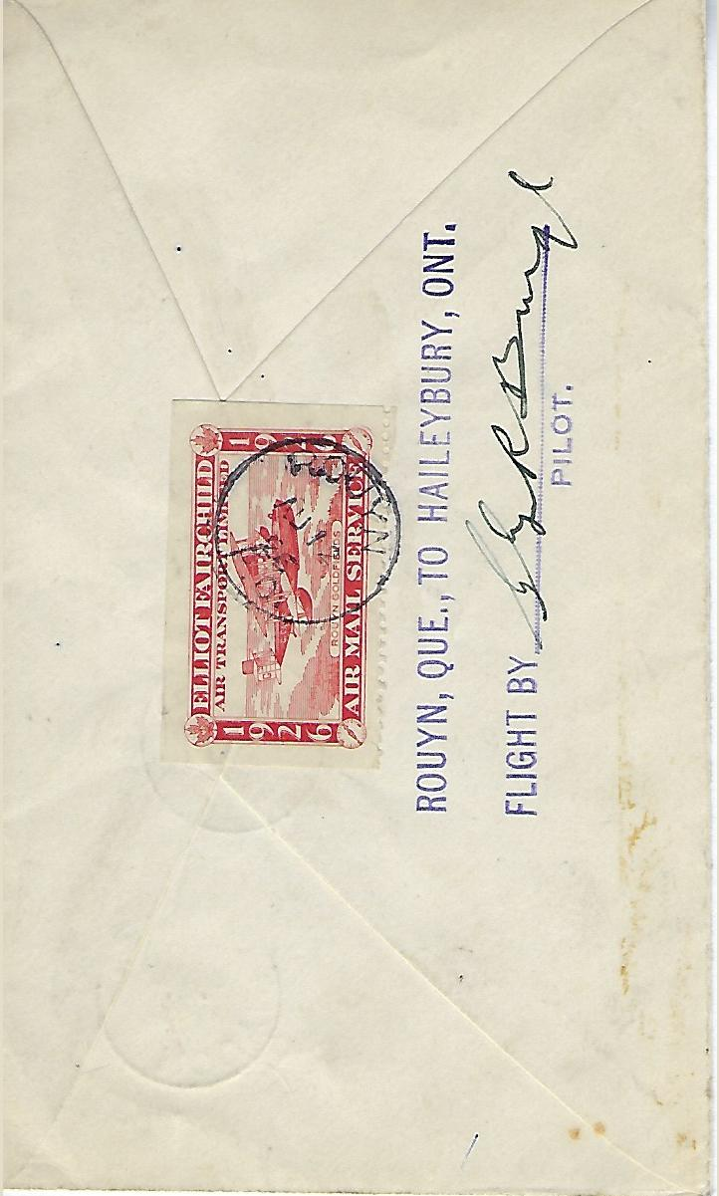
GLYN R. BURGE
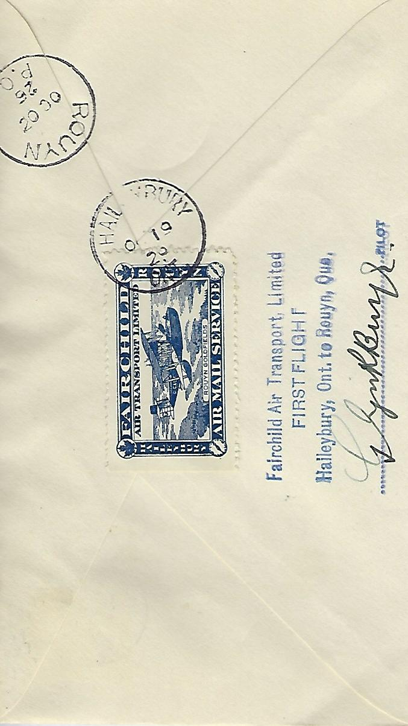

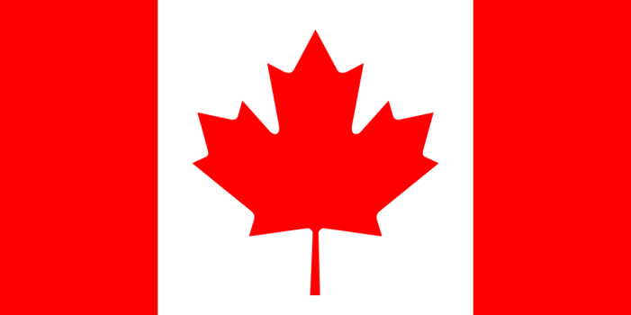

PAUL B. CALDER

PAUL B. CALDER
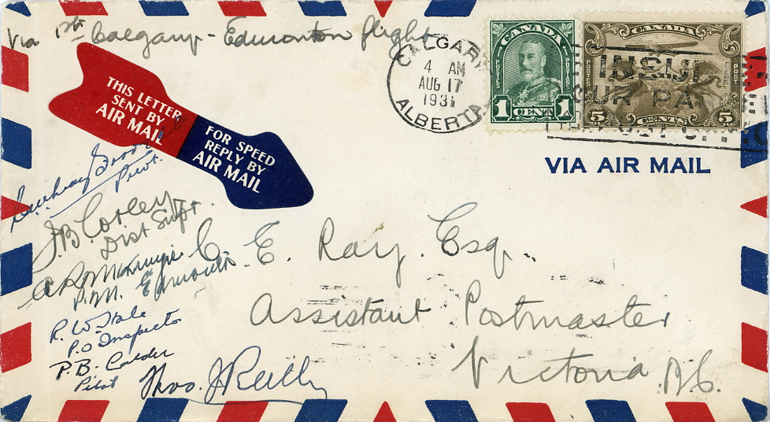

W.E. CATTON

W.E. CATTON
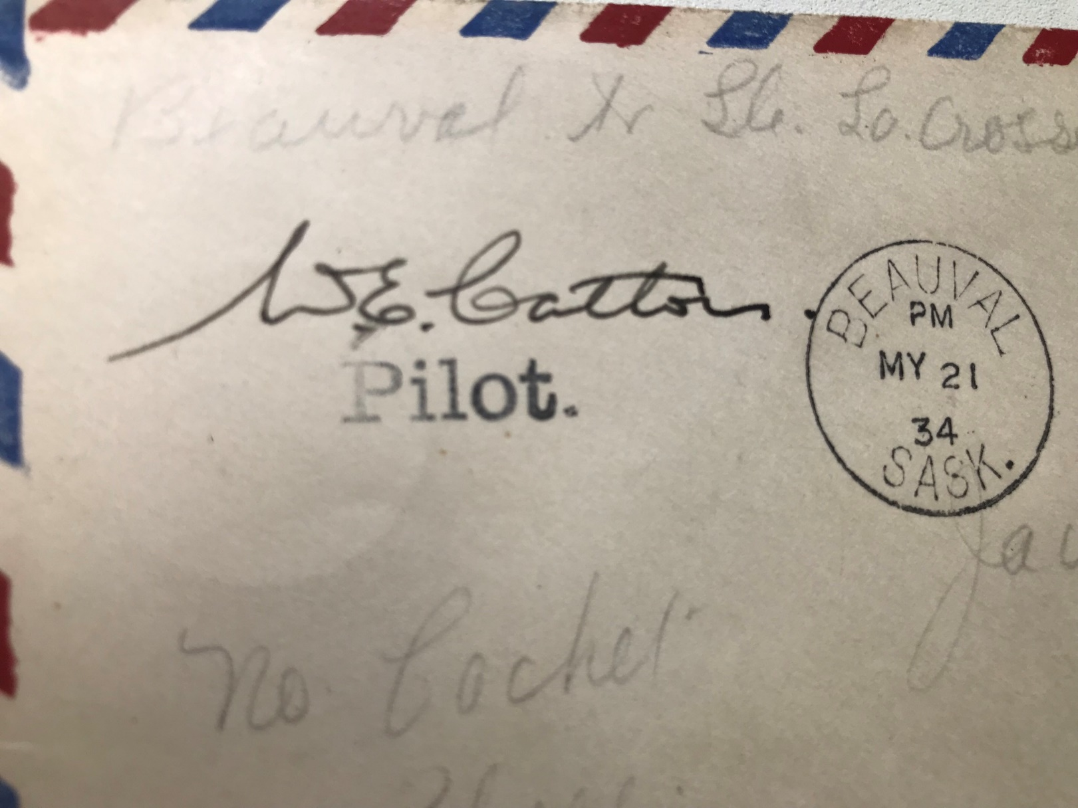
W.E. CATTON
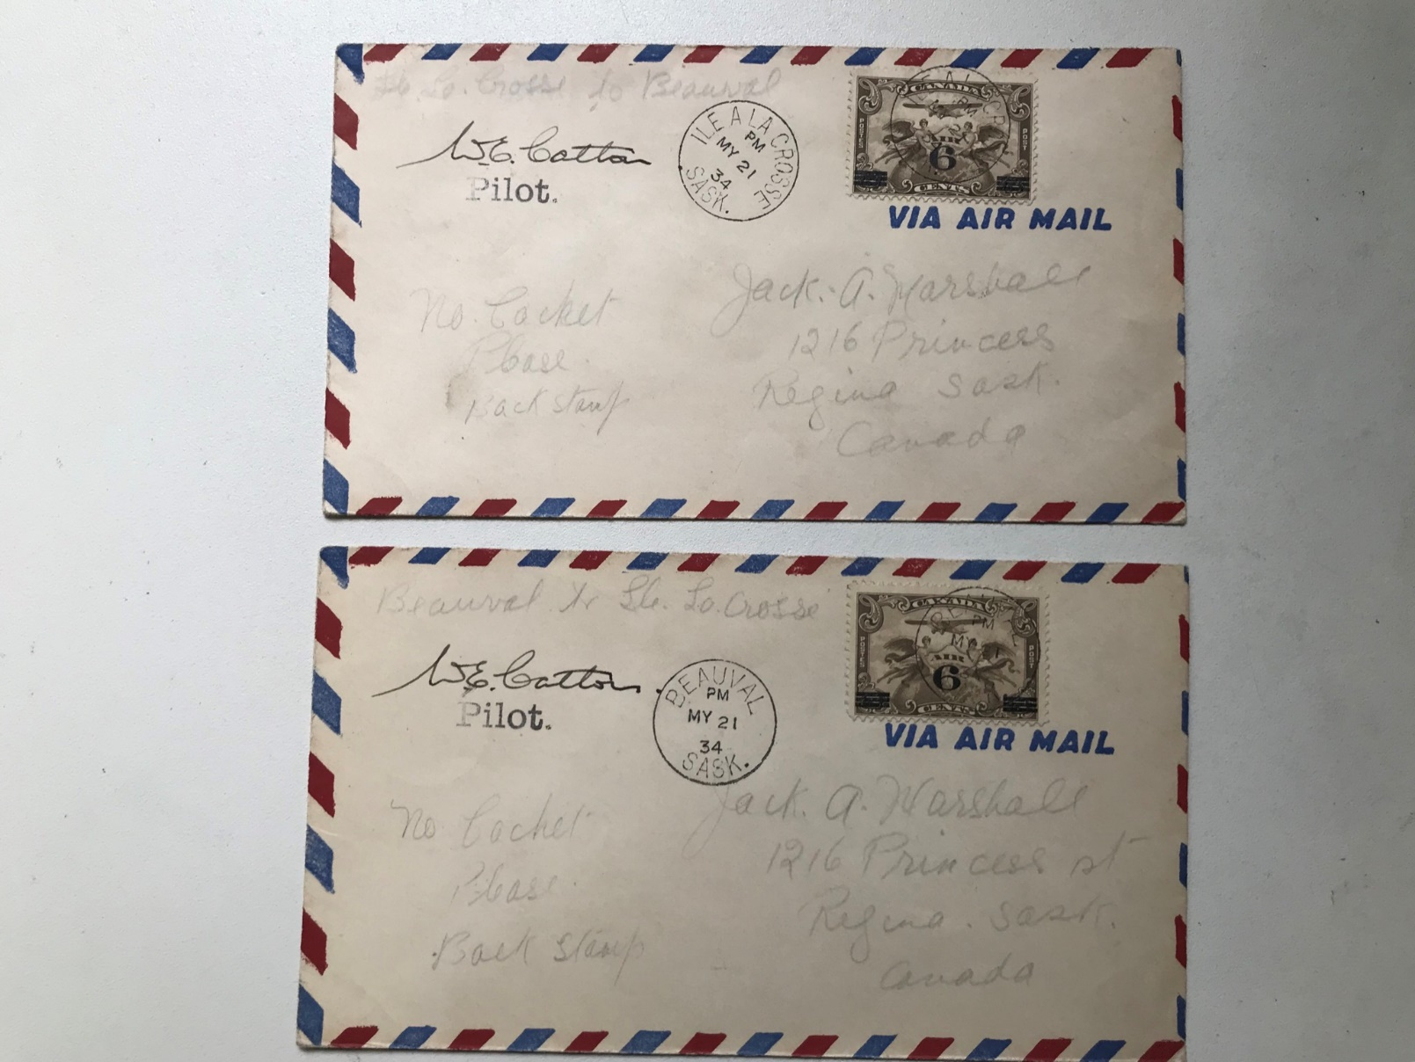

A.B. “ALF” CAYWOOD

A.B. “ALF” CAYWOOD
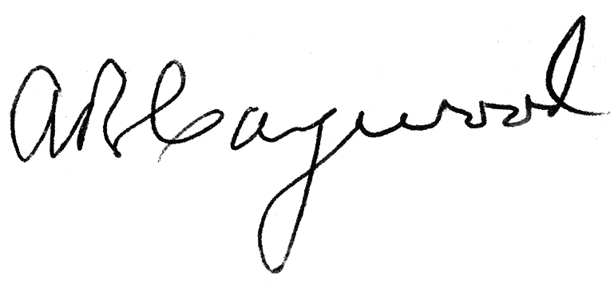

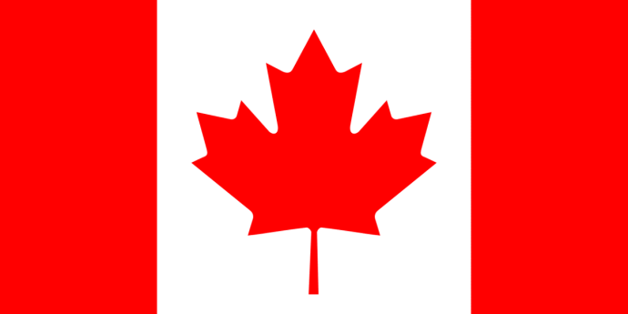

S. A. “AL” CHEESMAN

S. A. “AL” CHEESMAN
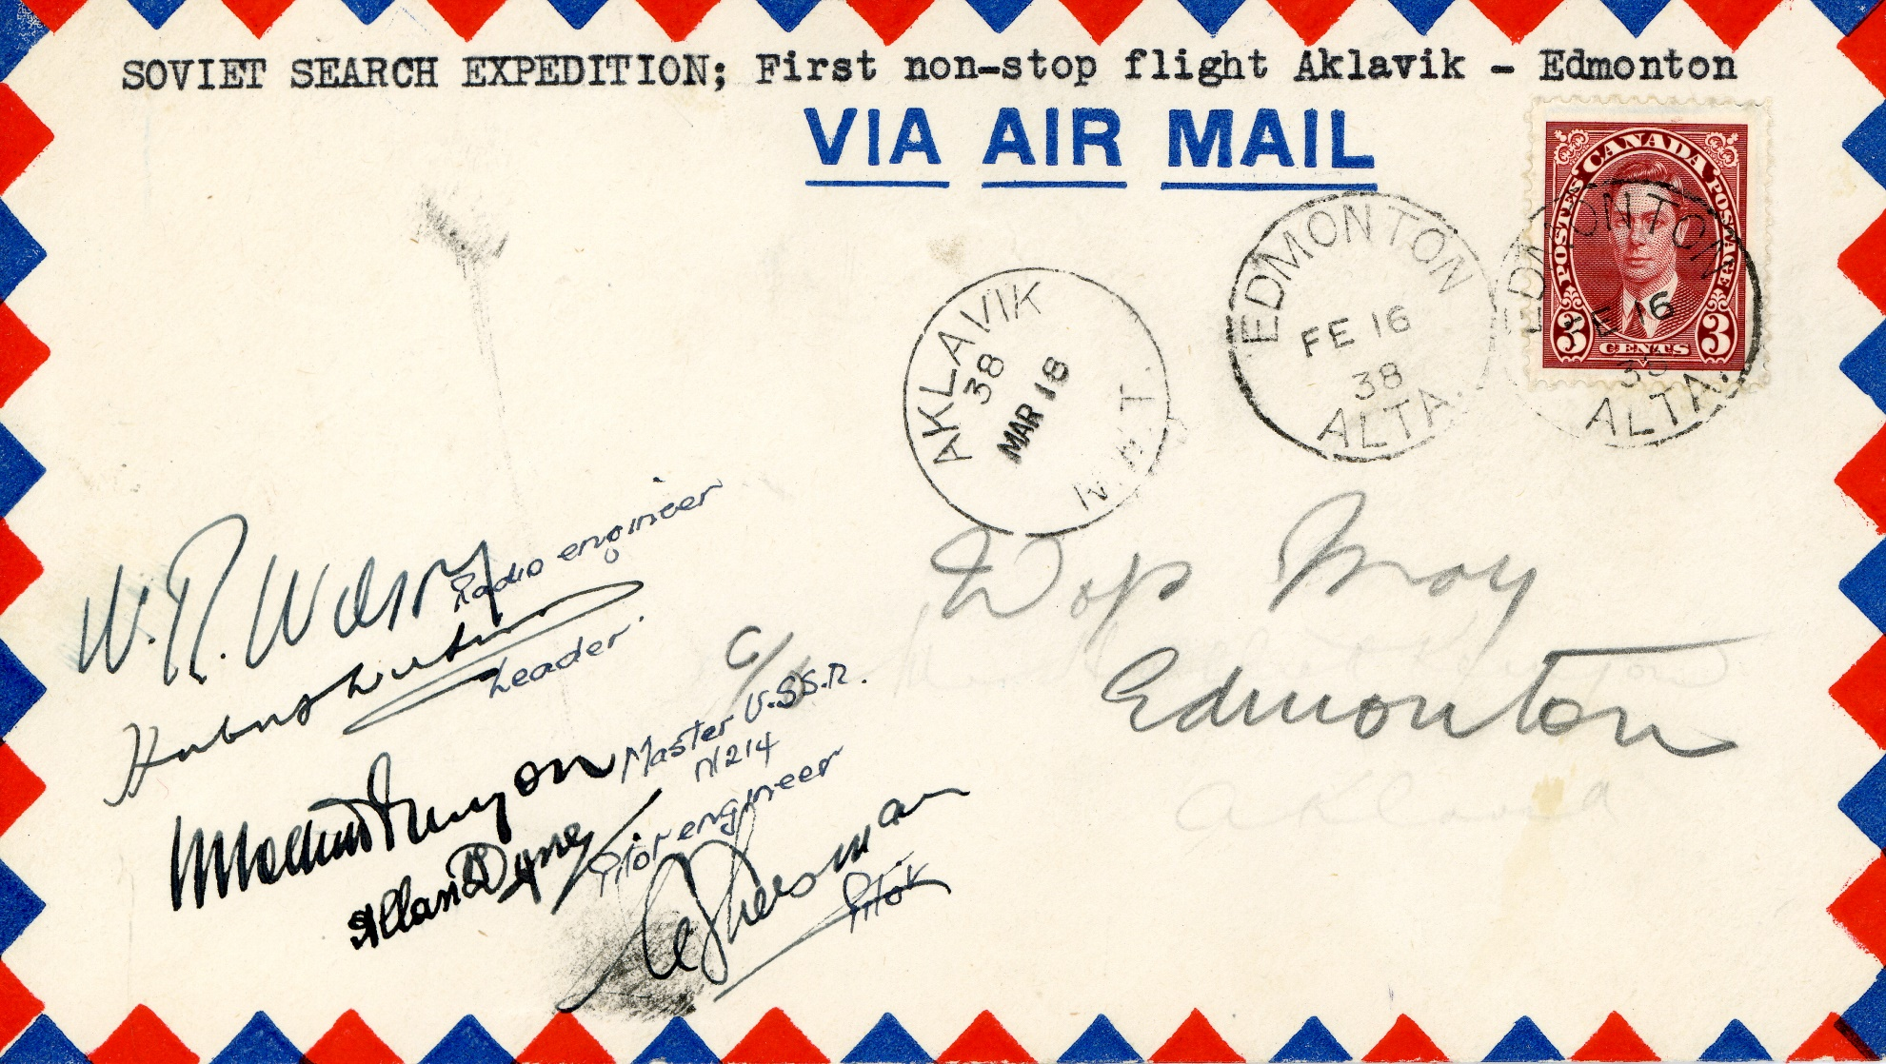

GEORGE CHIVERS

GEORGE CHIVERS
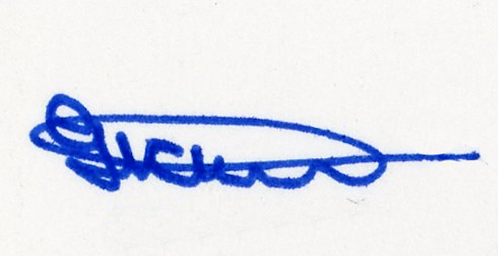

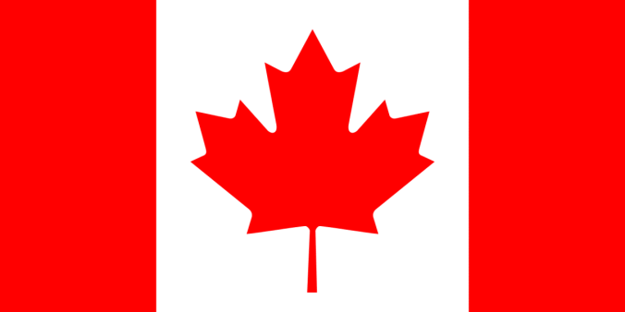

HARRY P. CONNOR
NAVIGATOR

HARRY P. CONNOR, NAVIGATOR
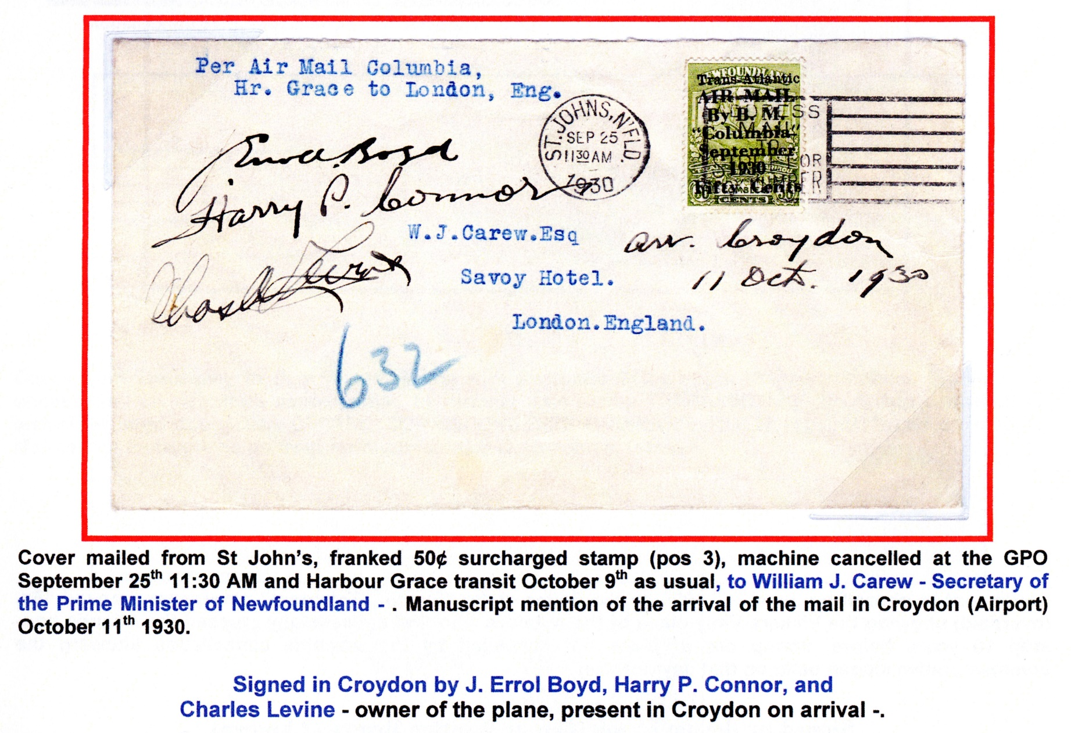

P.B. COX

P.B. COX
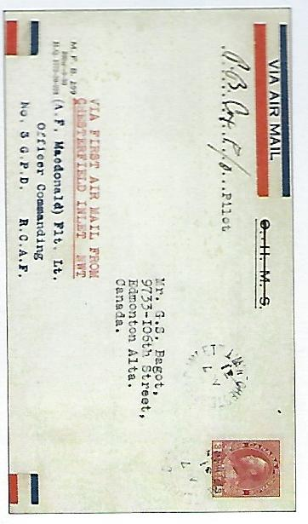

ANDREW “ANDY” CRUICKSHANK
ANDY CRUICKSHANK
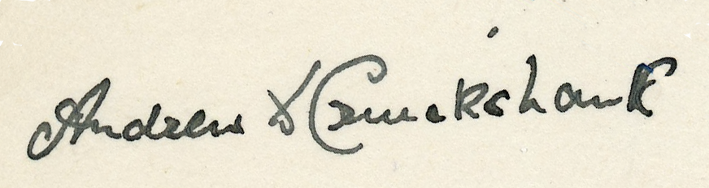

A.M. DELEMERE
A.M. DELEMERE
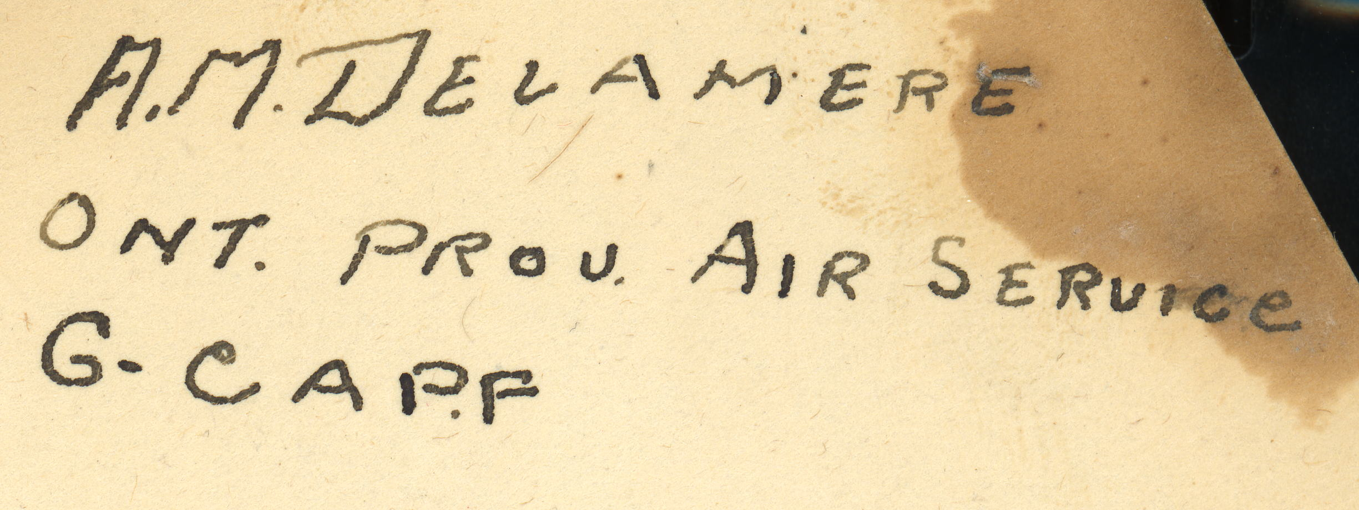

DAN DEMPSEY
DAN DEMPSEY
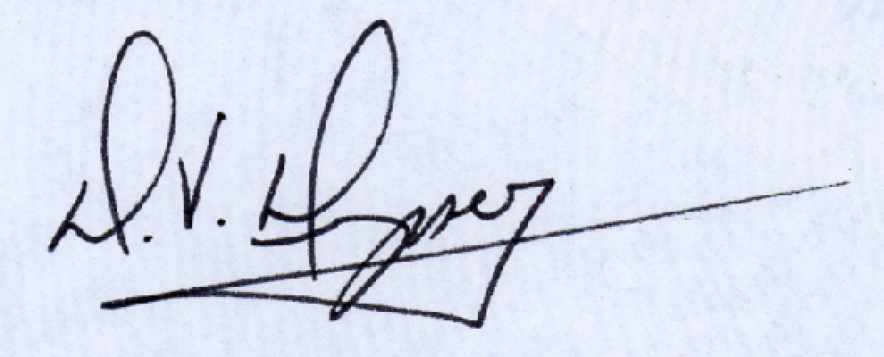

DAN DEMPSEY
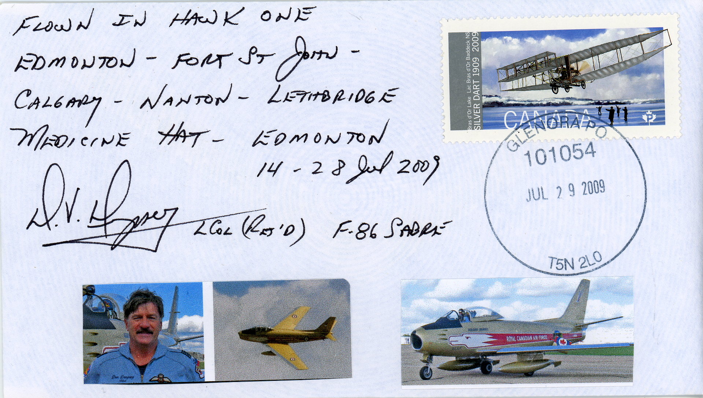

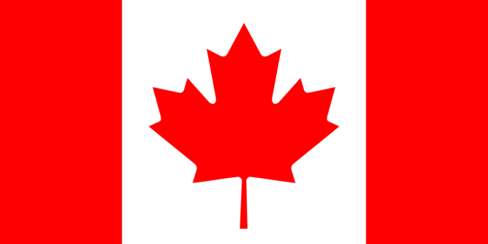

CLENNELL H. “PUNCH” DICKINS

CLENNELL H. “PUNCH” DICKINS
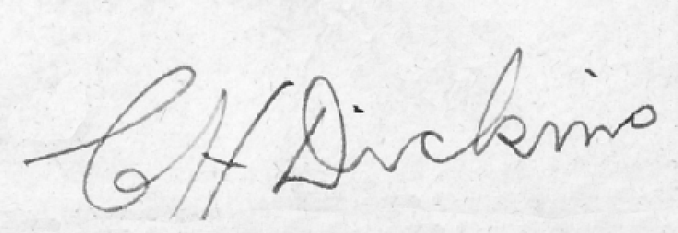

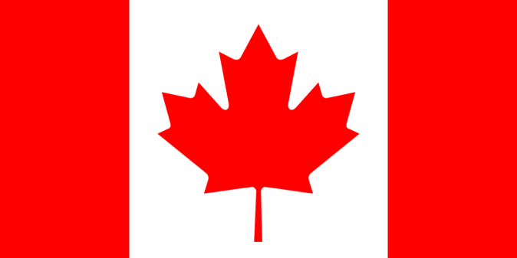

ALLAN DYNE

ALLAN DYNE

C.M.G. “CON” FARRELL
Also CONWAY FARRELL

C.M.G. “CON” FARRELL
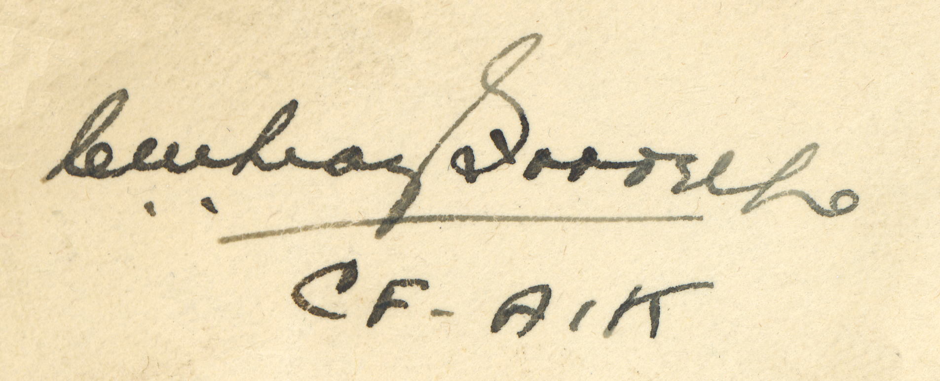

C.M.G. “CON” FARRELL
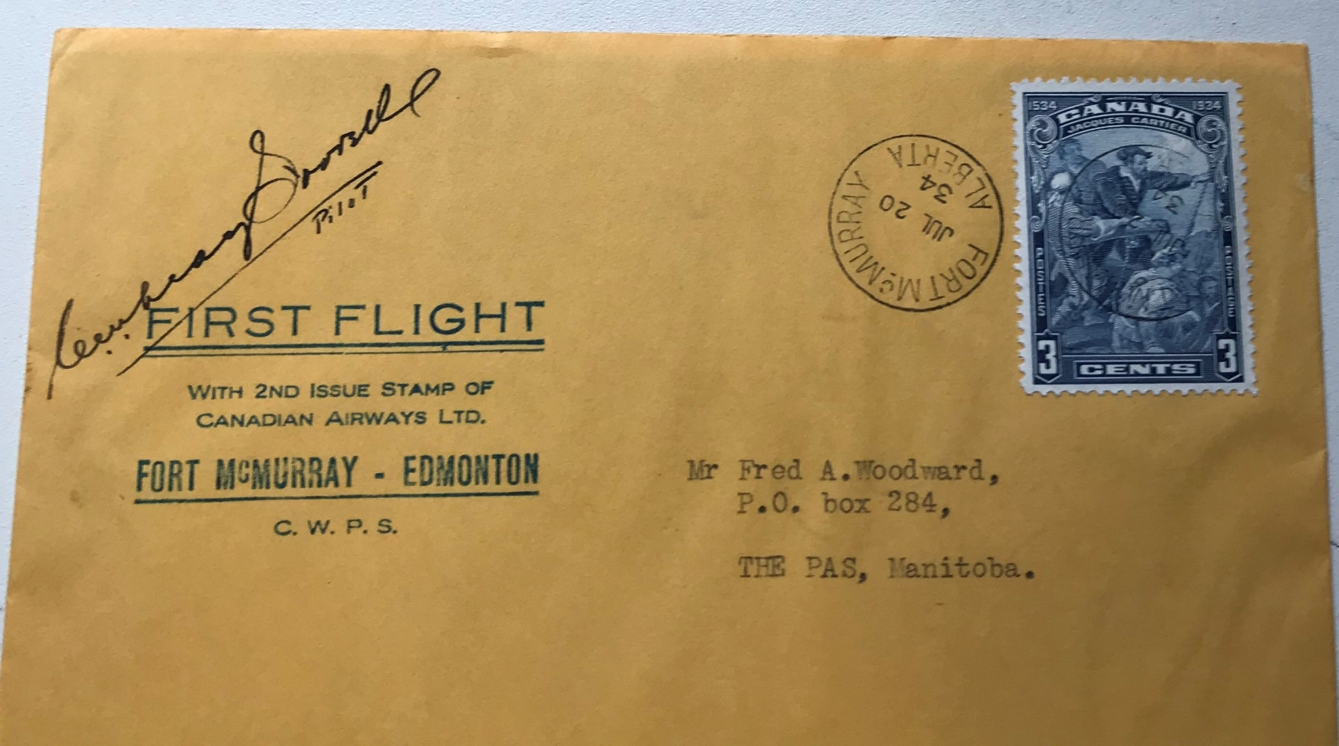

CONWAY FARRELL

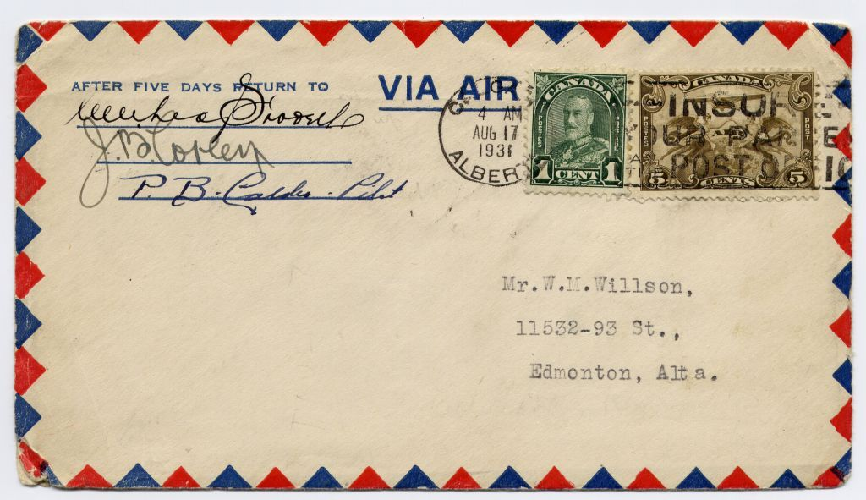

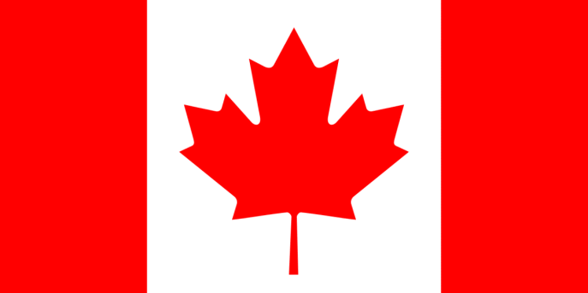

BLAIN FOWLER

BLAIN FOWLER

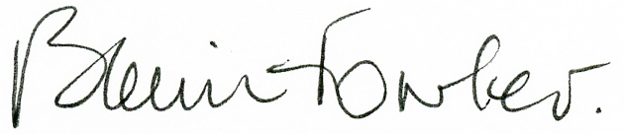

WALTER W. FOWLER

WALTER W. FOWLER
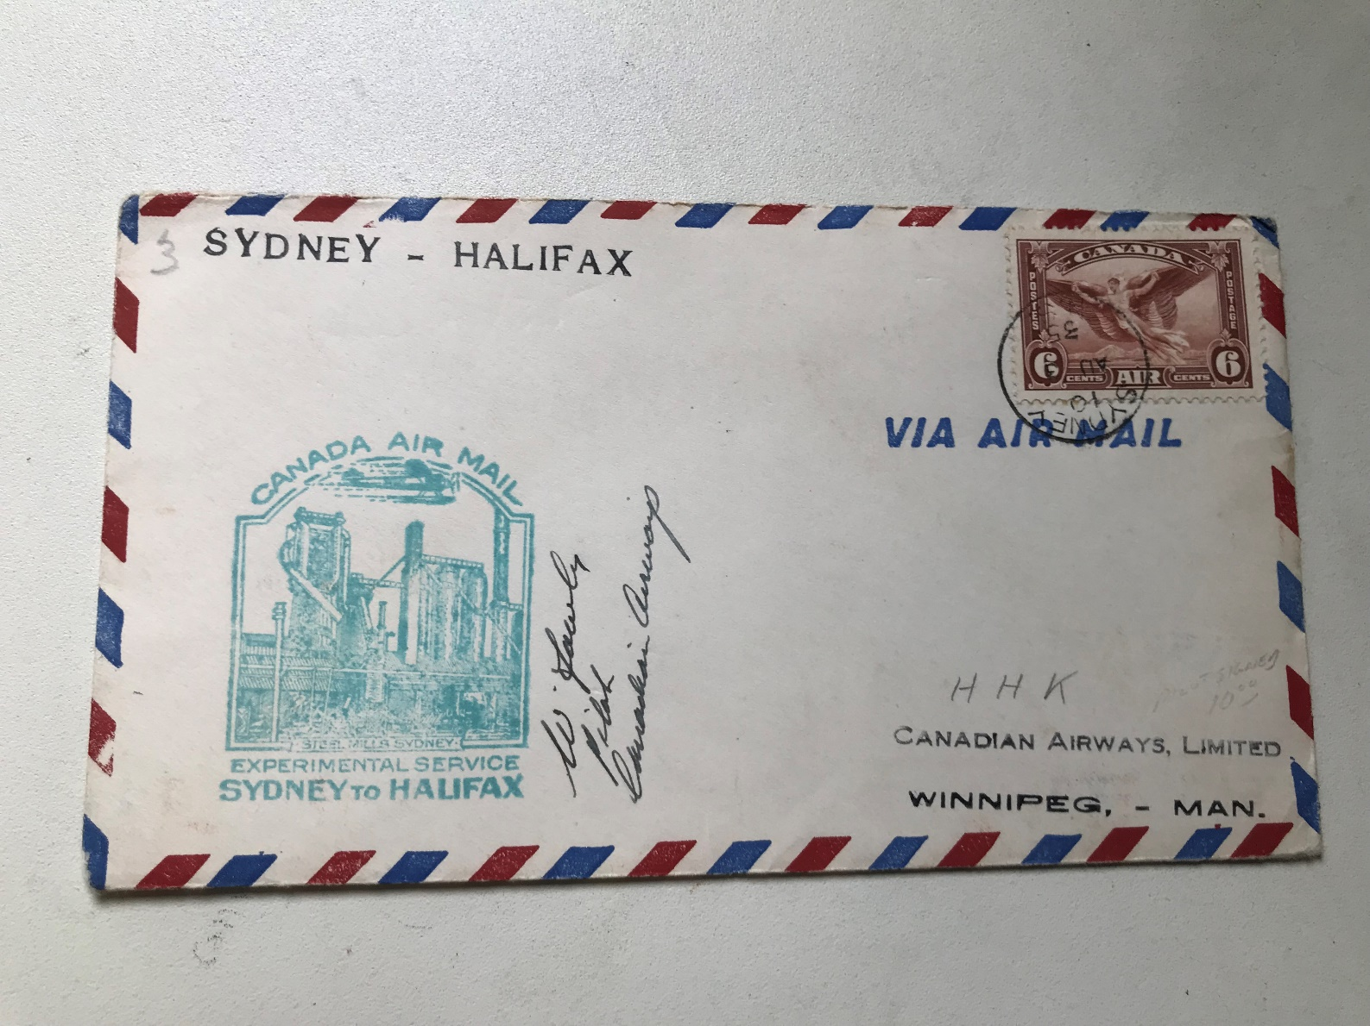
WALTER W. FOWLER
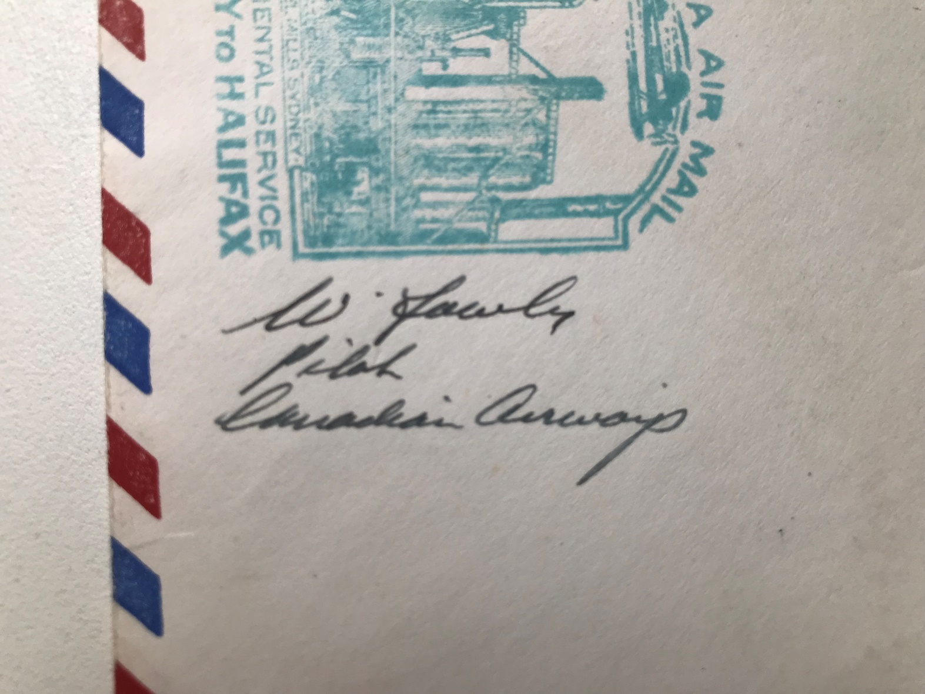

PHIL GARRATT
PHIL GARRATT
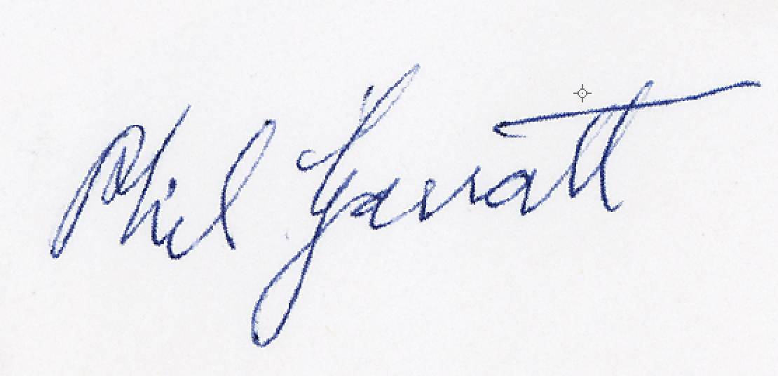

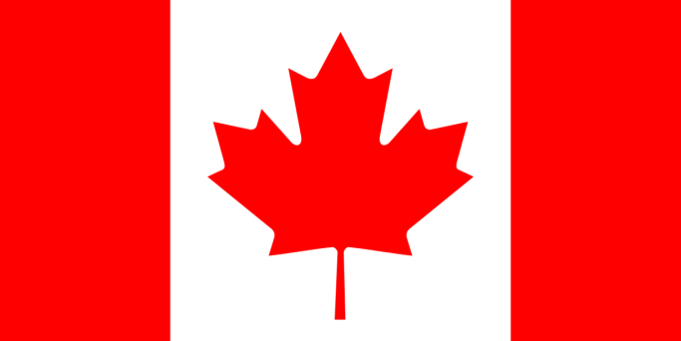

WALTER E. GILBERT

WALTER E. GILBERT

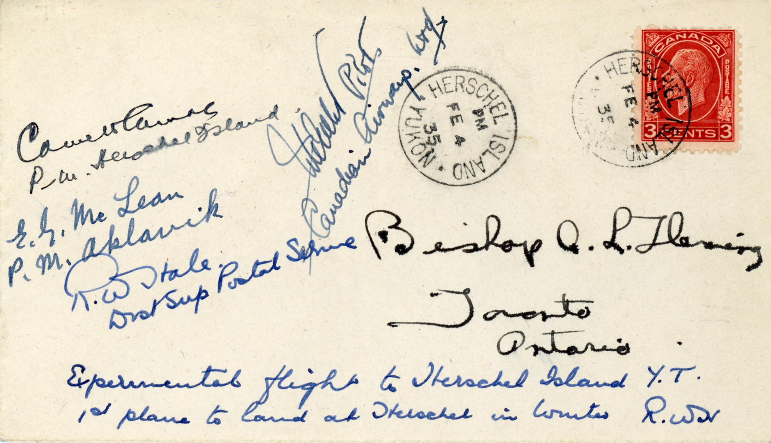

IDRIS GLYN ROBERTS

IDRIS GLYN ROBERTS

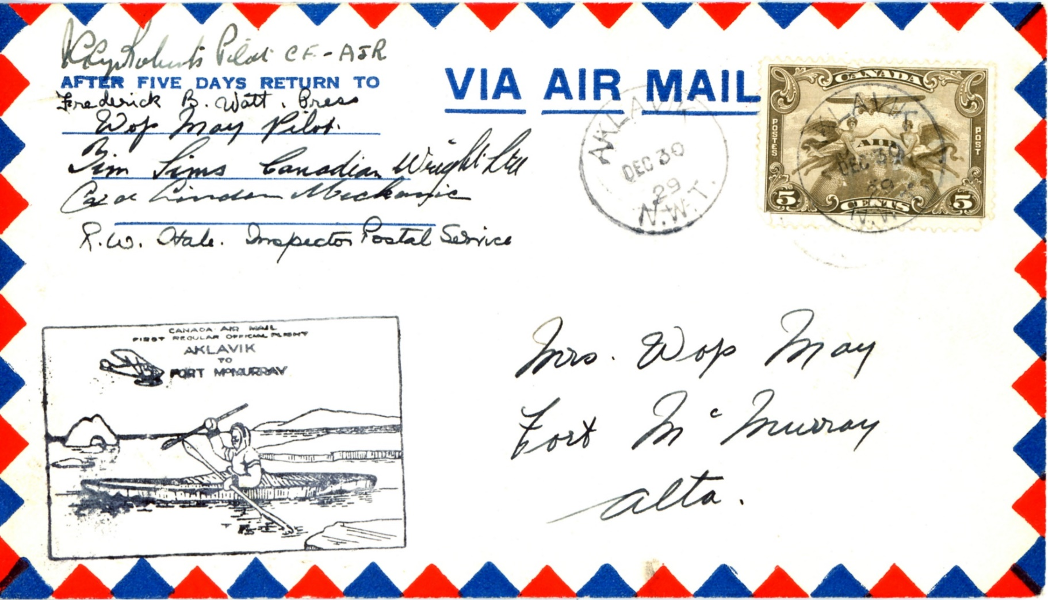

MAJ. A.E. GODFREY

MAJ. A.E. GODFREY
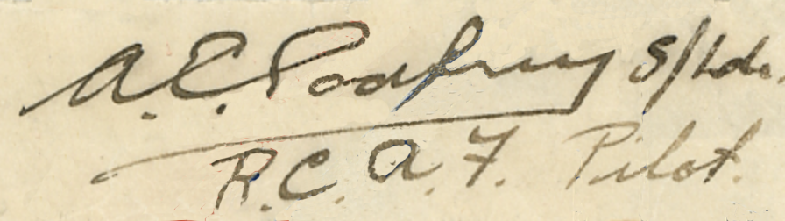

MAJ. A.E. GODFREY
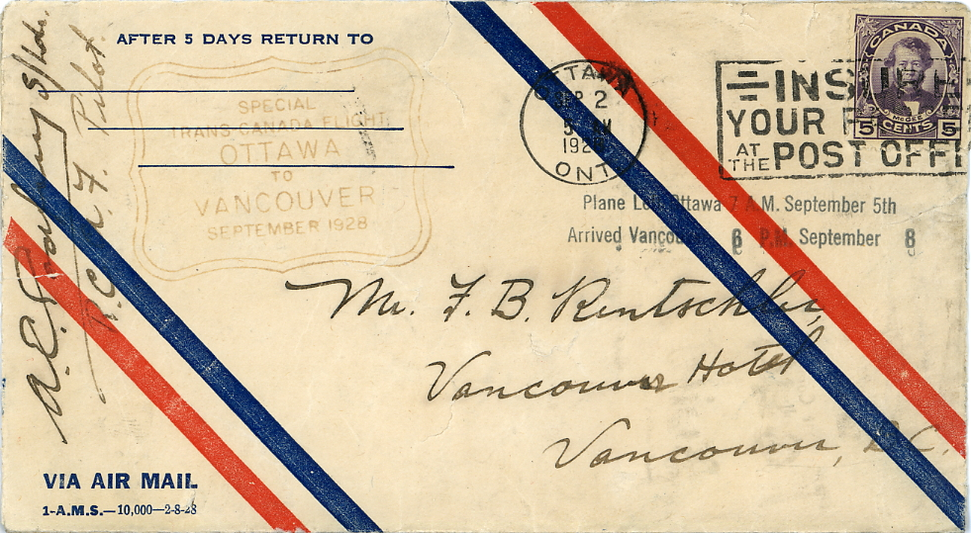

STUART GRAHAM

STUART GRAHAM
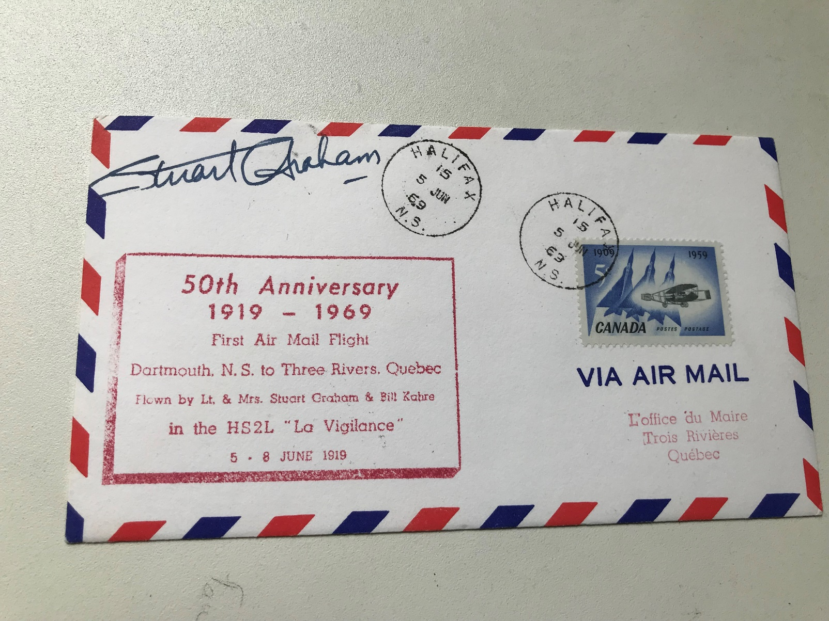

MacKENZIE K. GRIEVE NAVIGATOR

MacKENZIE K. GRIEVE, NAVIGATOR
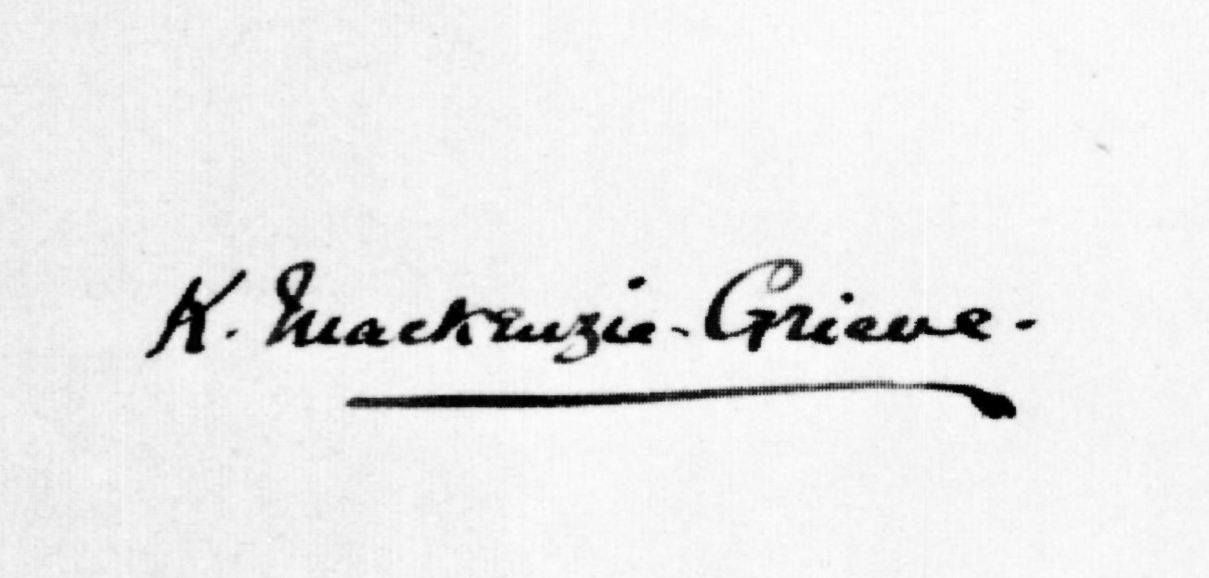

CARL HARBUCK

CARL HARBUCK
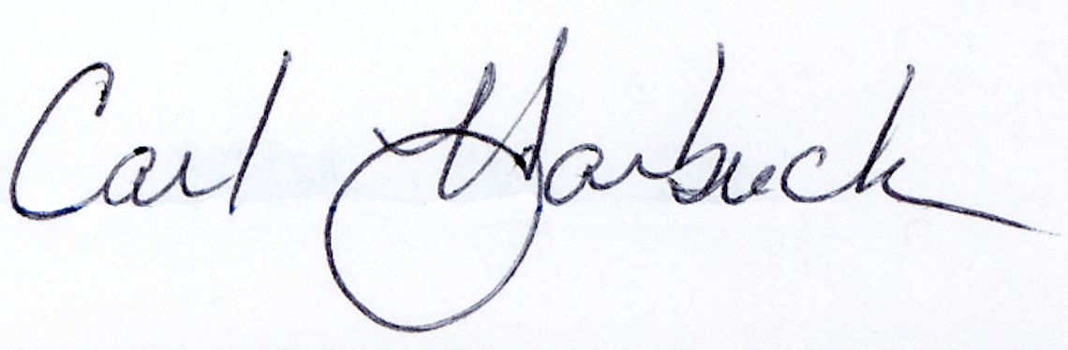

HARRY HAWKER

HARRY HAWKER

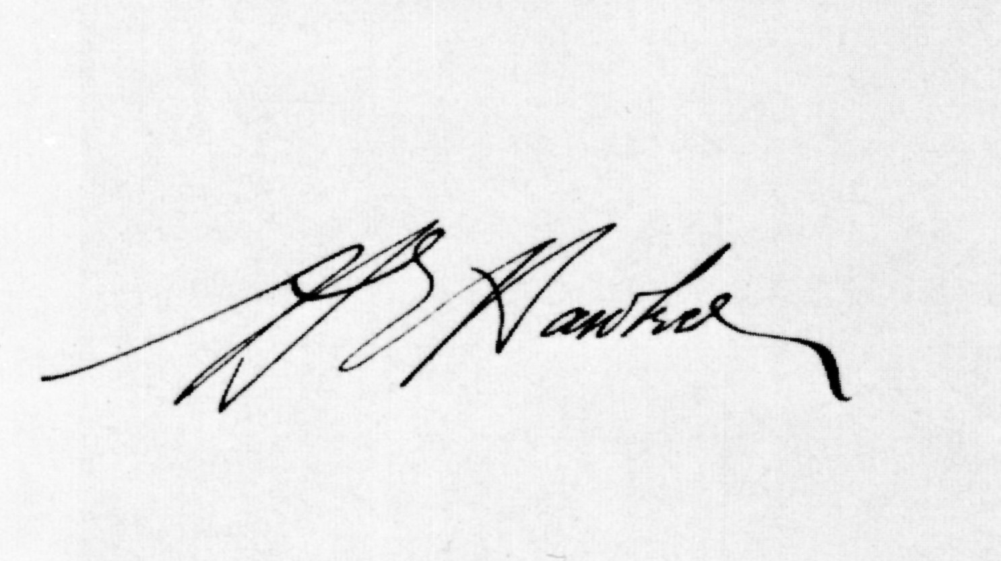

THOMAS “TOM” HINDERKS

THOMAS “TOM” HINDERKS
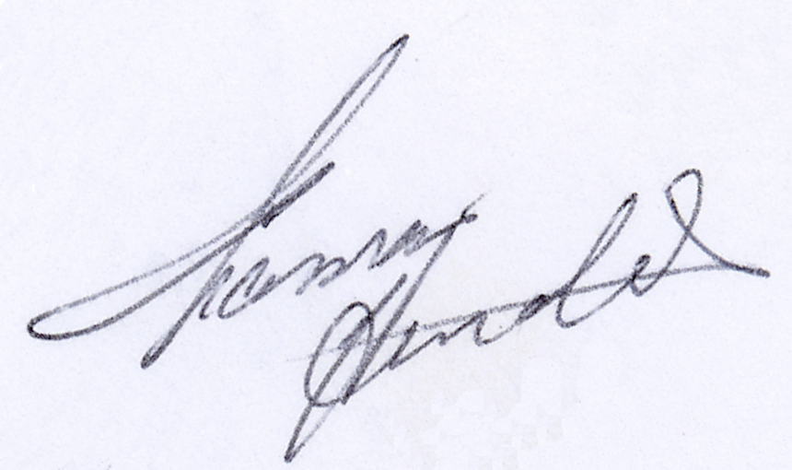
THOMAS “TOM” HINDERKS
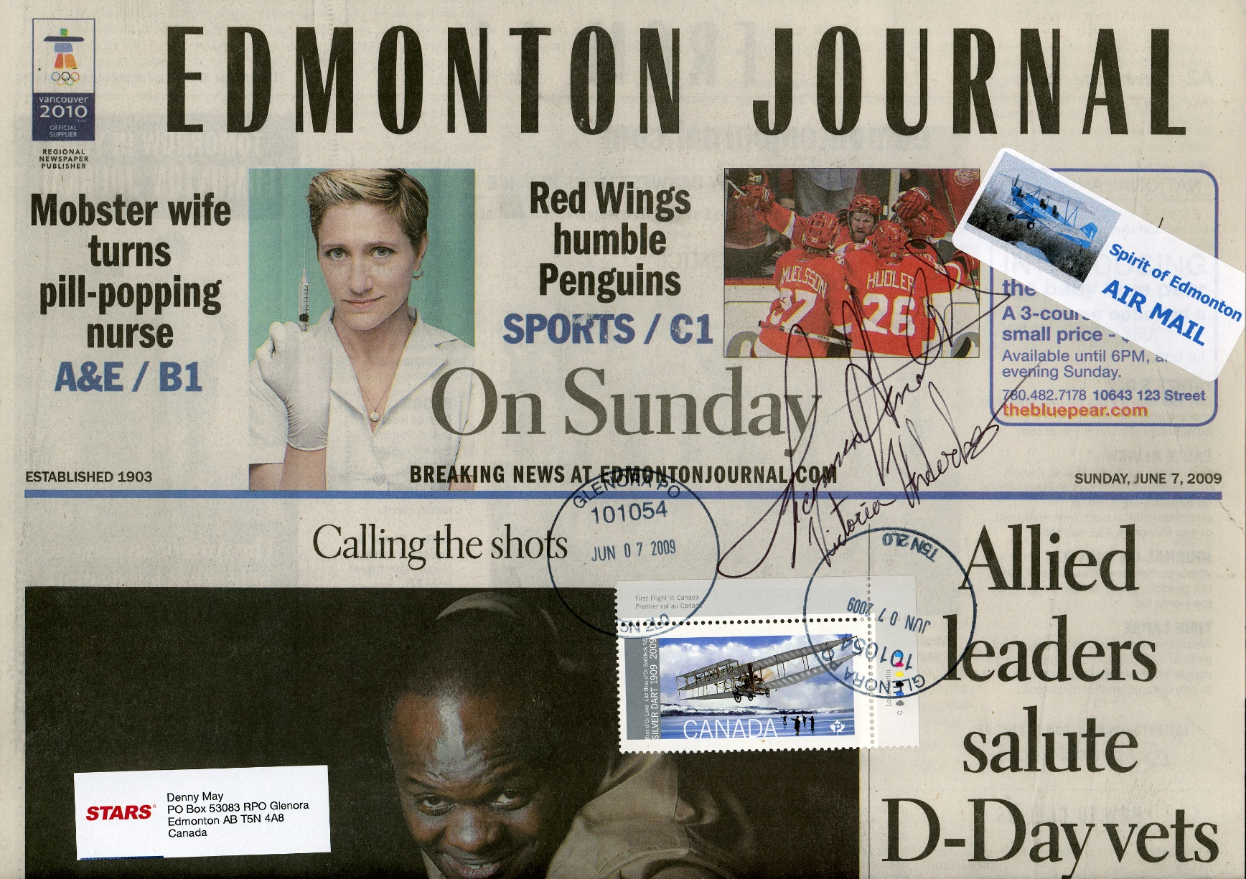

VICTORIA HINDERKS

VICTORIA HINDERKS
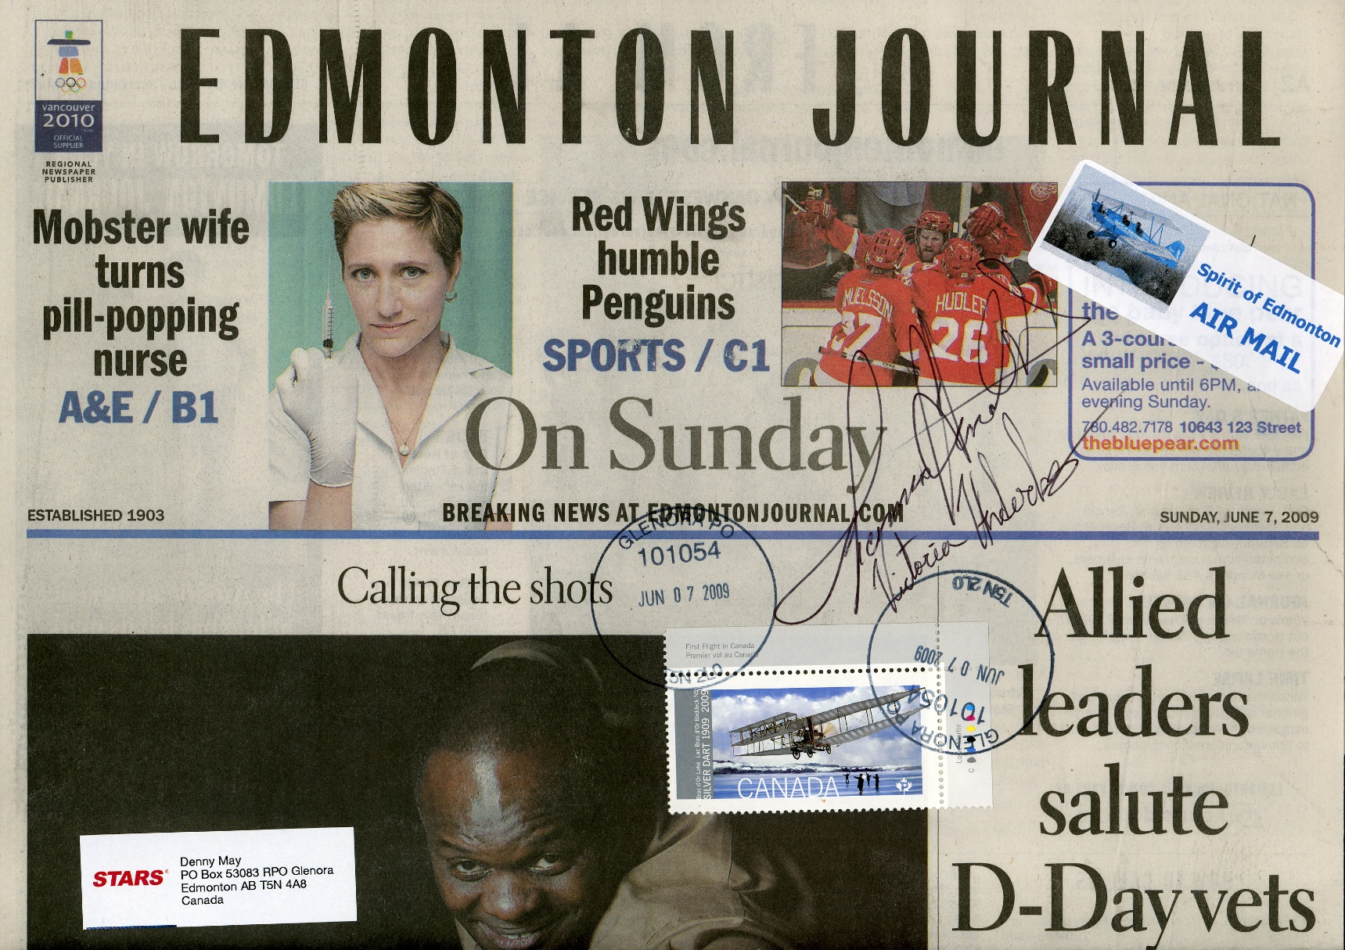

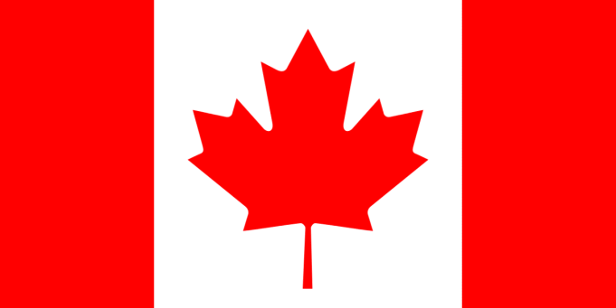

HOLGER HOIRUS

HOLGER HOIRUS
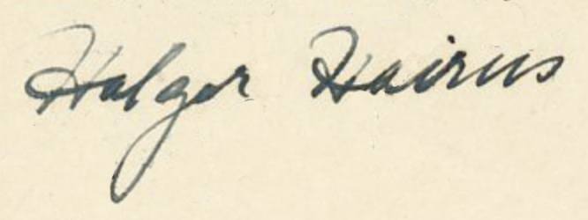

HERBERT HOLLICK-KENYON

HERBERT HOLLICK-KENYON
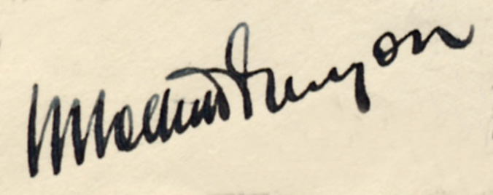

HERBERT HOLLICK-KENYON
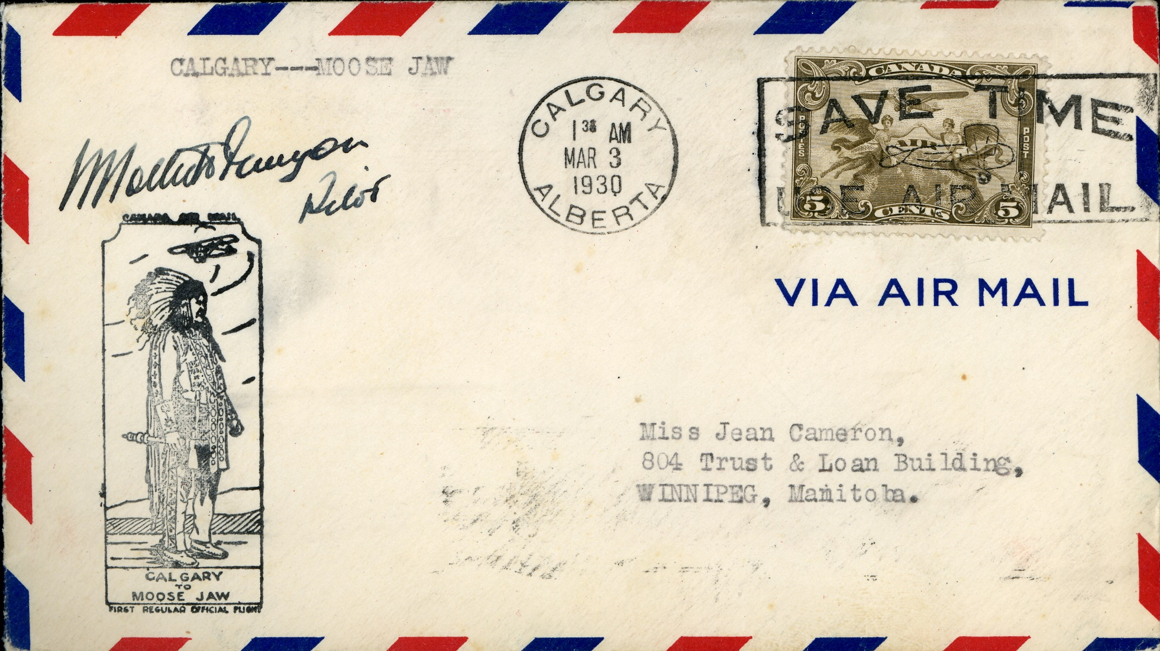
HERBERT HOLLICK-KENYON

HERBERT HOLLICK-KENYON

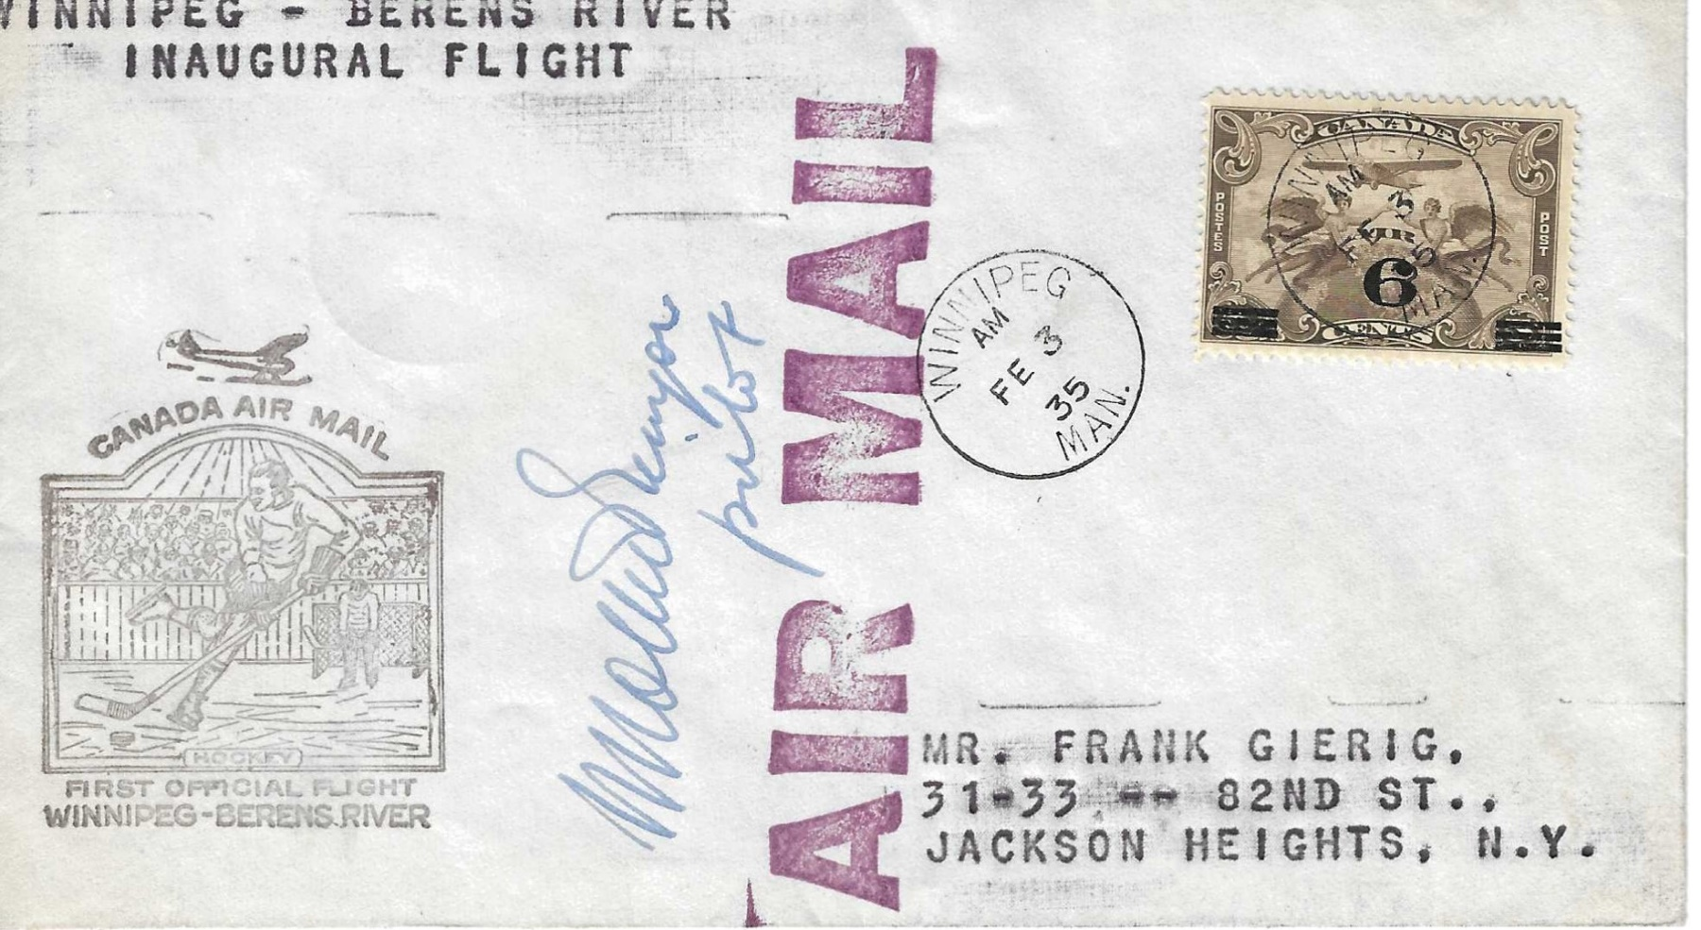

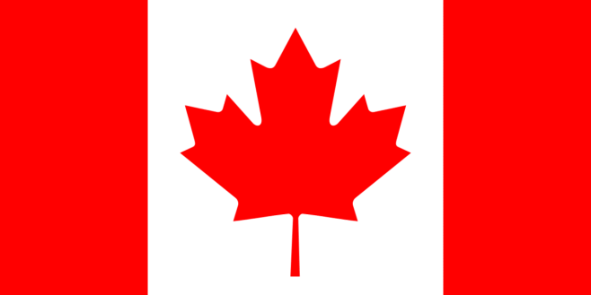

E. S. “TED” HOLMES

E. S. “TED” HOLMES
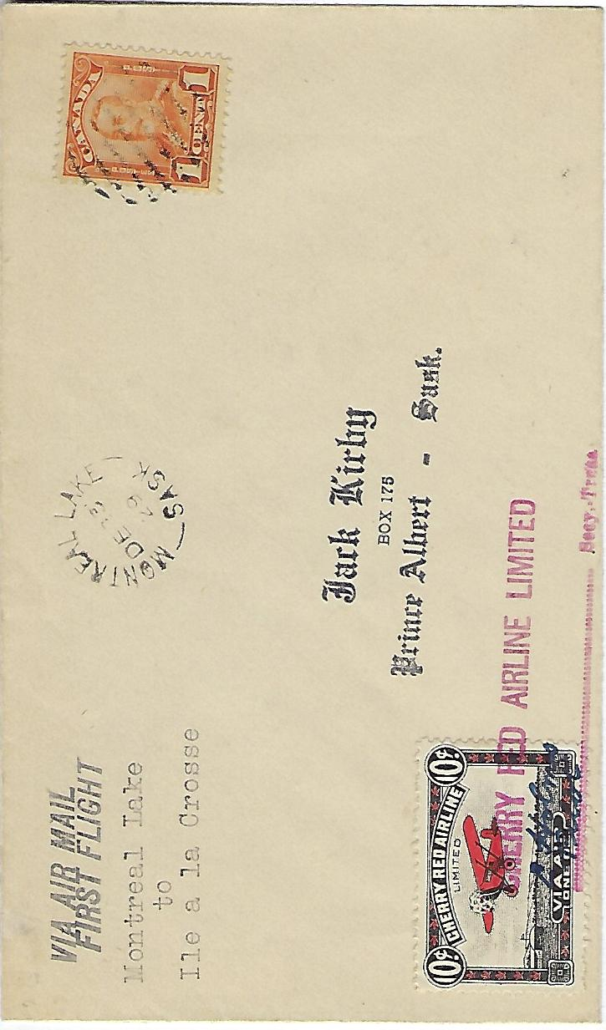

JEFFREY B. HOME-HAY

JEFFREY HOME-HAY (FACSIMILE AUTOGRAPH)
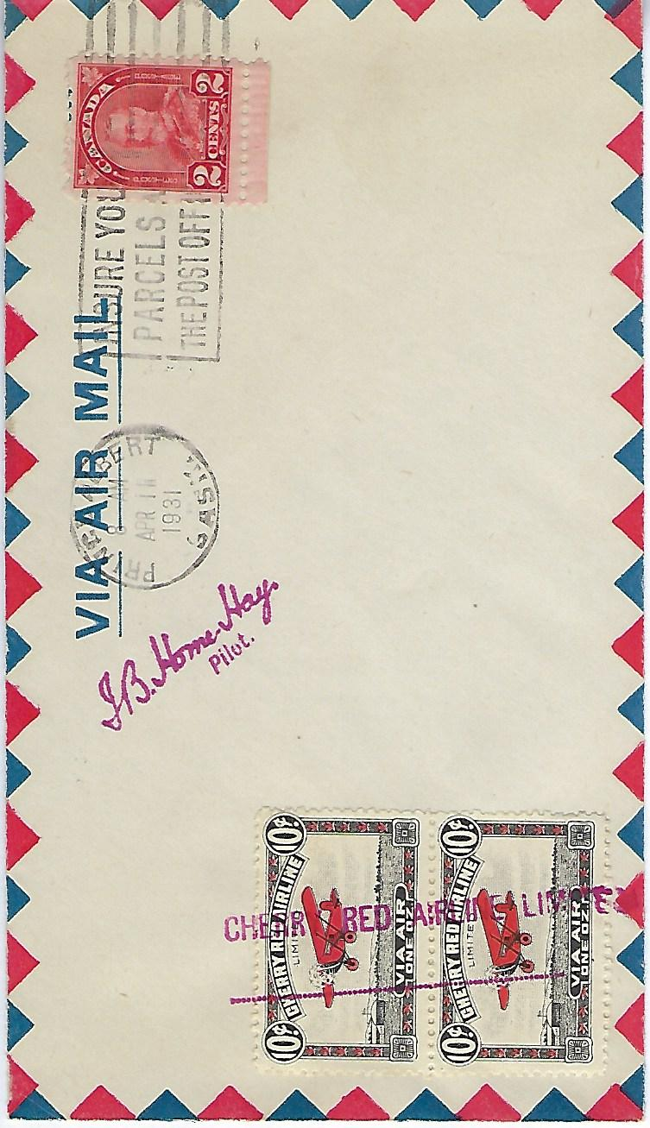

BOB HORNER
BOB HORNER
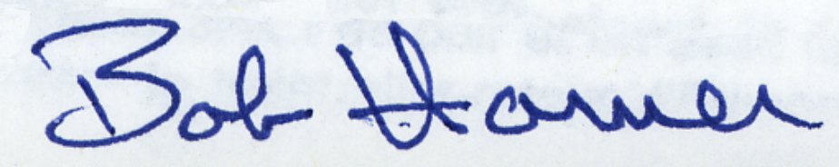

BOB HORNER
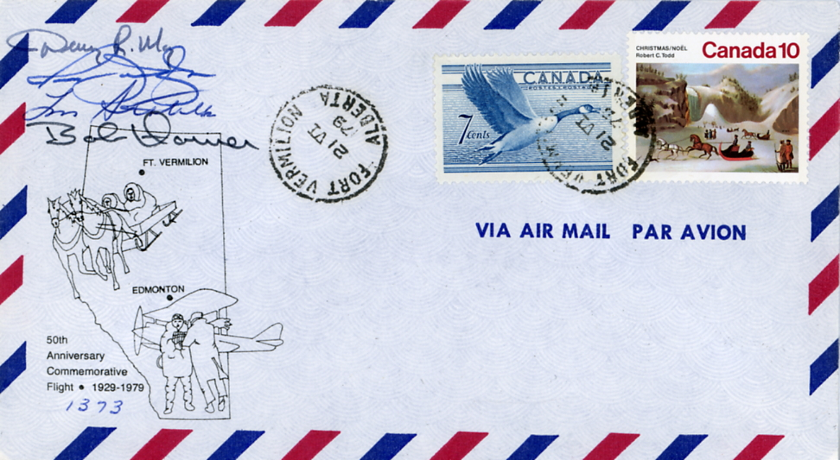

VIC HORNER
VIC HORNER
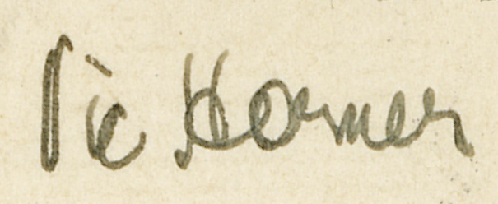

ERNEST C. HOY

ERNEST C. HOY

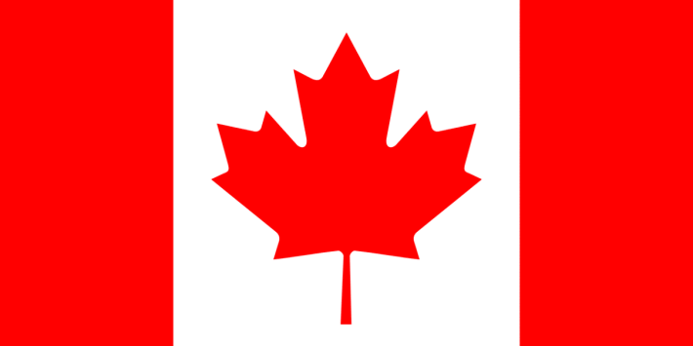

WILLIAM H. “BILLY” HUGHES

WILLIAM H. “BILLY” HUGHES
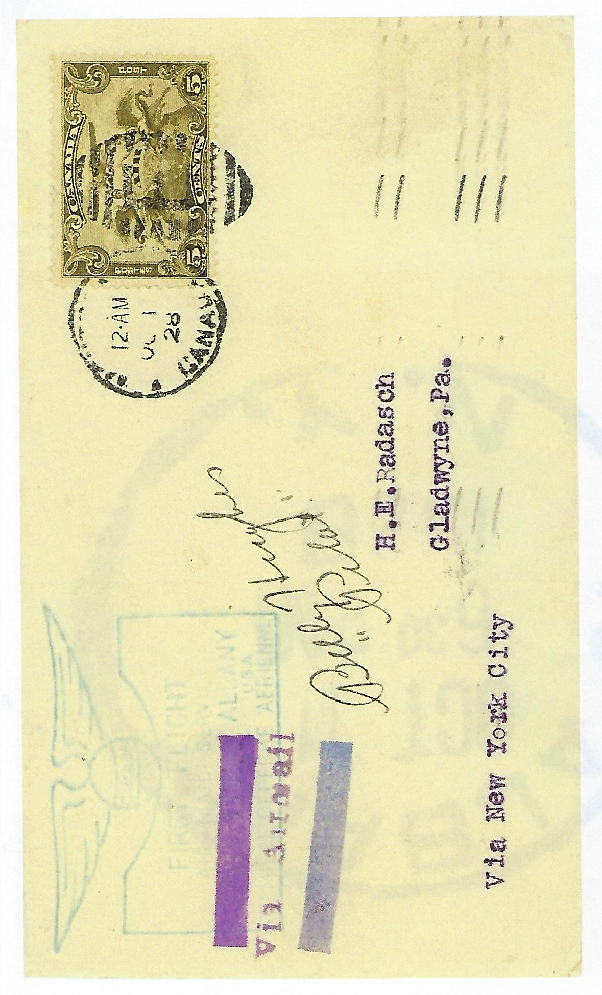

W.H. IRVINE

W. H. IRVINE
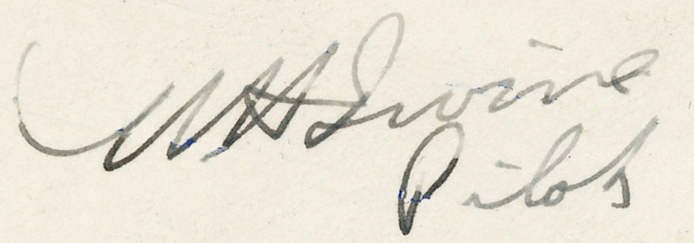

ATHENIA JANSEN

ATHENIA JANSEN
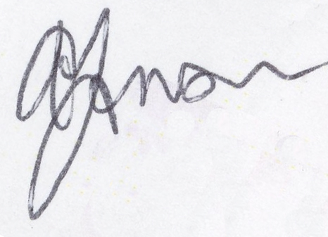
ATHENIA JANSEN
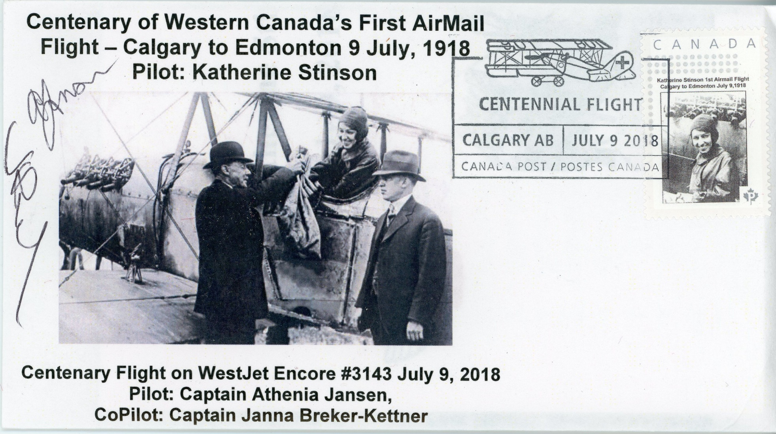

RUSS JANZEN

RUSS JANZEN
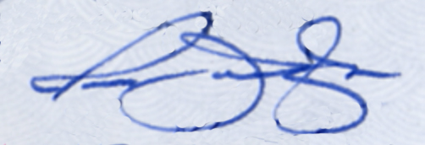

A. E. JARVIS

A.E. JARVIS
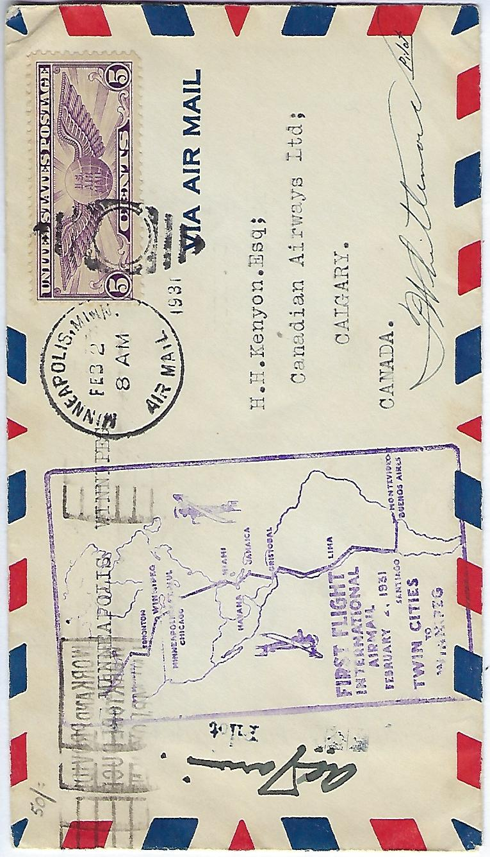

JACK JOHNSON

JACK JOHNSON
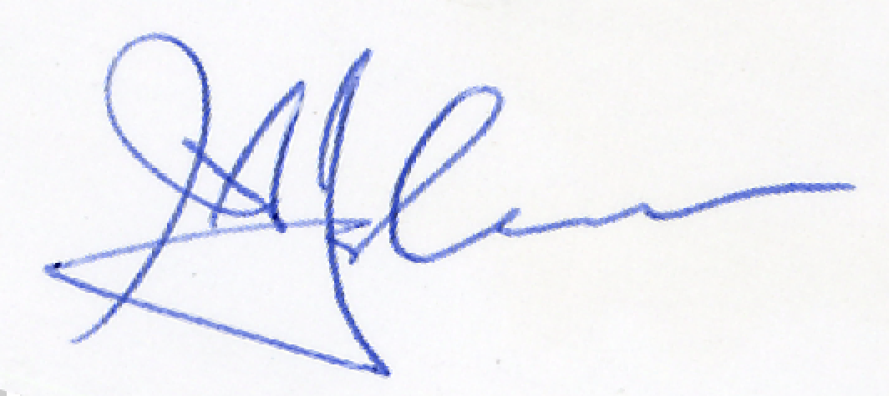

JACK JOHNSON
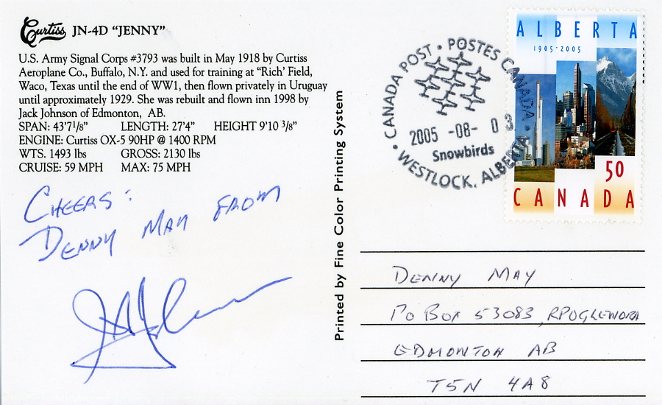

AUDREY KAHOVEC

AUDREY KAHOVEC
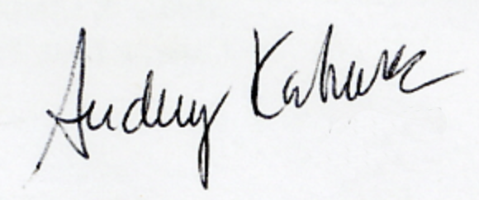

AUDREY KAHOVEC
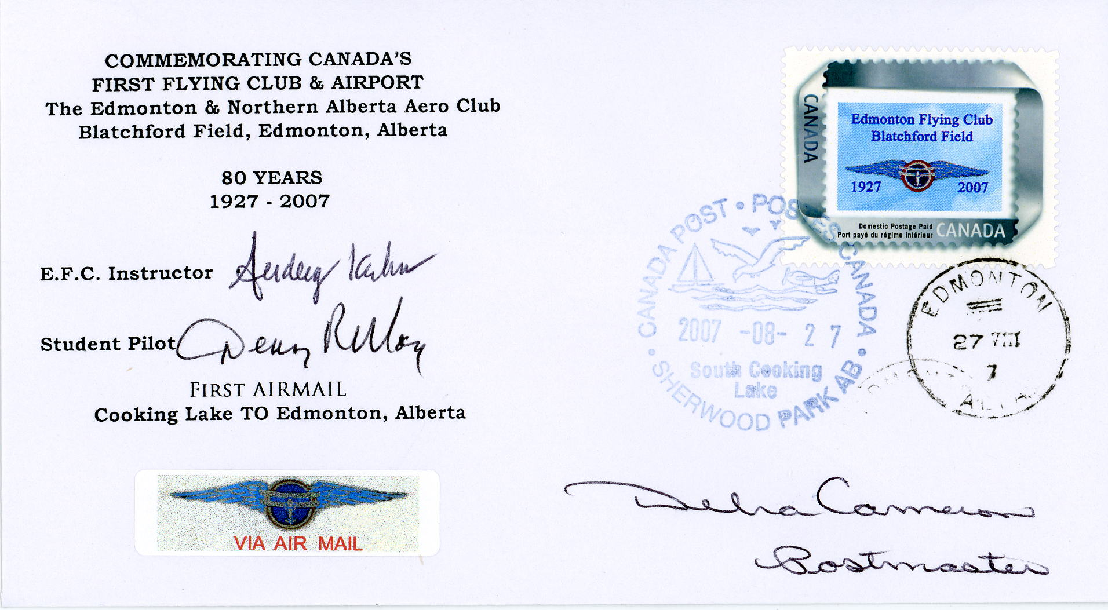

FRANK KEARNEY
FRANK KEARNEY
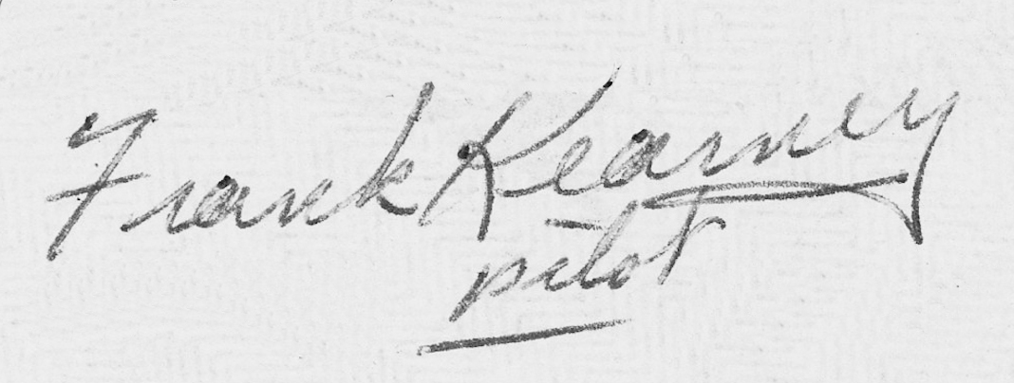

JOHN KELLNER

JOHN KELLNER
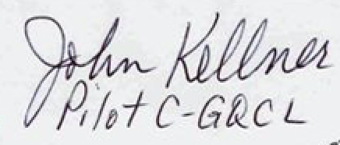

J.C. KELLY ROGERS

J.C. KELLY ROGERS

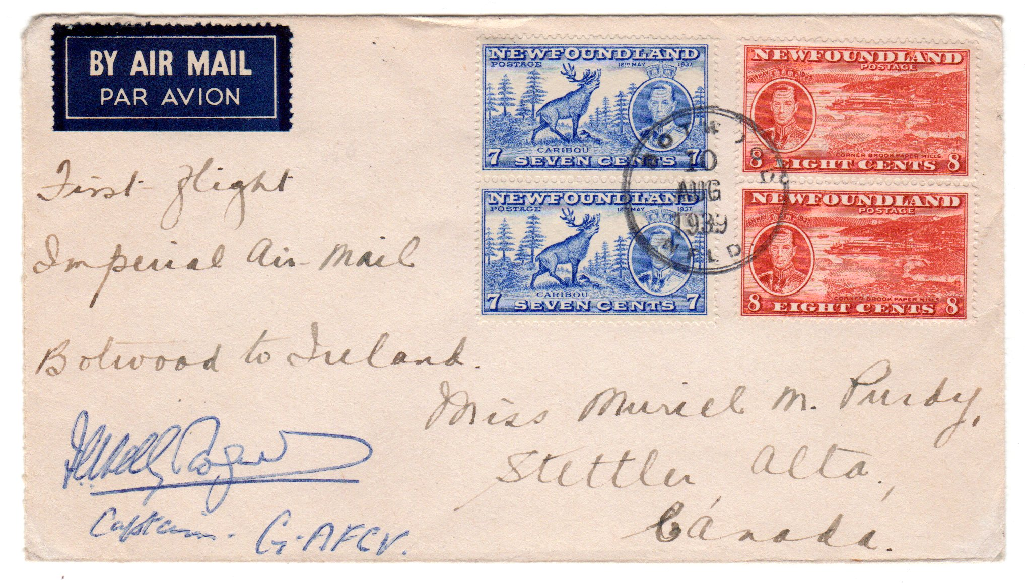

JERRY KLAMMER

JERRY KLAMMER
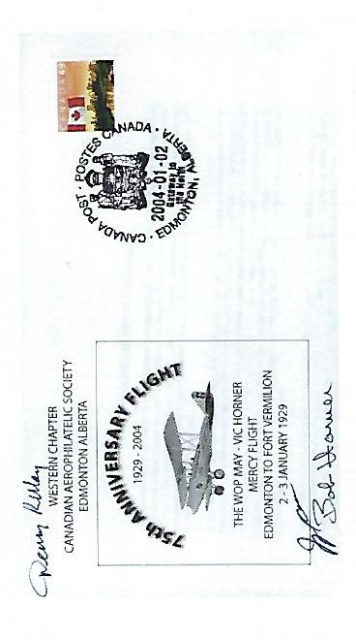

ERNEST W. KUBICEK

ERNEST W. KUBICEK
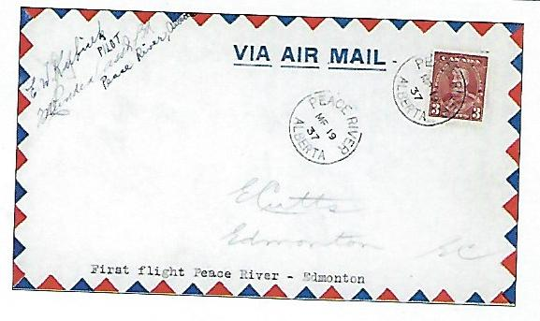

THOMAS LAWRENCE

THOMAS LAWRENCE
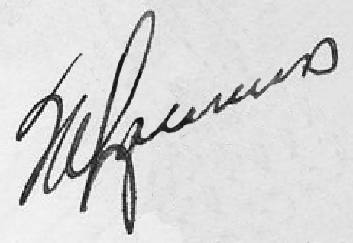

THOMAS LEE

THOMAS LEE
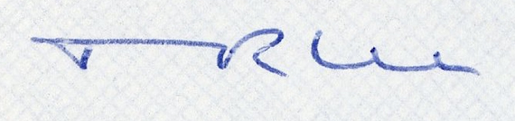

THOMAS LEE
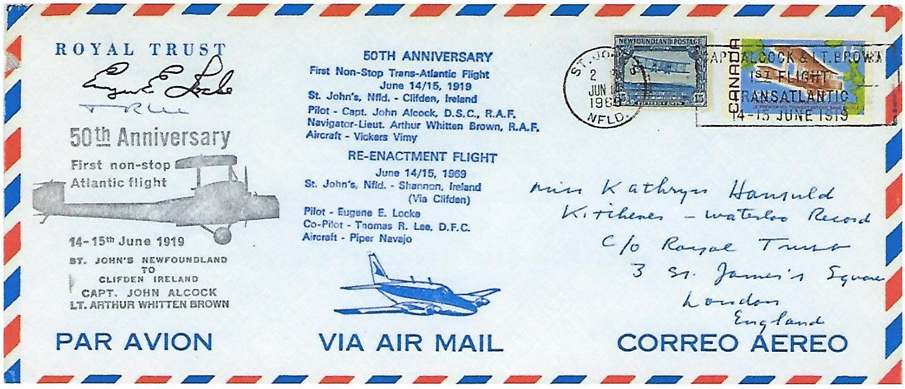

Z. LEWIS LEIGH

Z. LEWIS LEIGH
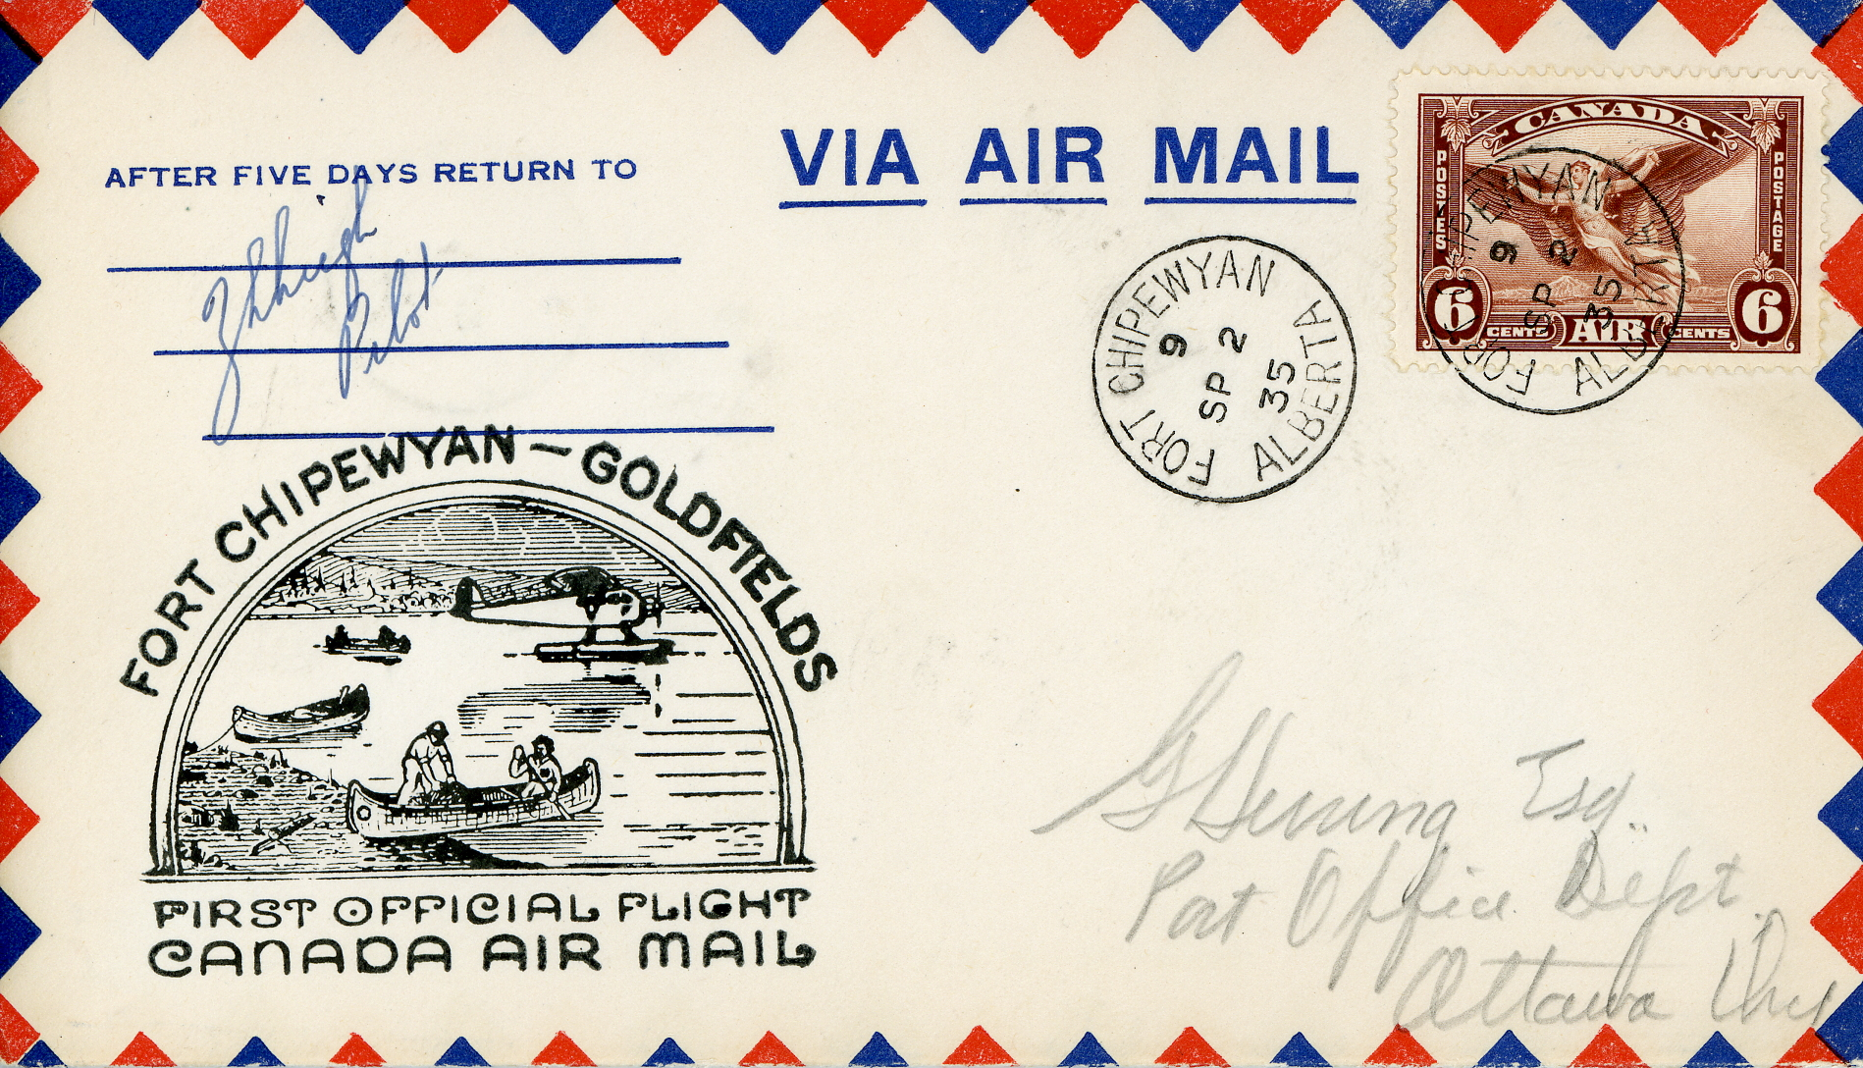

Z. LEWIS LEIGH
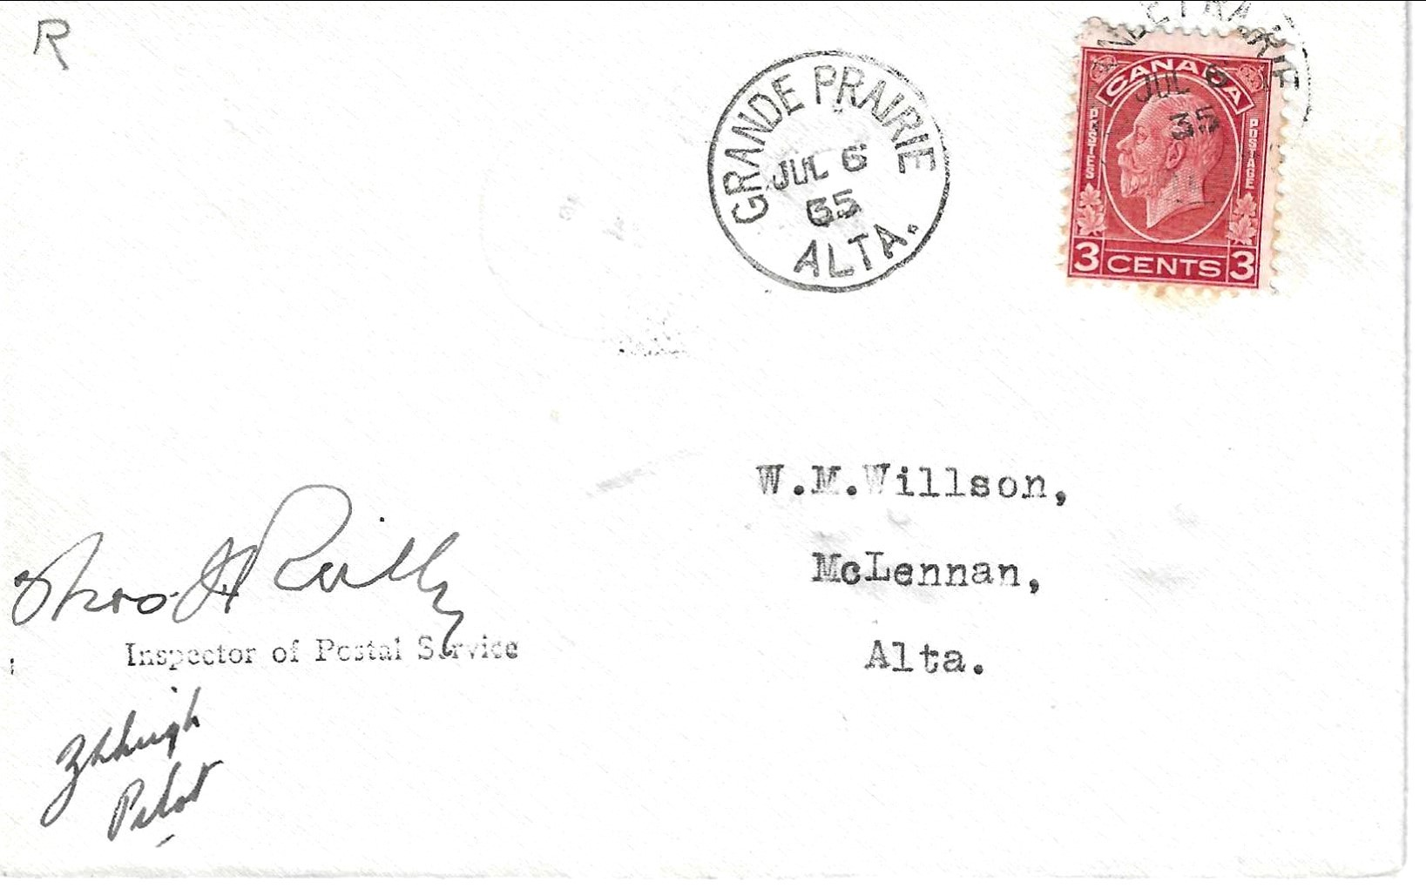

MARG LITTLEWOOD

MARG LITTLEWOOD
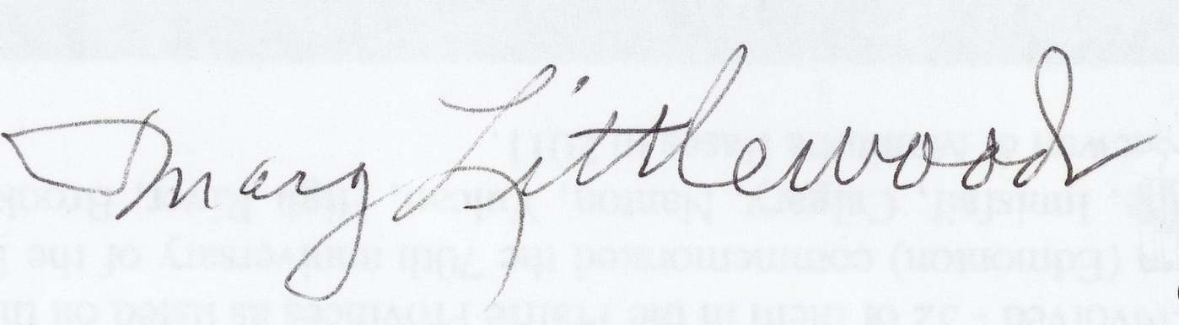

MARG LITTLEWOOD
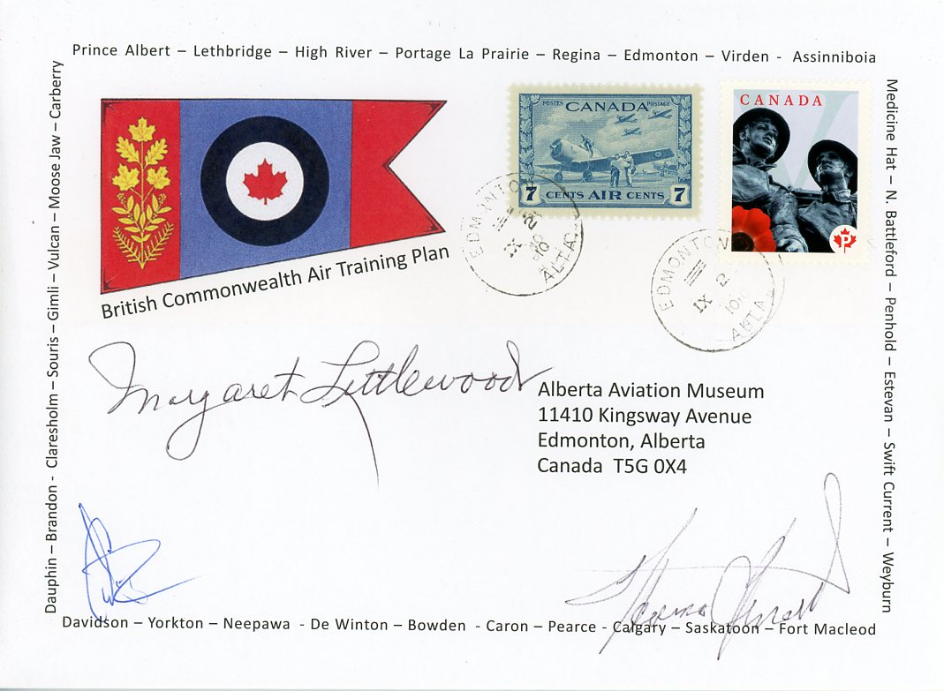

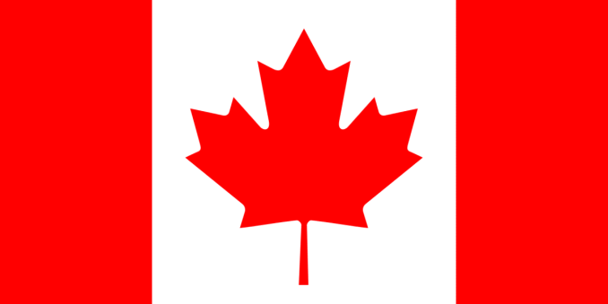

EUGENE LOCKE

EUGENE LOCKE
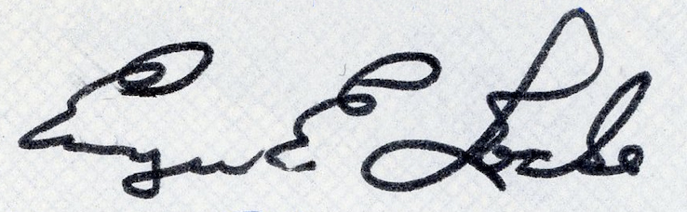

EUGENE LOCKE

JOHN MacGILLIVRAY
(MAJ.)

MAJ. JOHN MacGILLIVRAY
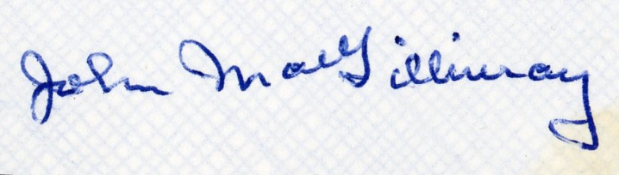

CHUCK MALLETT

CHUCK MALLETT
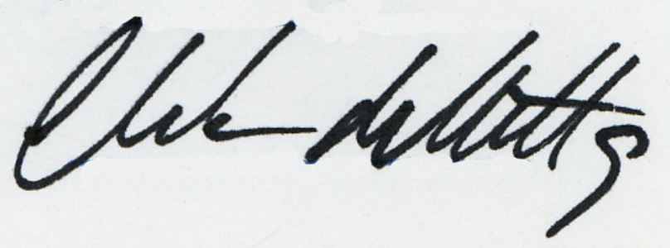

JIMMIE MATTERN

JIMMIE MATTERN
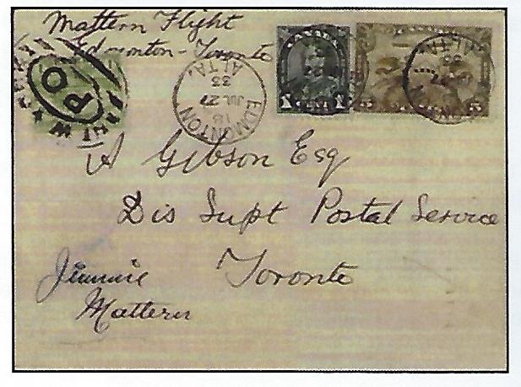

W. ROY MAXWELL

W. ROY MAXWELL
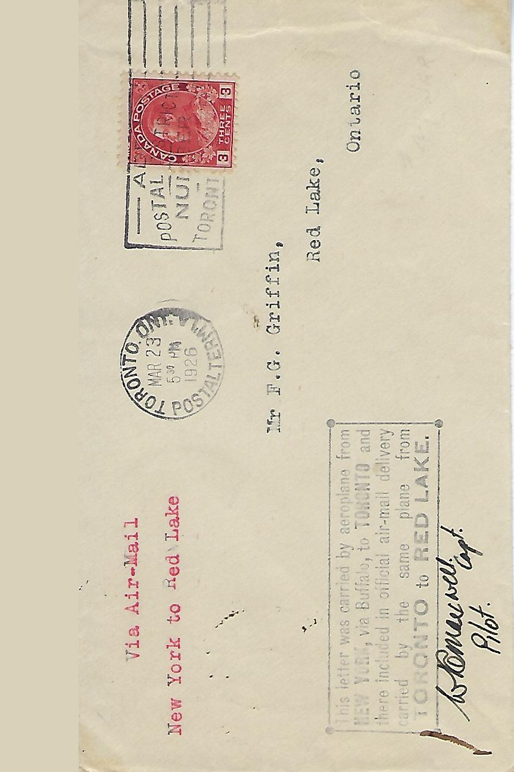

DENNY MAY

DENNY MAY
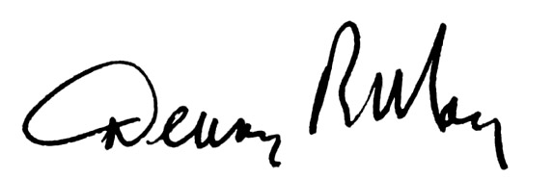
DENNY MAY

W. R. “WOP” MAY

W. R. “WOP” MAY
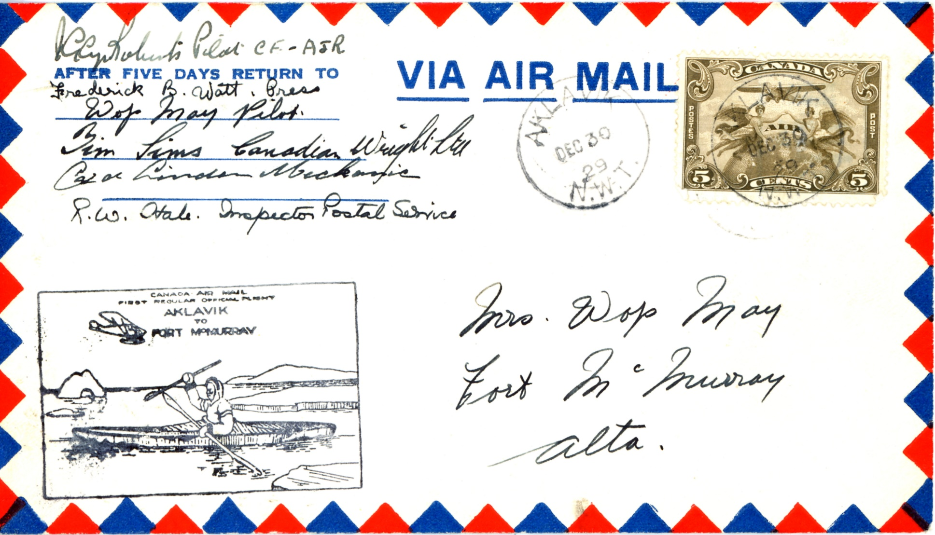

W. R. “WOP” MAY
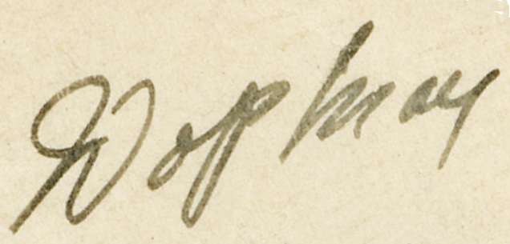

W. R. “WOP” MAY
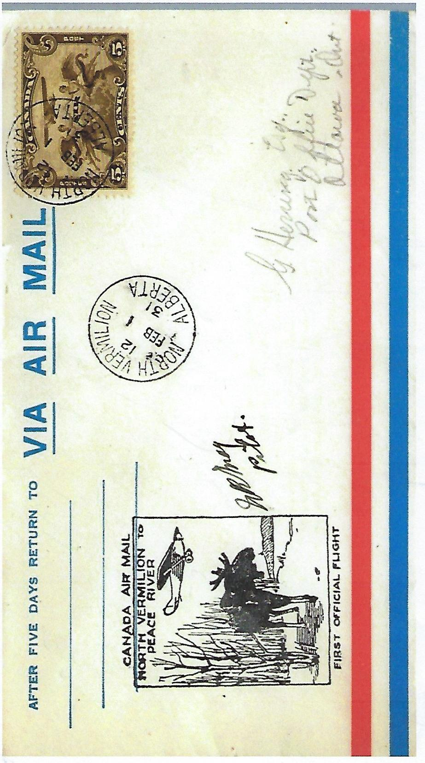

GRANT W. McCONACHIE

GRANT W. MCCONACHIE
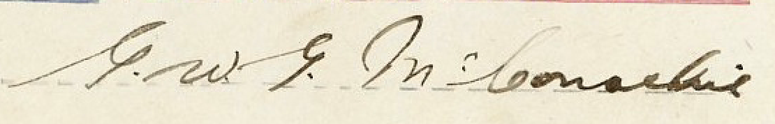

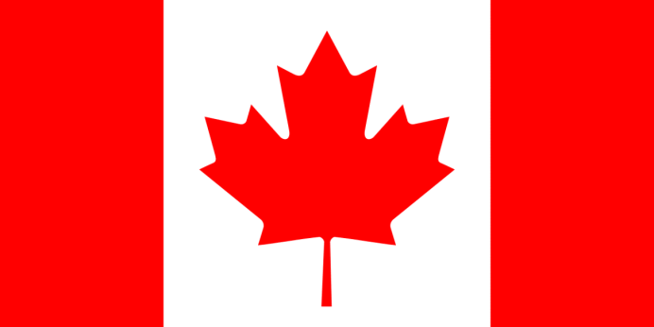

J.A.D. McCURDY

J.A.D. McCURDY
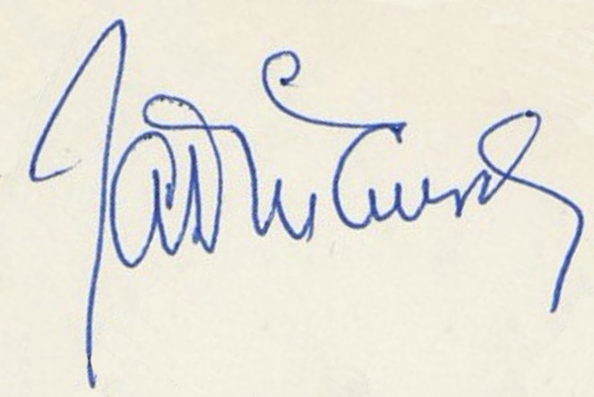

A.D. “DON” McLEAN

A.D. “DON” MCLEAN
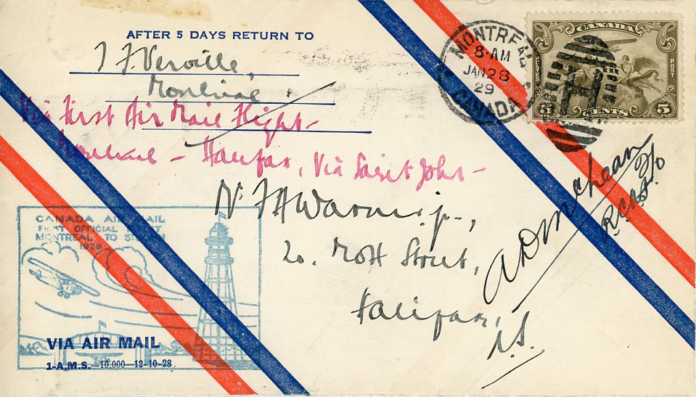

A.D. “DON” MCLEAN
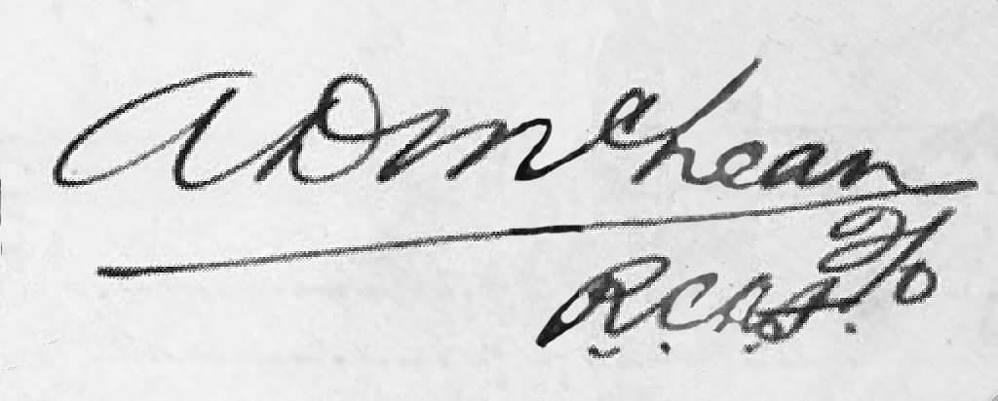

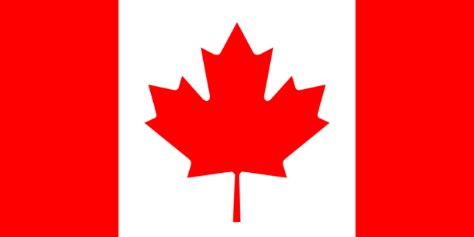

S.R. “STAN” McMILLAN

S.R. “STAN” MCMILLAN
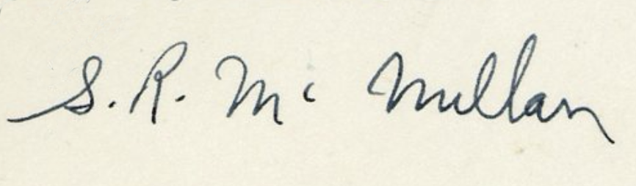

ARCHIE M. McMULLEN

ARCHIE M. McMULLEN
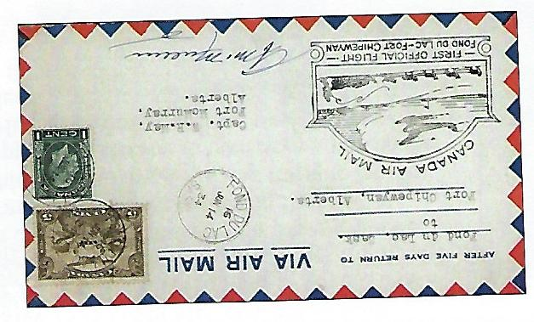

JAMES MOLLISON

JAMES MOLLISON
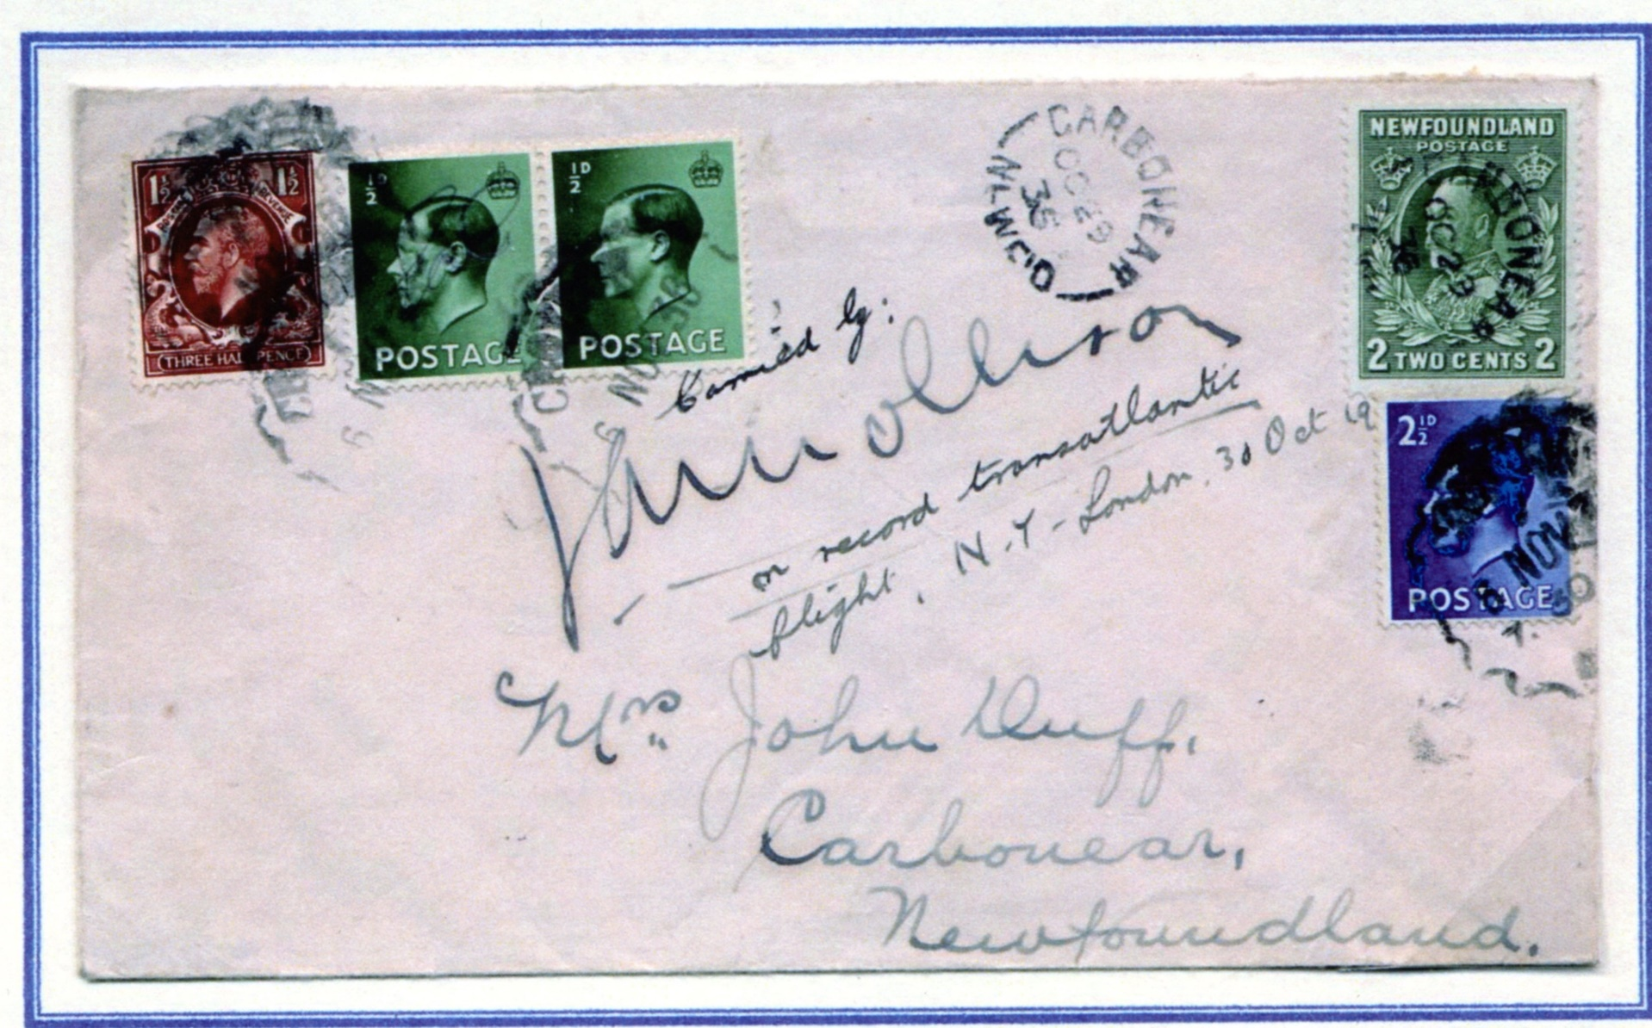

GEORGE NEAL

GEORGE NEAL
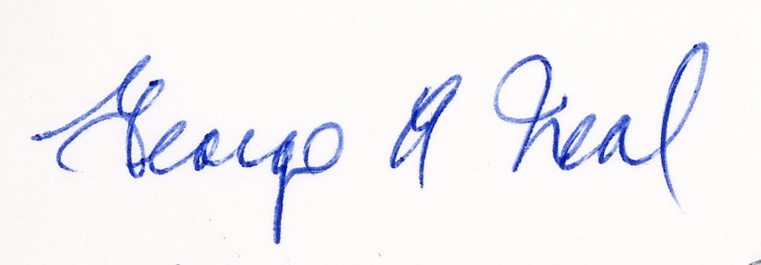

ALAN NESS

ALAN NESS
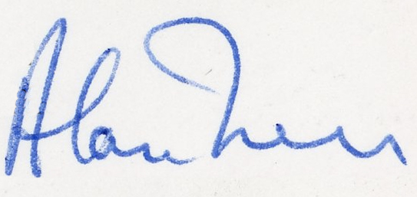

ALAN NESS
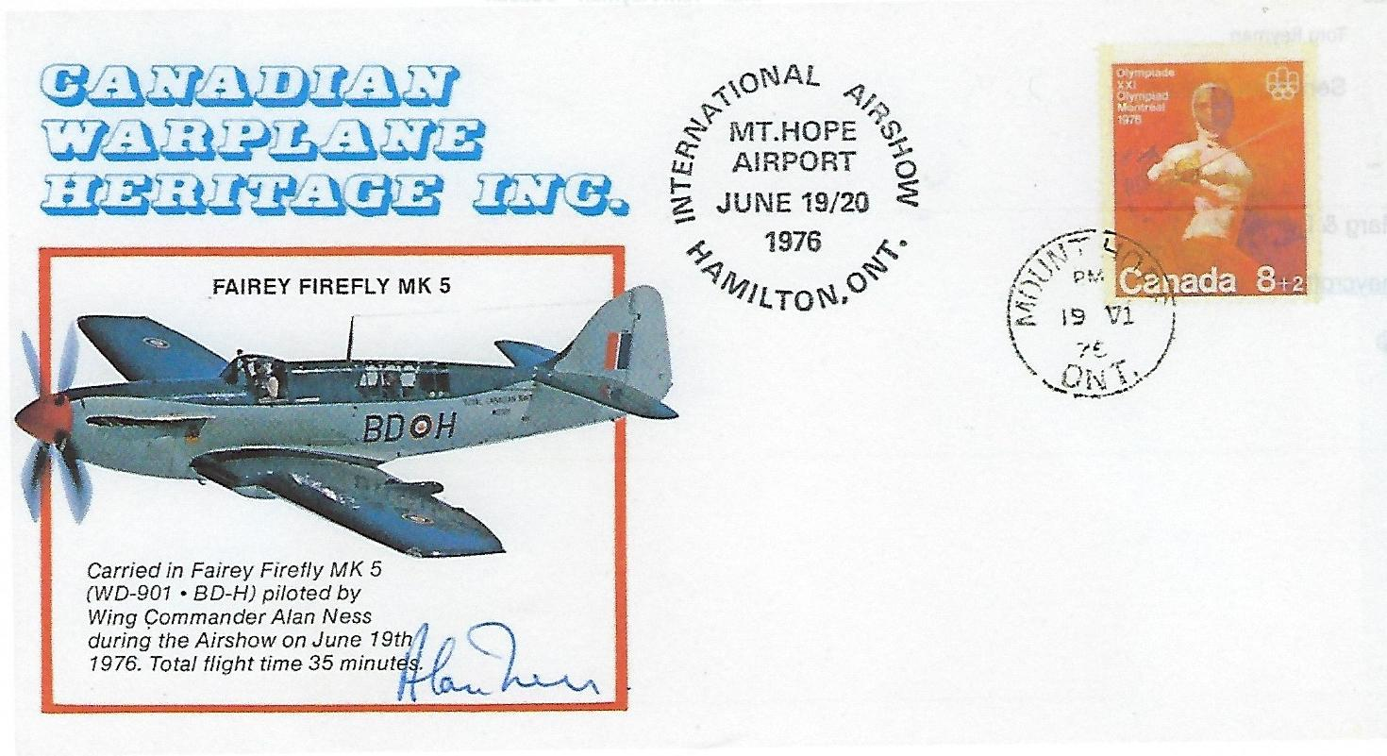

FRANK OGDEN
FRANK OGDEN
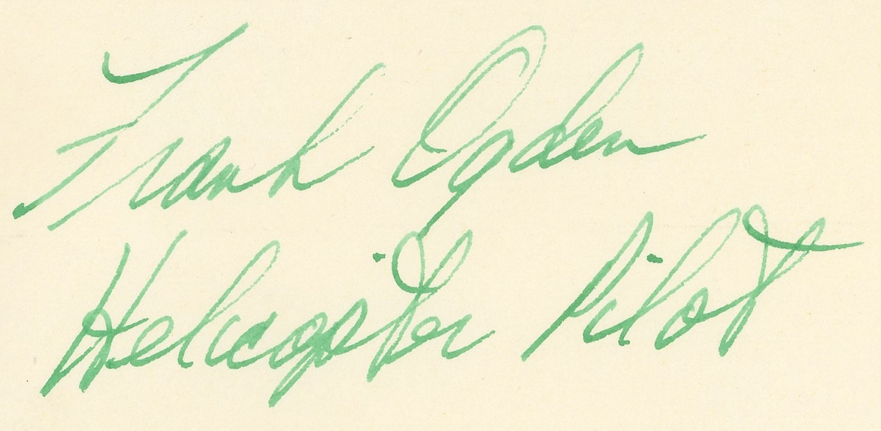

JOHN M. PATTERSON

JOHN M. PATTERSON
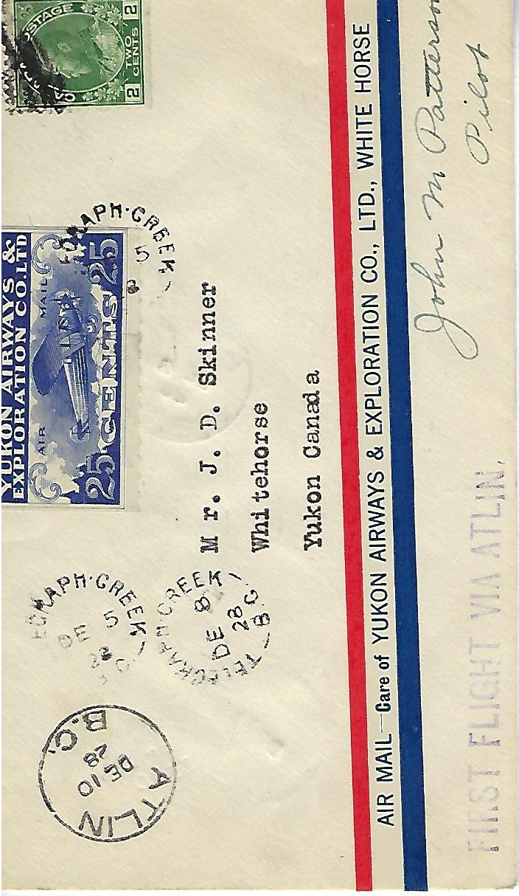

CURTIS PETERS

CURTIS PETERS
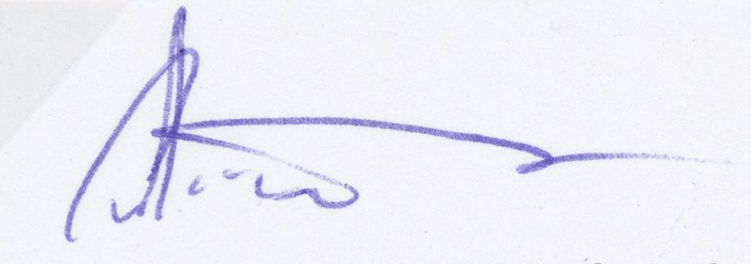

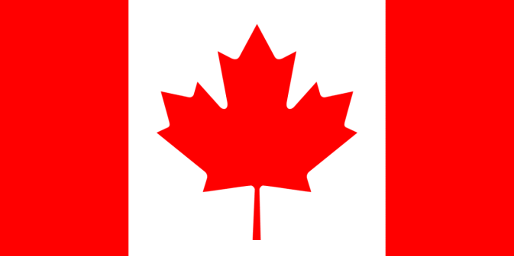

WILEY POST

WILEY POST
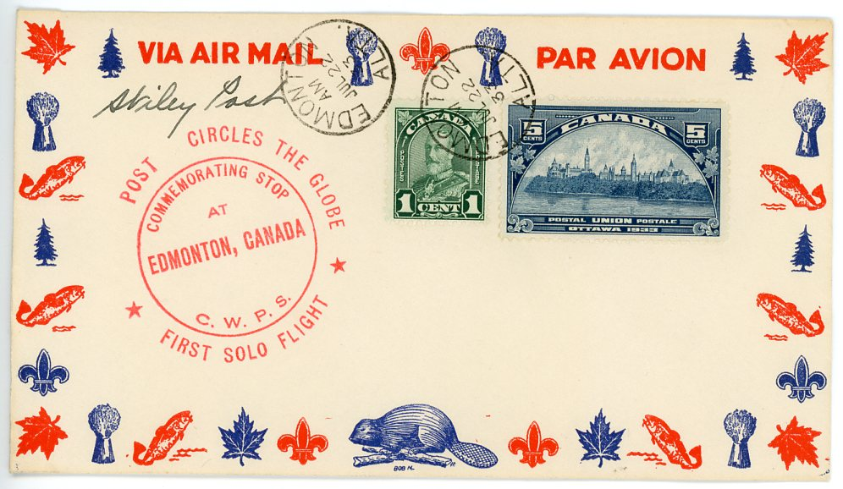

F.P. RAYNHAM

F.P. RAYNHAM
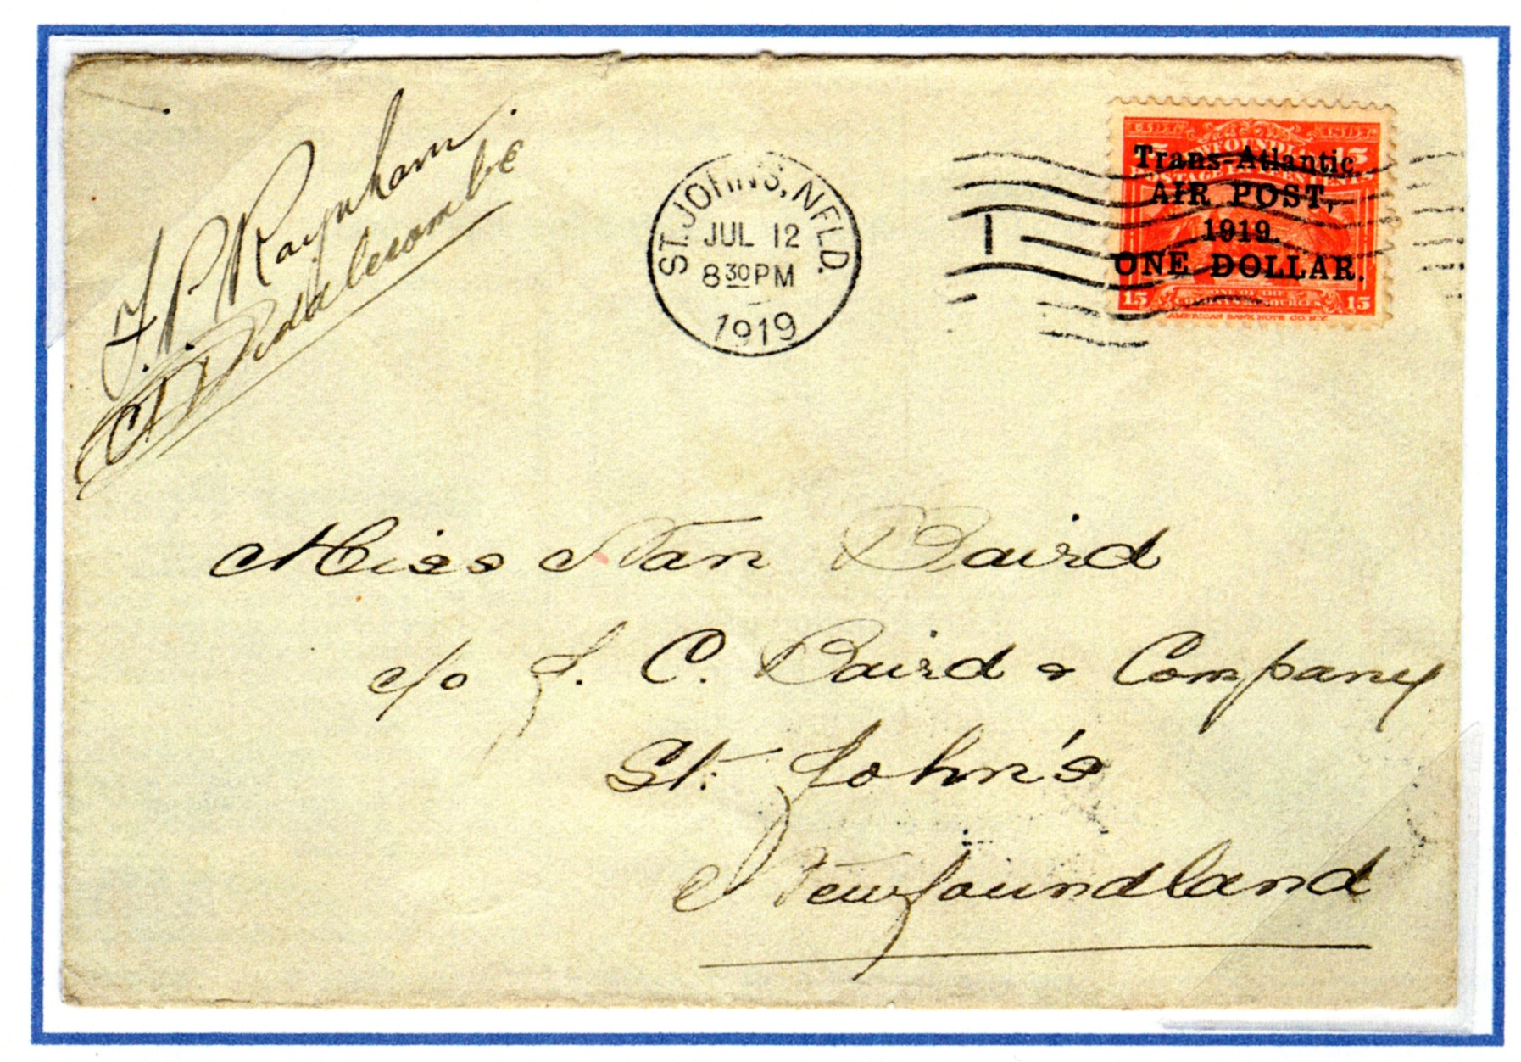

JACK REILLY

JACK REILLY

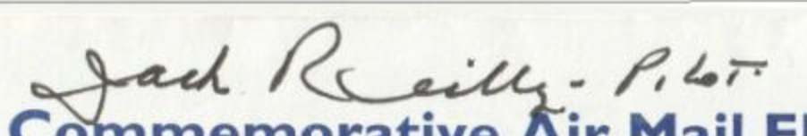

BYRON REYNOLDS

Byron Reynolds
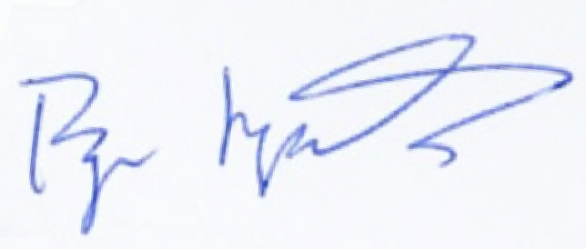

Byron Reynolds

PETER RUBIE

Peter Rubie
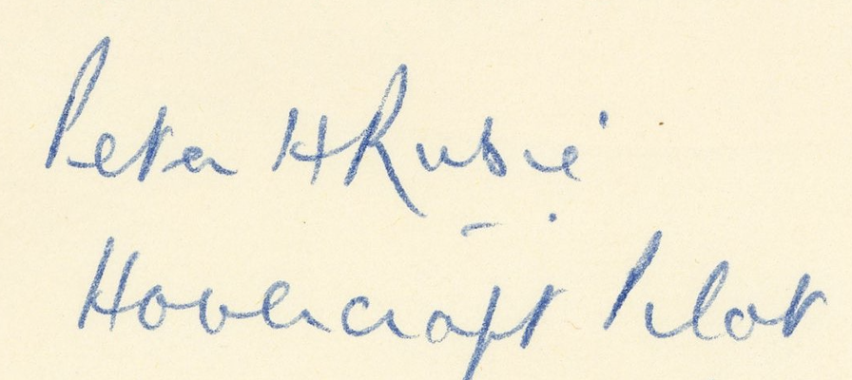

M.J. SANDERSON

M.J. SANDERSON
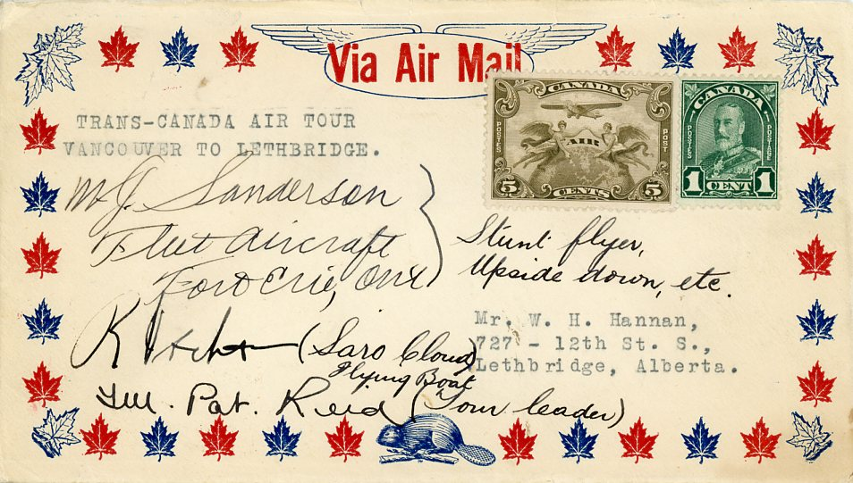

GARY SARTAIN

GARY SARTAIN
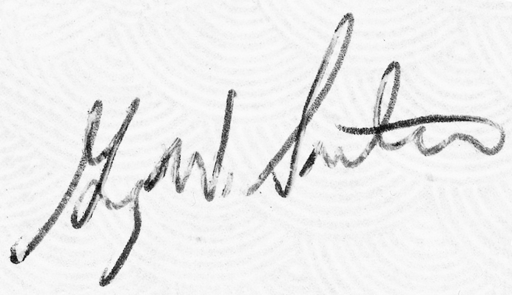
GARY SARTAIN
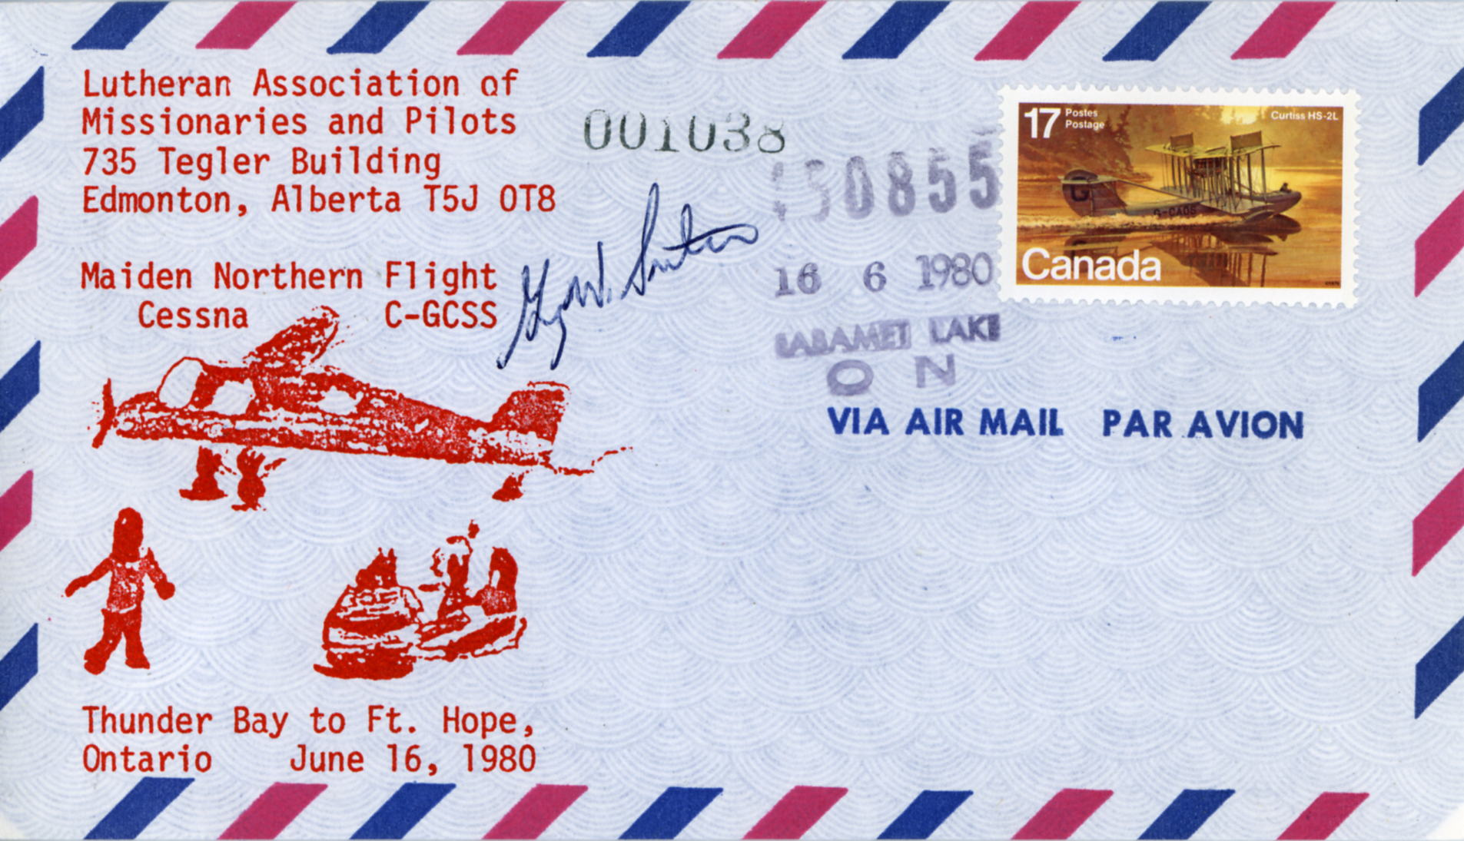

KENNETH SAUNDERS

KENNETH SAUNDERS

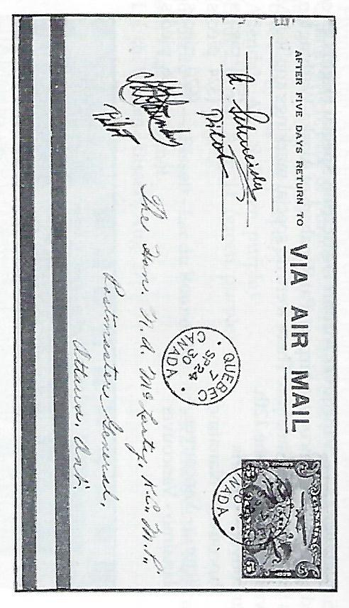
KENNETH SAUNDERS
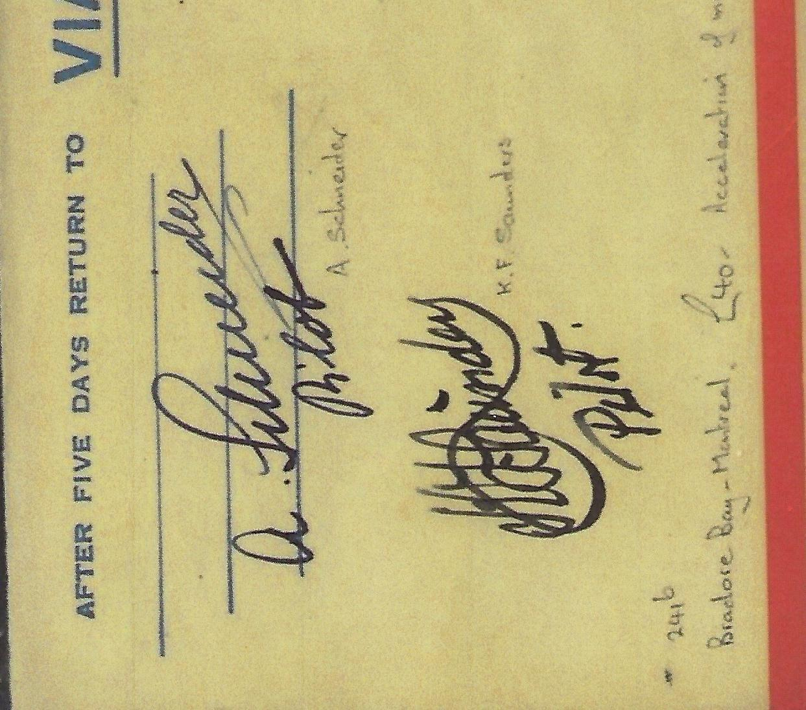

ALEX SCHNEIDER

ALEX SCHNEIDER

ALEX SCHNEIDER

CLARK SEABORN

CLARK SEABORN
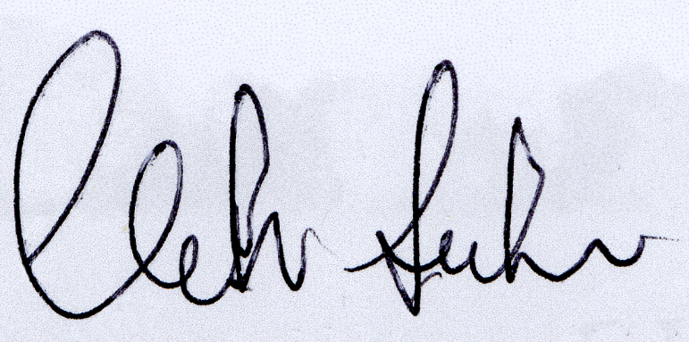

CLARK SEABORN
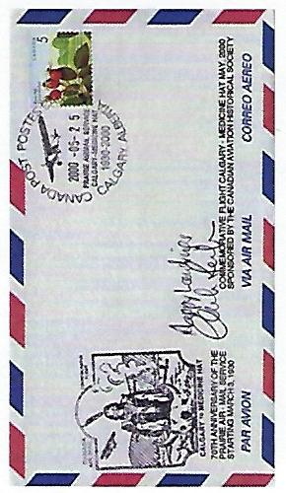

H.W. SEAGRIM

H.W. SEAGRIM
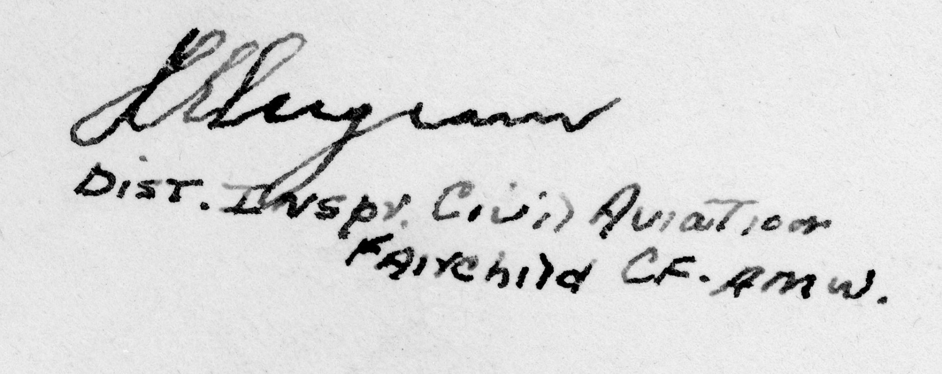

WAYNE J. SHELDON

WAYNE J. SHELDON
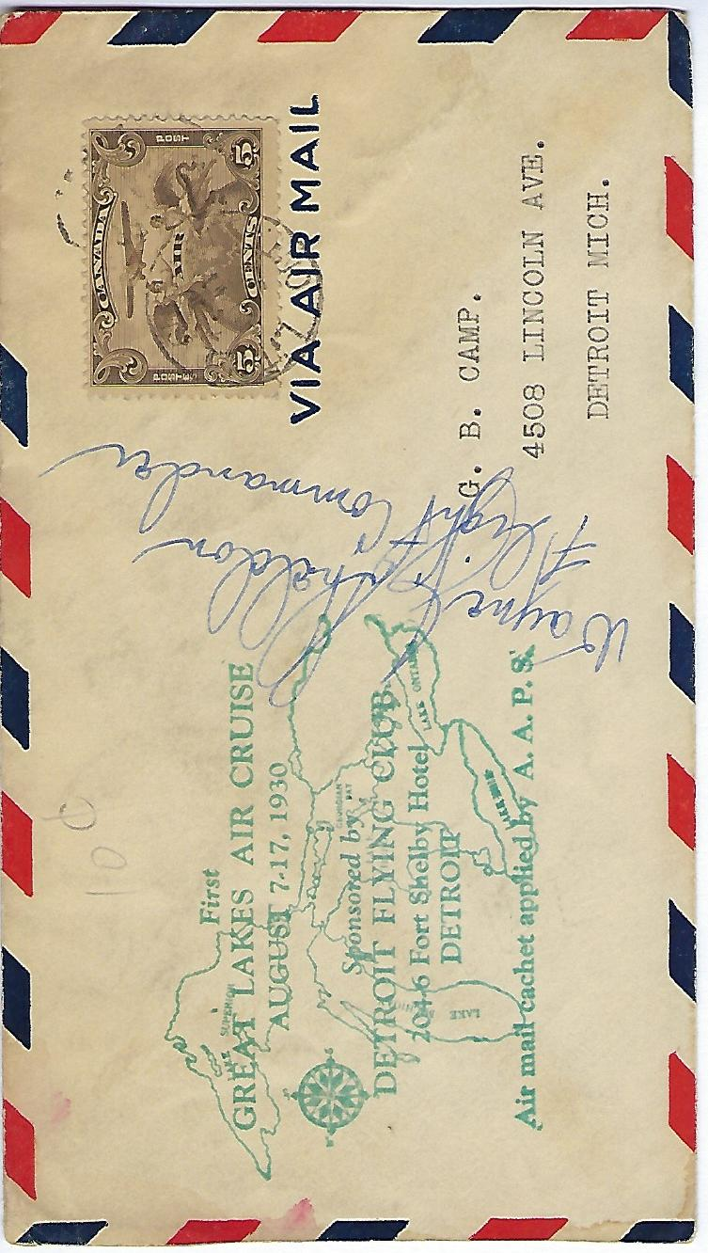

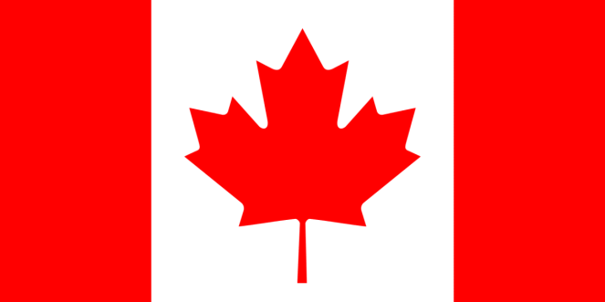

CHARLIE SIMPSON

CHARLIE SIMPSON
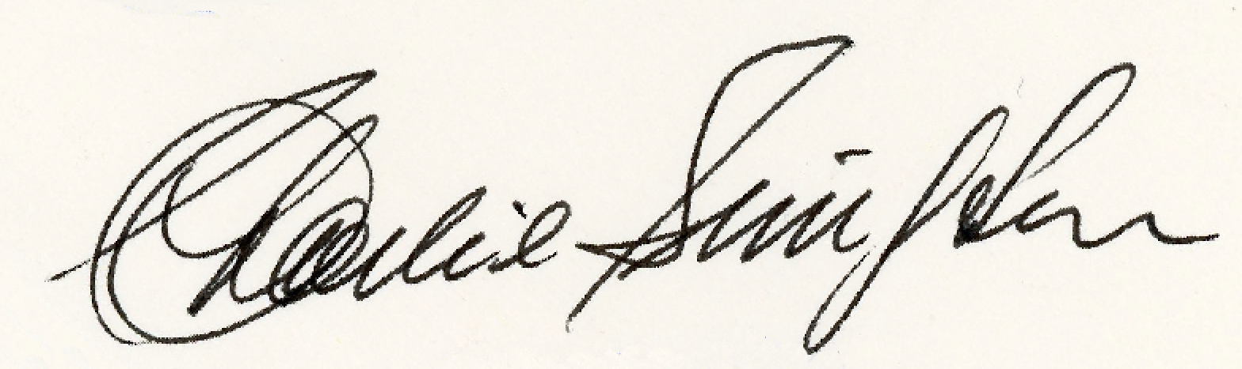

CHARLIE SIMPSON
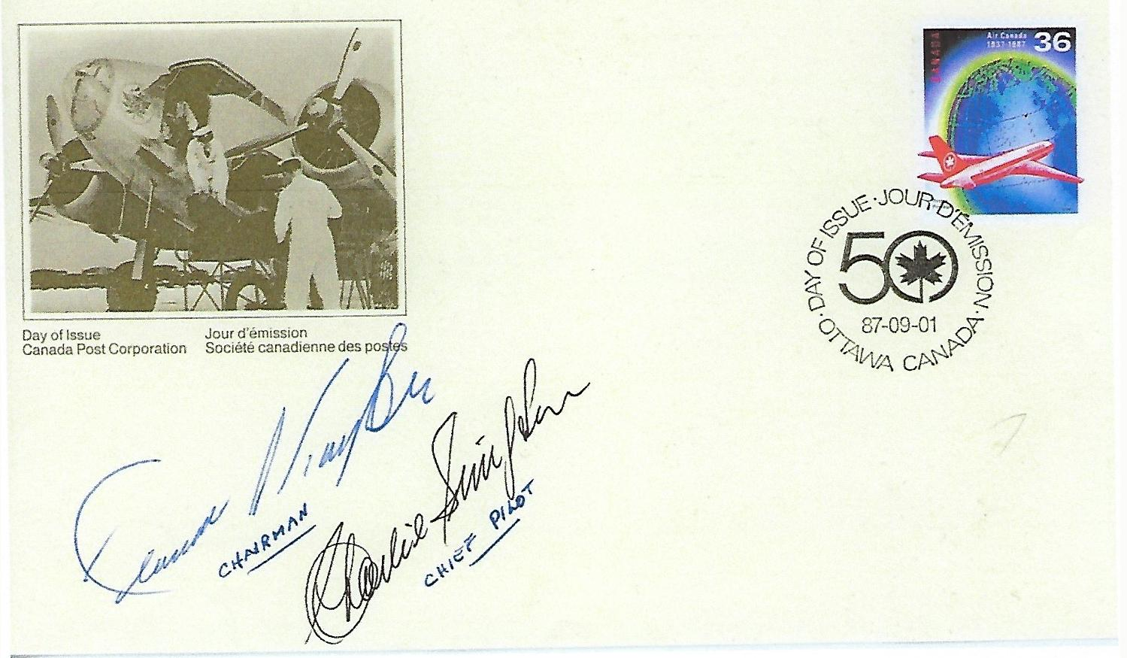

LES STAHLKE

LES STAHLKE
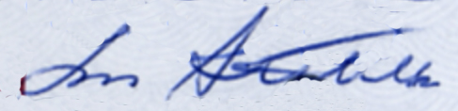

T. G. STEPHENS

T. G. STEPHENS
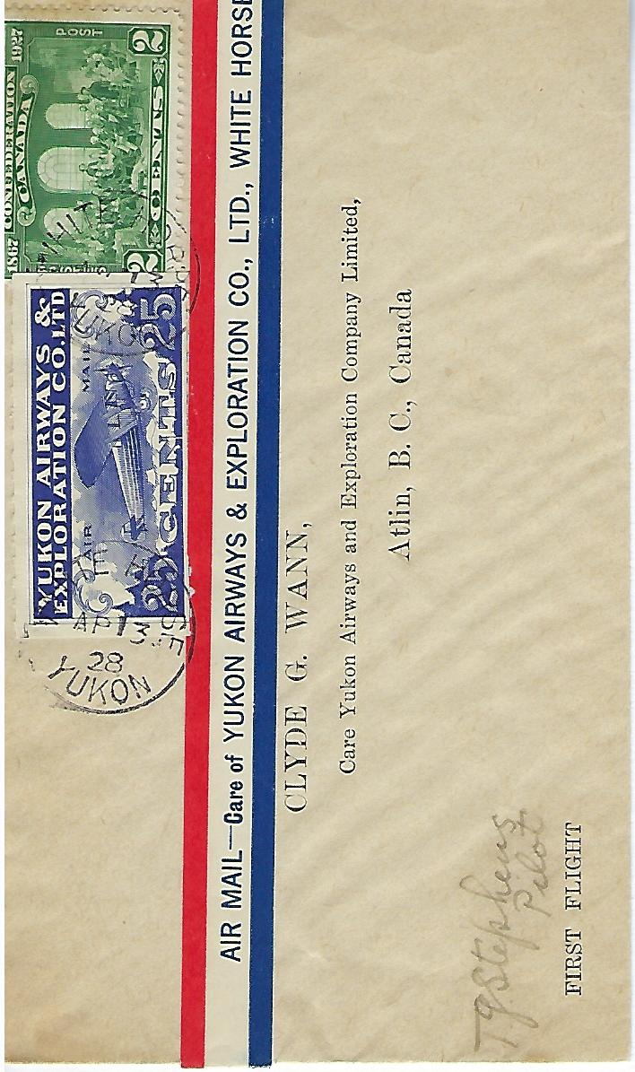

FRANCIS J. “FRED” STEVENSON

FRED STEVENSON
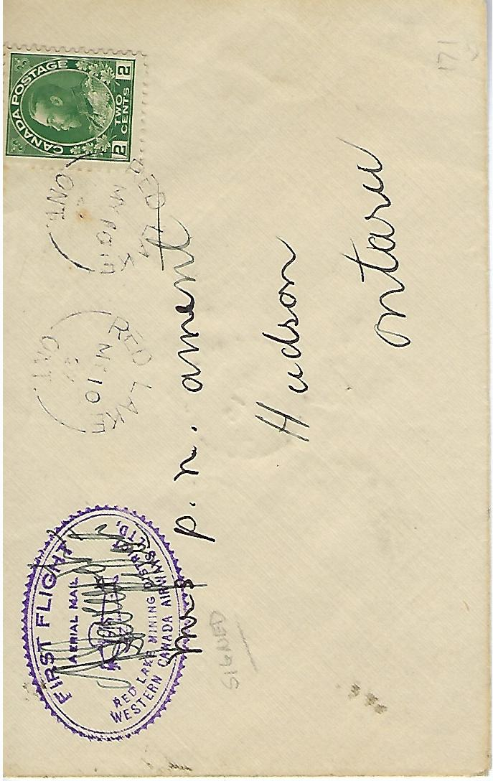
FRED STEVENSON
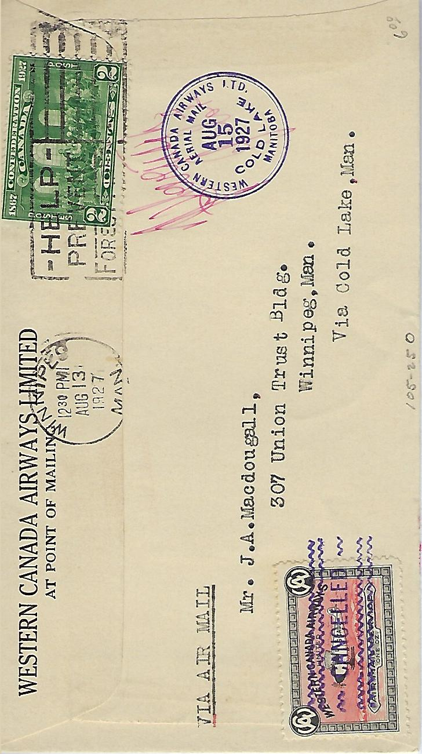

E.W. STULL

E.W. STULL
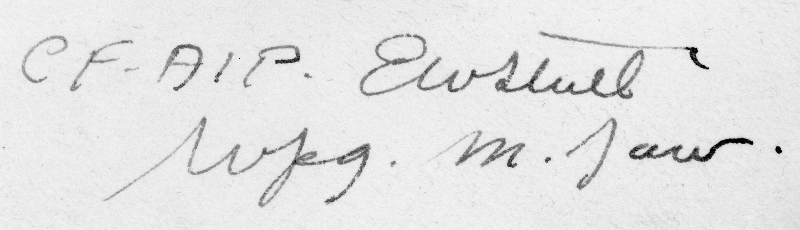

- D. SULLIVAN

A. D. SULLIVAN
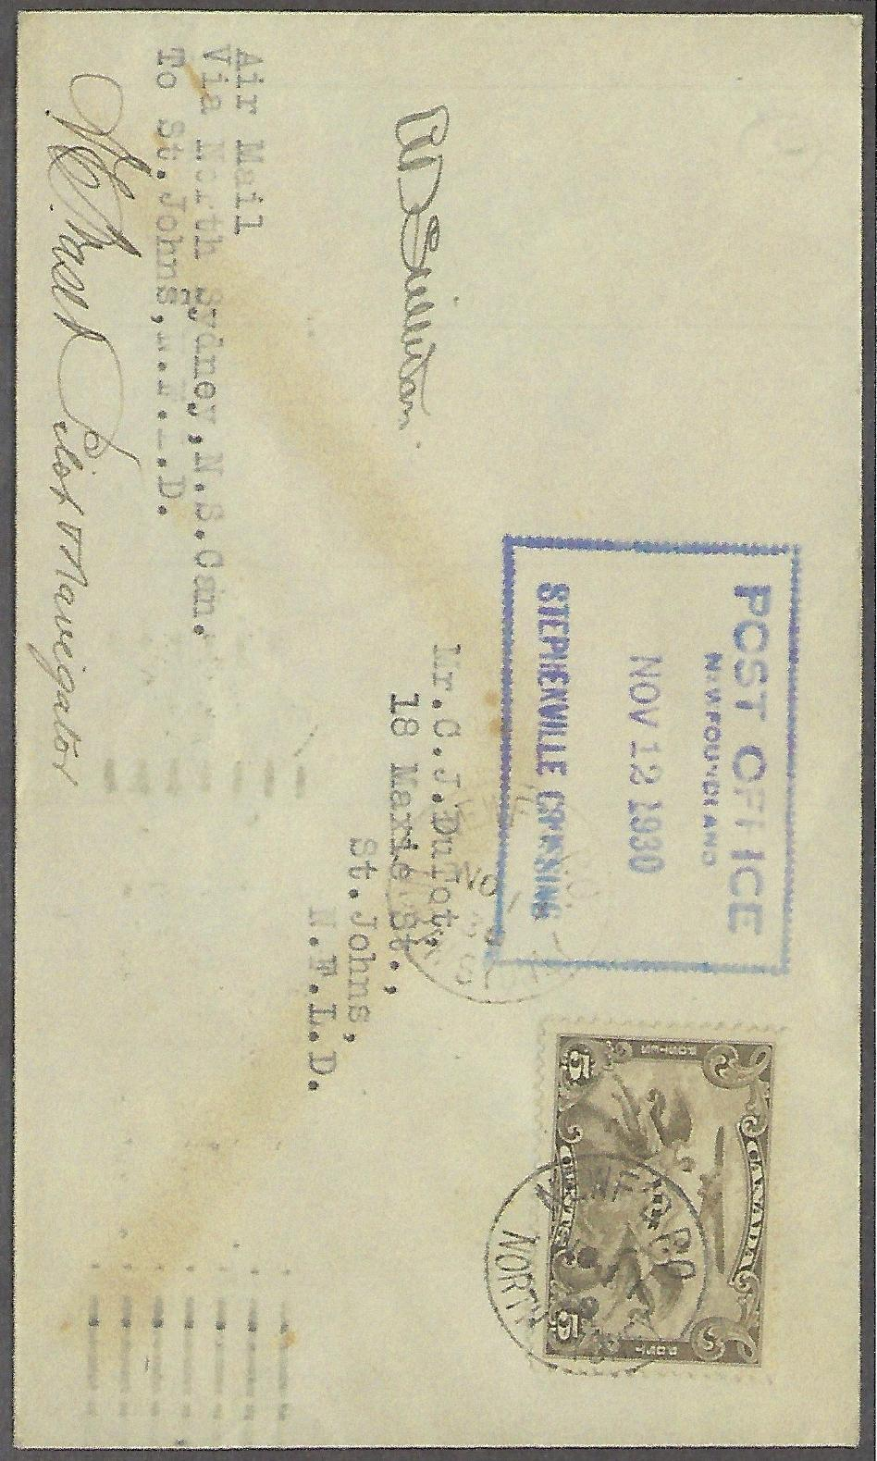

CLAUDE TAYLOR

CLAUDE TAYLOR
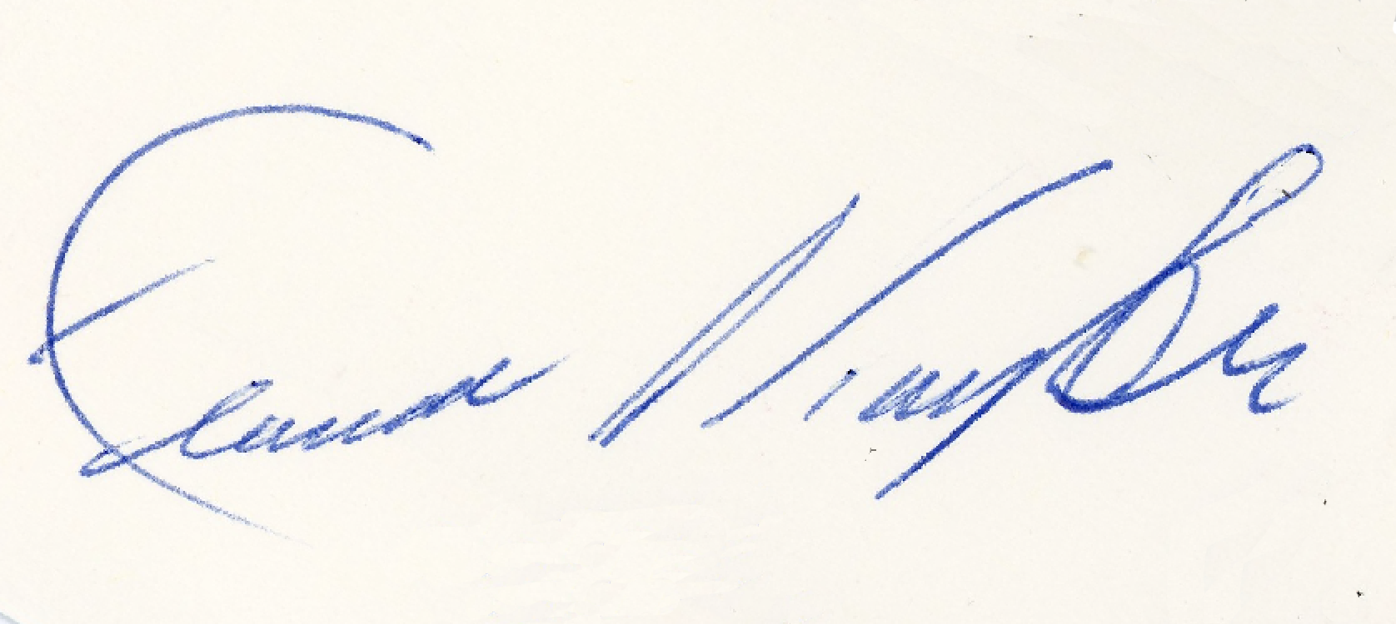

CLAUDE TAYLOR

IRENEE “PETE” VACHON

IRENEE “PETE” VACHON
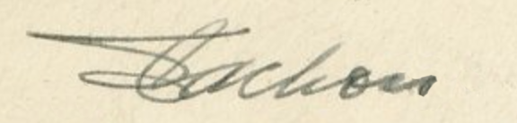

IRENEE “PETE” VACHON
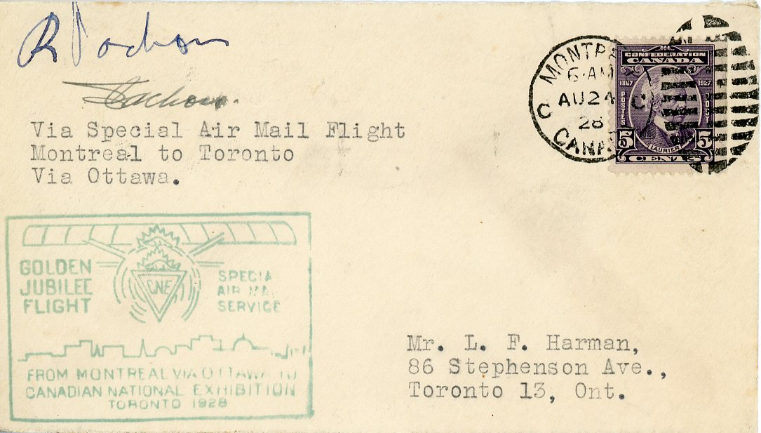

ROMEO VACHON

ROMEO VACHON

ROMEO VACHON
ROMEO VACHON
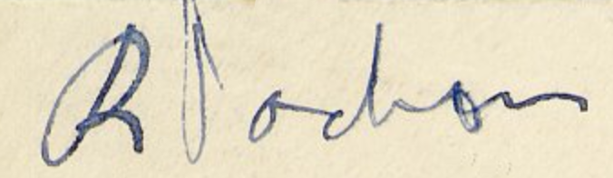

STEVE VALKO

STEVE VALKO
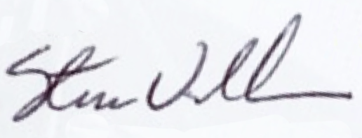

STEVE VALKO

U.S. WAGNER

U.S. WAGNER
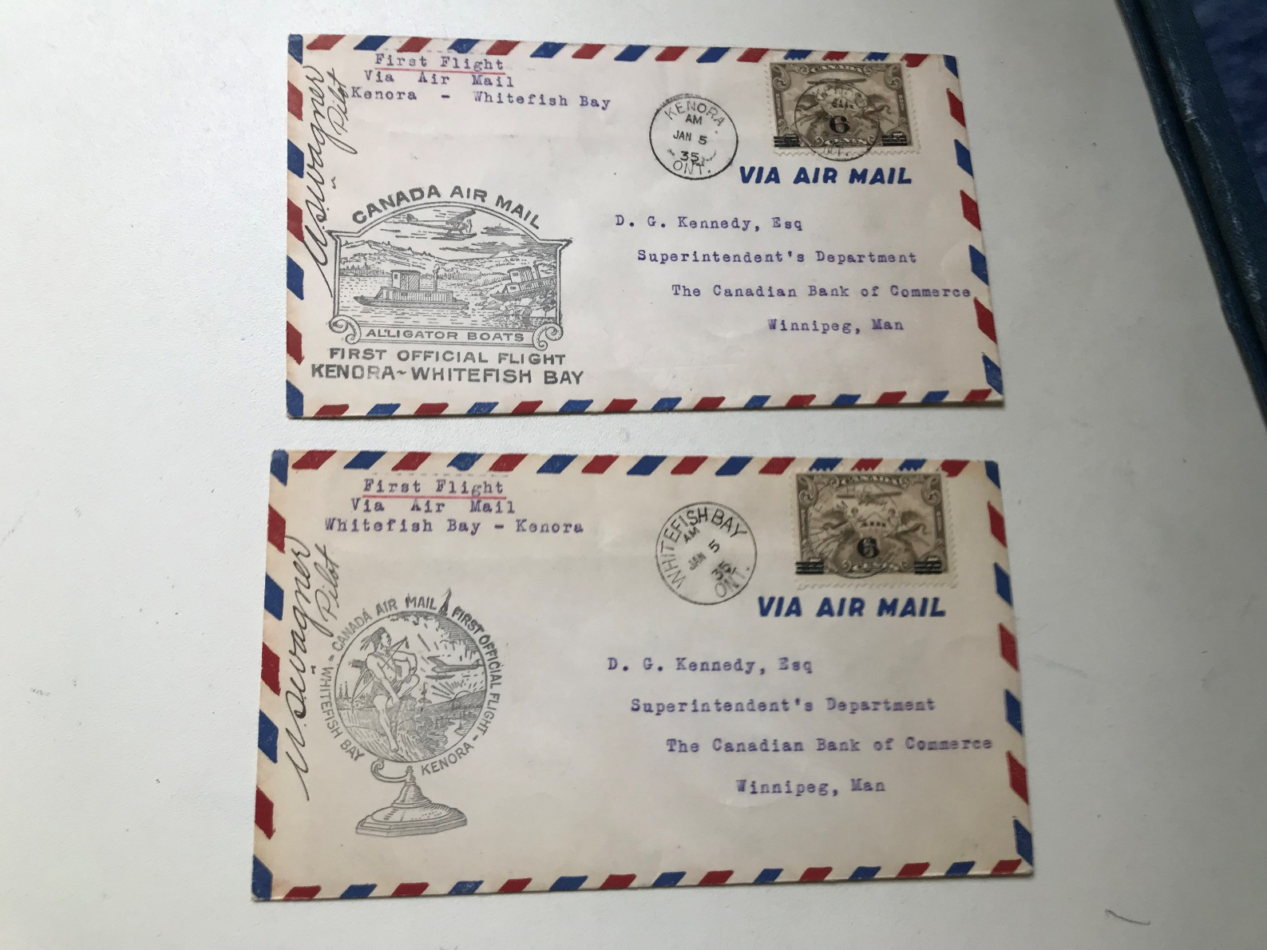
U.S. WAGNER
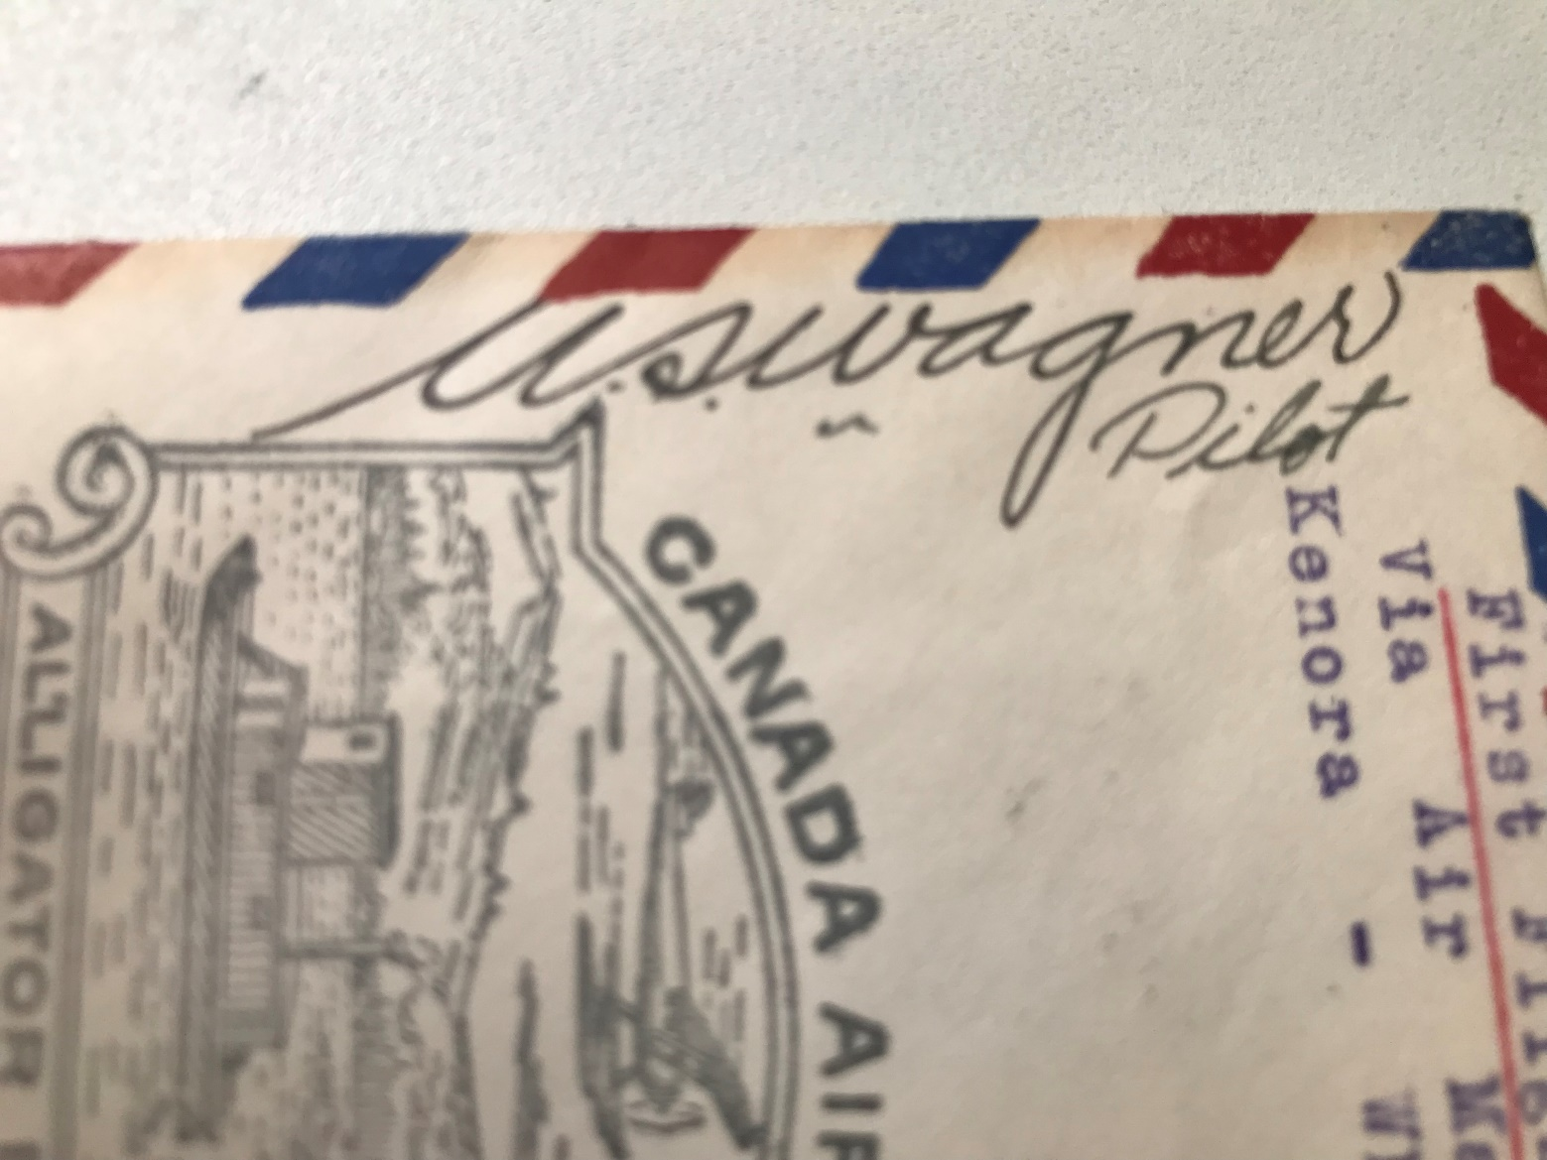

MAXWELL “MAX” WARD

MAX WARD
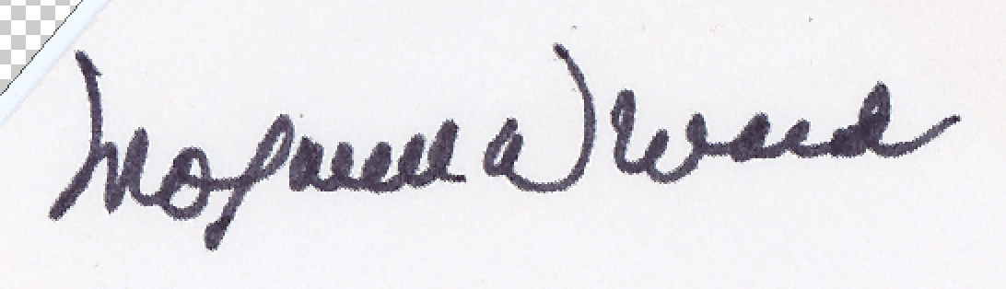

EVERETT WASSON
Everett Wasson
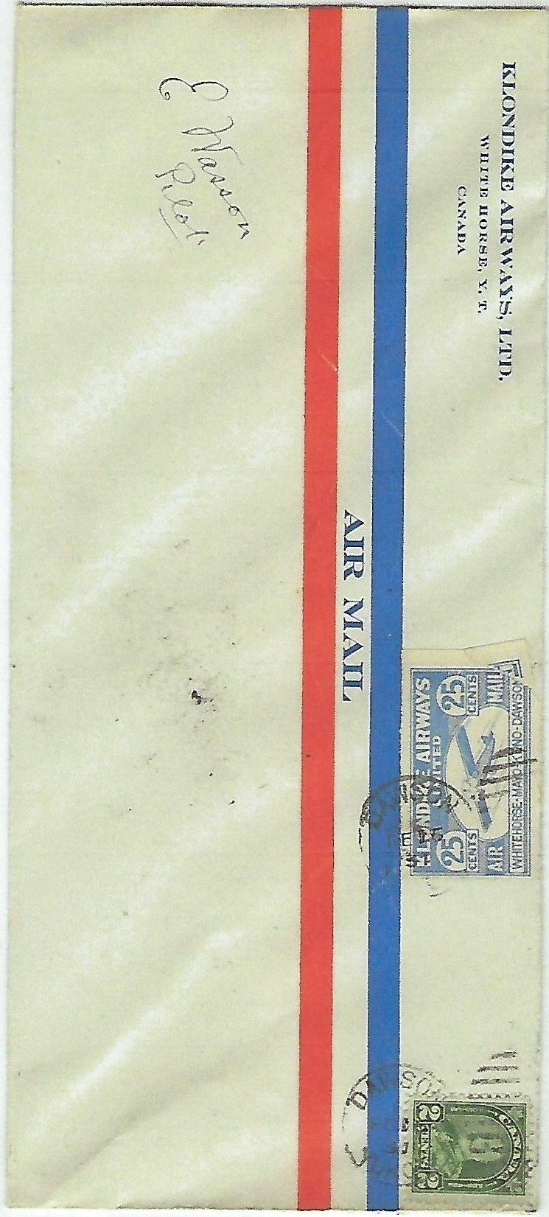

H. WHITTEMORE

H. WITTEMORE
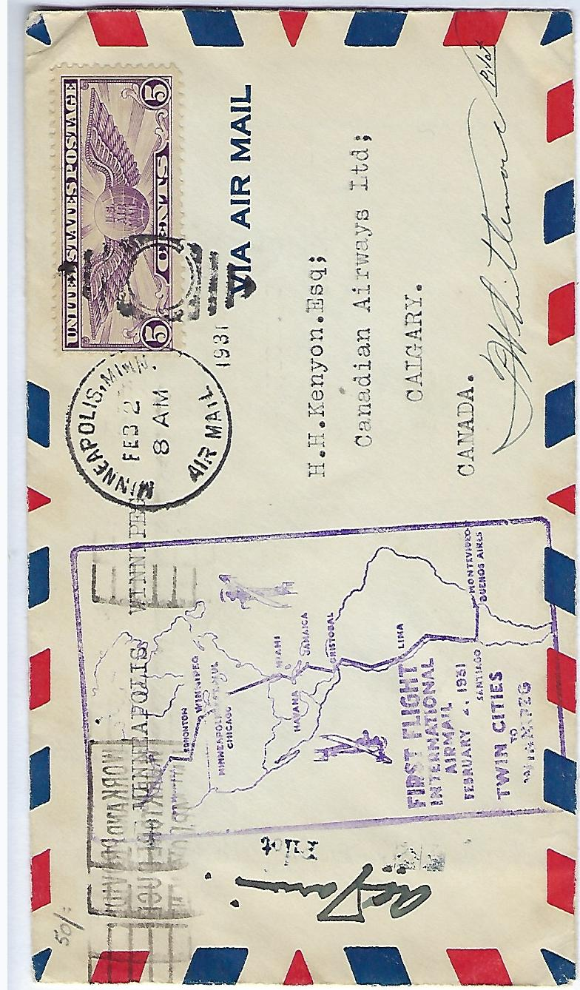

THOMAS WILLIAMS

THOMAS WILLIAMS

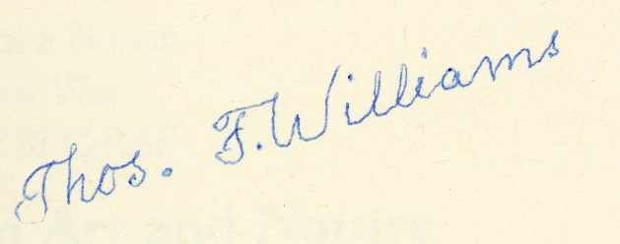

T.E. WOODS

T.E. WOODS

End

